Year 5, summer 2, 2025

Welcome back to the final term of Year 5! We’ve already been exploring our ‘Sow, Grow, Farm’ topic for four weeks, and there’s still so much exciting learning ahead as we finish the term strong. Let’s dive back in and make the most of our last few weeks together!

English    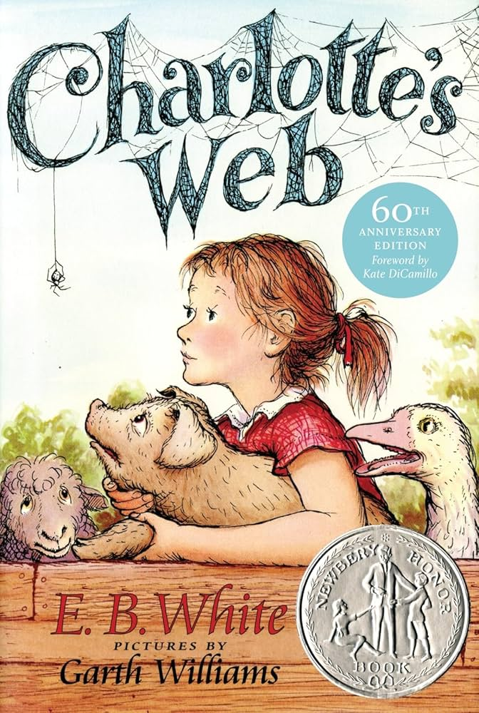 | This half term in English and our Love to Read lessons, Year 5 will continue to be exploring the book ‘Charlotte's Web’ by E.B White and illustrated by Garth Williams. The children will engage with the story by writing a film narrative and newspaper report.
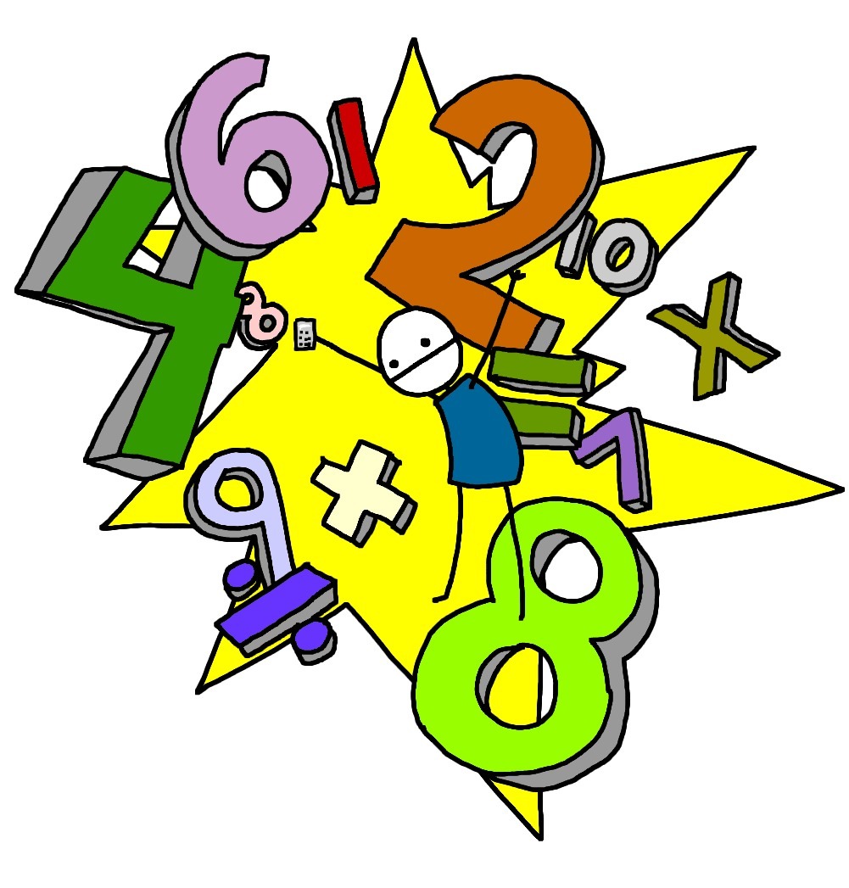  Maths | This half term in Year 5, we will start by learning about shapes, including angles and polygons. After that, we’ll focus on consolidating key skills from the year, especially calculating with whole numbers and decimals. The children will apply these skills to real-life situations like money and measurements, while practising both written methods and mental strategies, and explaining their reasoning clearly.
Science  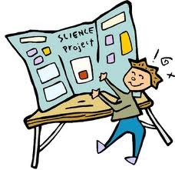 | This half term, Year 5 will continue exploring human reproduction and ageing. The children will study the life cycles of various animals, focusing on what defines a mammal and comparing their life cycles. They will investigate patterns in gestation periods and animal size using graphs.  We will also examine the human life cycle in detail, covering stages from embryo to adulthood, changes during puberty, and the effects of ageing. The children will learn about the human reproductive system and how humans grow and change over time.
Computing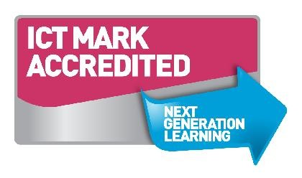 | In Computing this half term, we are continuing with our webpage design and creation. They will explore different tools for creating online content, evaluate how effective these tools are, and learn how to improve their work to communicate their ideas clearly.
Geography/History | This summer term, Year 5 will be studying the ‘Sow, Grow and Farm’ project. The children will discover the history of allotments in the UK and their role in supporting food rationing during the Second World War. They will explore food webs, life cycles, and plant reproduction, including dissecting flowers to examine their parts.  The children will also learn about modern farming in the UK, the challenges farmers face, and the seasonality of our food and its benefits. Finally, they will investigate farming around the world and how different climates influence where foods are grown.
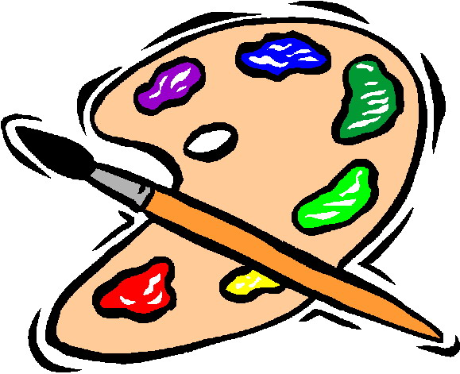  D&T and Art | Year 5 are now working on a project that explores the visual qualities of line, light, and shadow. The children study the works of Pablo Picasso and Rembrandt and learn a variety of shading techniques. They take black and white photographs and use pencil, pen, and ink wash to create shaded drawings inspired by their photos.
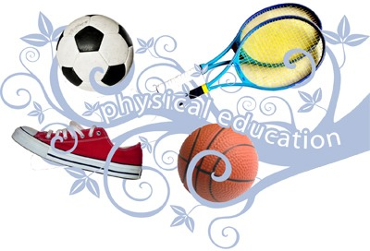  PE | This half term in PE, children will focus on sending and receiving skills with an emphasis on coordination and teamwork. Through a range of partner and group activities, they will practise throwing, catching, and controlling equipment, working together to complete challenges. These skills will support their athletics work by improving their timing, precision, and cooperation during competitive and non-competitive tasks.
  Music | Our Music lessons will consolidate the learning from throughout the year. The children will revisit songs and musical activities, while exploring the history of music and the foundations of the language of music.
RE   | This half term in RE, Year 5 will be exploring the theme of Hindu Beliefs. Our big question for the unit is: ‘How can Brahman be everywhere and in everything?’ The children will learn about the concept of Brahman in Hinduism and how this idea influences the beliefs and practices of Hindus.
PSHE  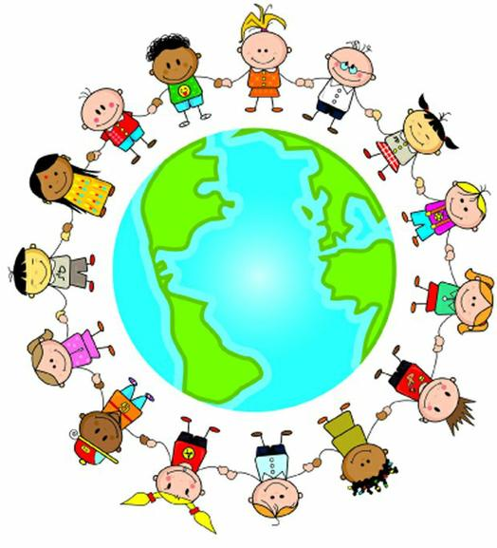 | This half term in PSHE, Year 5 will continue following the Jigsaw scheme and focus on the theme ‘Changing Me’. The children will explore the physical and emotional changes that happen during growing up, learning how to manage these changes with confidence and understanding.

Homework will be sent home on Thursdays and should be returned by the following Wednesday. Each week your child will have spellings to learn. Children will be also asked to complete a topic-based activity as detailed on the weekly homework sheet which is stuck into your child’s homework book.

PE kit – in on Monday please and to remain in school for the week.
Dance and PE days – these will be on Mondays and Tuesdays.
Water bottles – these should contain plain, unflavoured water. Label them please!
Uniform – please label all uniform as it makes it much easier for us to return any lost items to your child!

As always, if you have any questions or would like to know more about how you can help at home, please come and ask me; I am always happy to help.

Many thanks,

Miss Cowley: Class teacher
Mrs Bradley: Learning Support Assistant
Mr Hemming: Learning Support Assistant

