

Kingsway Community Primary School
Document Reference Number (if already used) | 2
Title | SEND Policy
Policy Owner | Sophie Finch
Version | 2.2
Approved Date | 29.09.25
Approving Body | Education Advisory Board
Next Review Date | September 2026

Version Control
Version | Last Modified | Last Modified By | Document Changes
2.2 | September 2025 | Sara Hartshorn | 1.3 reworded for clarity; 4.2 working reordered for clarity; 7.1 diagram of assess, plan, do, review added; page numbers reformatted; remaining SENCO changed to SENDCO; term CLA clarified
2.1 | September 2025 | Sophie Finch | Version number; date; SENCO changed to SENDCO; LAC changed to CLA

Contents:

Statement of intent

- Identifying SEND
- Definitions
- Roles and responsibilities
- Children with specific circumstances

- Involving pupils and parents in decision-making
- Local Offer
- Graduated approach
- Promoting mental health and wellbeing
- Transferring between different phases of education
- Supporting successful preparation for adulthood

Statement of intent

Kingsway Community Primary School values all pupils and celebrates diversity of experience, interest and achievement. All pupils need to experience praise, recognition and success, and pupils with SEND have equal entitlement to this.
This policy outlines the framework for the school to meet its duty, obligation and principal equality values to provide a high-quality education to all of its pupils, including pupils with SEND, and to do everything it can to meet the needs of pupils with SEND.
Through successful implementation of this policy, the school aims to:
- Eliminate discrimination.
- Promote equal opportunities.
- Foster good relationships between pupils with SEND and pupils without SEND.

Identifying SEND
  - The school has a clear approach to identifying and responding to SEND. We recognise that early identification and effective provision improves long-term outcomes for the pupils.
  - With the support of the SLT, classroom teachers will conduct regular progress assessments for all pupils, with the aim of identifying pupils who are making less than expected progress.
  - Progress will be characterised using the following stipulations:
- Progress is significantly not in line with the class average, from the same baseline
- Progress does not match or better the pupil’s previous rate of progress
- Progress fails to close the attainment gap within the class
- The attainment gap is widened by the plateauing of progress

Definitions
  - For this policy, a pupil is defined as having SEND if they have a:
- Significantly greater difficulty in learning than most others of the same age.
- Disability or health condition that prevents or hinders them from making use of educational facilities used by peers of the same age in mainstream schools or mainstream post-16 institutions.
  - Under the Equality Act 2010, a disability is a physical or mental impairment which has a long-term and substantial adverse effect on a person’s ability to carry out normal day-to-day activities.
  - The school reviews how well equipped we are to provide support across the following areas:
- Communication and interaction
- Cognition and learning
- Social, emotional and mental health difficulties
- Sensory and physical needs

Communication and interaction
  - Pupils with speech, language and communication needs (SLCN) have difficulty in communicating with others, often because they have difficulty saying what they want, they cannot understand what is being said to them, or they do not understand or use social rules of communication.

  - The school recognises that:
- Pupils with Autism Spectrum Condition (ASC) can have particular difficulties with social interaction.
- The profile for every pupil with SLCN is different and their needs may change over time. They may have difficulty with one, some, or all the different aspects of speech, language or social communication at different times of their lives.
  - The SENDCO will work with pupils, parents and language and communication experts (where necessary) to ensure pupils with communication and interaction difficulties reach their potential.

Cognition and learning
  - Pupils with learning difficulties may require support – the school will offer learning support in line with its teaching and learning policy.
  - The school understands that learning difficulties cover a wide range of needs, such as moderate learning difficulties (MLD), severe learning difficulties (SLD) and profound and multiple learning difficulties (PMLD). The SENDCO will ensure that any provision offered will be suitable to the needs of the pupil.
  - Specific learning difficulties (SpLD), affect one or more specific aspects of learning. This encompasses a range of conditions such as dyslexia, dyscalculia and dyspraxia.

Social, emotional and mental health difficulties
  - Pupils may experience a wide range of social and emotional difficulties that manifest themselves in many ways, including becoming withdrawn or isolated, or displaying challenging, disruptive and disturbing behaviour.
  - The school recognises that these behaviours may reflect underlying mental health difficulties such as anxiety or depression, and the school will implement support for pupils with these difficulties.

Sensory or physical needs
  - Impairments that prevent or hinder pupils from using the school facilities, such as vision impairment (VI), do not necessarily have SEND. The school will ensure staff understand that:
- Some conditions can be age-related and can fluctuate over time.
- A pupil with a disability is covered by the definition of SEND if they require special educational provision.

Roles and responsibilities
  - The governing body will be responsible for:
- Communicating with pupils with SEND and their parents when drawing up policies that affect them.
- Taking necessary steps to ensure that pupils with disabilities are not discriminated against, harassed or victimised, e.g. in line with an Equal Opportunities Policy.
- Regularly monitoring the school’s policies and procedures, to review their impact on pupils with SEND, including on their mental health and wellbeing.
- Preparing the accessibility plan, showing how the school intends to progressively improve access over time.
- Publishing annual information, setting out the measures and facilities to assist access for pupils with disabilities on the school’s website.
- Ensuring arrangements are in place to support pupils at school with medical conditions, in line with the school’s Supporting Pupils with Medical Conditions Policy.
- Appointing an individual governor or sub-committee to oversee the school’s arrangements for SEND.
  - The headteacher will be responsible for:
- Ensuring that those who are teaching or working with pupils with SEND are aware of their needs and have arrangements in place to meet them.
- Ensuring that teachers monitor and review pupils’ progress during the academic year.
- Cooperating with the LA during annual EHC plan reviews.
- Ensuring that the SENDCO has sufficient time and resources to carry out their functions.
- Providing the SENDCO with sufficient administrative support and time away from teaching to enable them to fulfil their responsibilities.
- Regularly and carefully reviewing the quality of teaching for pupils at risk of underachievement, as a core part of the school’s performance management arrangements.
- Ensuring that teachers understand the strategies to identify and support vulnerable pupils.
- Ensuring teachers have an established understanding of different types of SEND.
- Ensuring that procedures and policies for the day-to-day running of the school do not directly or indirectly discriminate against pupils with SEND.
- Ensuring that pupils with SEND and their parents are actively supported in contributing to needs assessments and developing and reviewing EHC plans.
- Establishing and maintaining a culture of high expectations and including pupils with SEND in all opportunities available to other pupils.
- Consulting health and social care professionals, pupils and parents to ensure the needs of children with medical conditions are effectively supported.
- Keeping parents and relevant teachers up to date with any changes or concerns involving a pupil.
- Identifying any patterns in the identification of SEND within the school and comparing these with national data.
- Reporting to the governing body on the impact of SEND policies and procedures, including on pupils' mental health and wellbeing.
- Ensuring that the SENDCO is provided with training, with an emphasis on mental health, on an annual basis.
  - The SENDCO will be responsible for:
- Collaborating with the governing body and headteacher, as part of the SLT, to determine the strategic development of the SEND policy and provision in the school.
- Working with the relevant governors and the headteacher to ensure that the school meets its responsibilities under the Equality Act 2010, regarding reasonable adjustments and access arrangements.
- The day-to-day operation and implementation of the SEND policy.
- Coordinating the specific provision made to support individual pupils with SEND, including those with EHC plans.
- Liaising with the relevant, designated teacher where a Looked After Child has SEND.
- Advising on a graduated approach to providing SEND support.
- Advising on the deployment of the school’s delegated budget and other resources to meet pupils’ needs effectively.
- Liaising with the parents of pupils with SEND.
- Liaising with early years providers, other schools, educational psychologists, health and social care professionals, and independent or voluntary bodies, as required.
- Being a key point of contact for external agencies, especially the LA and LA support services.
- Liaising with the potential future providers of education to ensure that pupils and their parents are informed about the options, and a smooth transition is planned.
- Providing professional guidance to colleagues and working closely with staff members, parents and other agencies, including SEND charities.
- Being familiar with the provision in the Local Offer and being able to work with professionals who are providing a supporting role to the family.
- Ensuring, as far as possible, that pupils with SEND take part in activities run by the school, together with those who do not have SEND.
- Ensuring that the school keeps the records of all pupils with SEND up to date, in line with the school’s Data Protection Policy.
- Informing the parents of pupils with SEND, who do not have an EHC plan, that SEND provision is being made.
- In collaboration with the headteacher, identifying any patterns in the identification of SEND within the school and comparing these with national data.
- Participating in training and CPD opportunities, some of which emphasise mental health to a greater extent.
- Providing training to relevant class teachers.
- Supporting teachers in the further assessment of a pupil’s particular strengths and weaknesses and advising on effective implementation of support.

  - Classroom teachers will be responsible for:
- Planning and reviewing support for pupils with SEND on a graduated basis, in collaboration with parents, the SENDCO and, where appropriate, the pupils themselves.
- Setting high expectations for every pupil and aim to teach them the full curriculum, whatever their prior attainment.
- Planning lessons to address potential areas of difficulty to ensure that there are no barriers to every pupil achieving.
- Ensuring every pupil with SEND is able to study the full national curriculum.
- Being accountable for the progress and development of the pupils in their class.
- Being aware of the needs, outcomes sought, and support provided to any pupils with SEND they are working with.
- Keeping the SLT up to date with any changes in behaviour, academic developments and causes of concern.

Children with specific circumstances

LAC – ‘Looked After Children’ (Warwickshire now use the term CLA – ‘Children Looked After’)
  - Children at the school who are being accommodated, or who have been taken into care, by the LA are legally defined as being ‘looked after’ by the LA.
  - The school recognises that ‘looked after’ children are more likely to be SEND, and it is likely that a significant proportion of them will have an EHC plan.
  - The school has a designated member of staff for coordinating the support for LAC.
  - Where that role is carried out by a person other than the SENDCO, designated teachers should work closely with the SENDCO to ensure that the implications of a child being both looked after and having SEND are fully understood by relevant school staff.

EAL
  - The school gives particular care to the identification and assessment of the SEND of pupils whose first language is not English.
  - It is necessary to consider the pupil within the context of their home, culture and community.
  - Where there is uncertainty about an individual pupil, the school will make full use of any local sources of advice relevant to the ethnic group concerned, drawing on community liaison arrangements wherever they exist.
  - The school appreciates having EAL is not equated to having learning difficulties. At the same time, when pupils with EAL make slow progress, it should not be assumed that their language status is the only reason; they may have learning difficulties.
  - The school will look carefully at all aspects of a pupil’s performance in different subjects to establish whether the problems they have in the classroom are due to limitations in their command of English that is used there or arise from SEND.

Involving pupils and parents in decision-making
  - Parents of pupils with SEND are encouraged to share their knowledge of their child; the Headteacher and SENDCO will aim to give them the confidence that their views and contributions are valued and will be acted upon.
  - Parents will always be formally notified when the school provides their child with SEND support.
  - Decisions on whether the school will commission added provisions will be discussed thoroughly with the LA, parents and, when appropriate, the pupil involved.
  - Decisions about education will not unnecessarily disrupt a pupil’s education or any health treatment underway.
  - The planning that the school implements will help parents and pupils with SEND express their needs, wishes and goals, and will:
- Focus on the pupil as an individual, not allowing their SEND to become a label.
- Be easy for pupils and their parents to understand by using clear, ordinary language and images, rather than professional jargon.
- Highlight the pupil’s strengths and capabilities.
- Enable the pupil, and those who know them best, to say what they have done, what they are interested in and what outcomes they are seeking in the future.
- Tailor support to the needs of the individual.
- Organise assessments to minimise demands on families.
- Bring together relevant professionals to discuss and agree together the overall approach.
  - The class teacher, supported by the SENDCO, will meet with pupils, and their parents twice an academic year to set clear outcomes, review progress, discuss activities and support, and identify parental responsibilities.

Local Offer
  - In developing and reviewing the Local Offer, the school will adopt the following approach:
- Collaborative: The school will work with LAs, parents and pupils in developing and reviewing the Local Offer. The school will also co-operate with those providing services.
- Accessible: The published Local Offer will be easy to understand, factual and jargon free. It is structured in a way that relates to pupils’ and parents’ needs (for example by broad age group or type of special educational provision). It will be well signposted and publicised.
- Comprehensive: Parents and pupils will know what support can be expected to be available across education, health and social care from age 0 to 25 and how to access it. The Local Offer will include eligibility criteria for services, where relevant, and make it clear where to go for information, advice and support, as well as how to make complaints about provision or appeal against decisions.
- Up to date: When parents and pupils access the Local Offer, it is important that the information is up to date.

Graduated approach
  - Once a pupil with SEND has been identified, the school will employ a graduated approach to meet the pupil’s needs by:

UNIVERSAL PROVISION

➢ Quality first teaching, differentiated for individual children is the first step in responding to children who have or may have SEND. To make progress, this differentiation may involve modifying learning objectives, teaching styles and access strategies. Under these circumstances, a child’s needs will be provided for within the whole class planning frameworks and individual target setting.

➢ Differentiation will be recorded in the daily planning by the class teacher.

➢ Monitoring of progress will be carried out by the class teacher and used to inform future differentiation within the classroom setting. Where a period of differentiated curriculum support has not resulted in the child making adequate progress OR where the nature or level of a child’s needs are unlikely to be met by such an approach, provision at the SEND support level may need to be made.

➢ Teachers observe and assess the progress of all individual children continually and report on a termly and/or half termly basis through our school assessment system. This will provide information about areas where a child is not progressing

➢ This cycle is assess, plan, do and review and is explained in the diagram below:
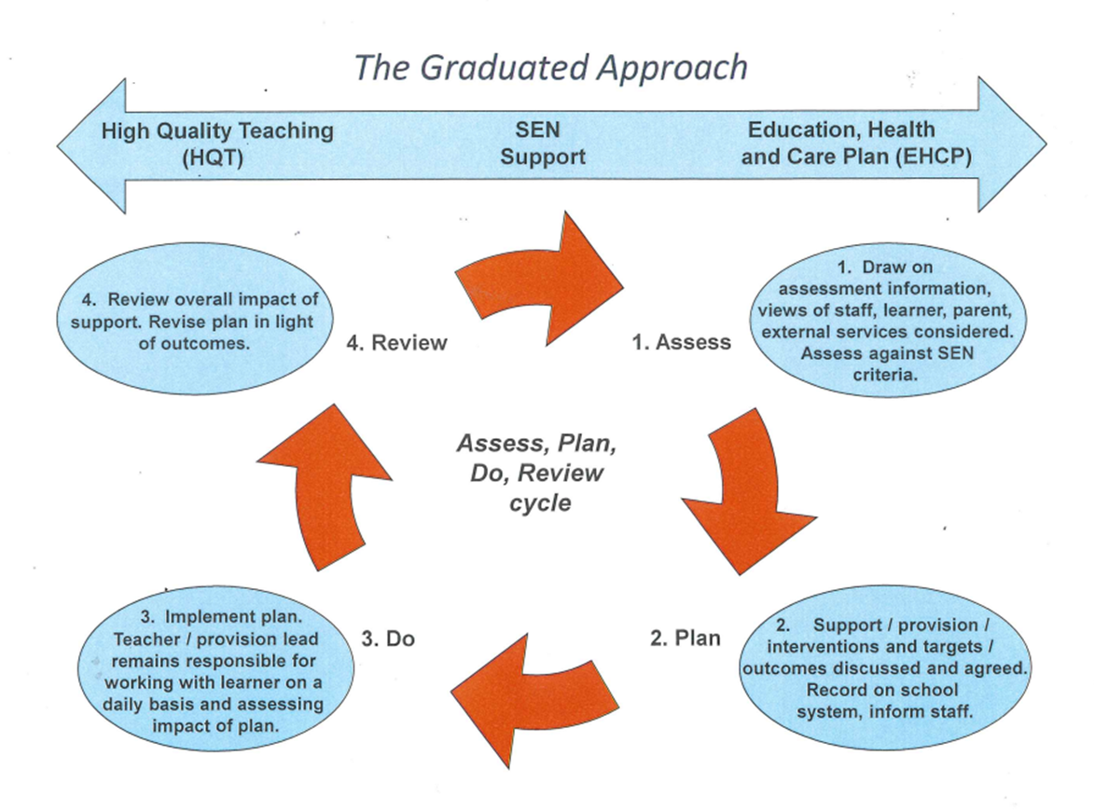

SEND SUPPORT

“SEND support should take the form of a four-part cycle through which earlier decisions and actions are revisited, refined and revised with a growing understanding of the pupil’s needs and of what supports the pupil in making good progress and securing good outcomes.” SEND code of practice 2014

➢ SEND support would be indicated where there is evidence that there has been little, or no progress made with existing differentiated support and interventions within the classroom and that barriers to learning are affecting progress in one or more of the following:
- Communication and Interaction
- Cognition and Learning
- Social, Emotional and Mental Health
- Sensory and /or Physical

➢ The responsibility for planning for these children remains with the class teacher, in consultation with the SENDCO.

“Teachers are responsible and accountable for the progress and development of the pupils in their class, including where pupils access support from teaching assistants or specialist staff.” SEND code of practice 2014

➢ A child at this point will have short term targets and goals to achieve and these will be in the form of a Personalised Learning Plan (PLP)

➢ At this point, parents will be asked to attend a meeting to discuss placing their child on the SEND register and to be consulted about any adjustments, interventions, or support to be put in place. A copy of the PLP will go home so parents can support their child as well as have clear information about their progress.

“Parents should be fully aware of the planned support and interventions and, where appropriate, plans should seek parental involvement to reinforce or contribute to progress at home.” SEND code of practice 2014

➢ As soon as targets are achieved the class teacher will create new targets.

TARGETED SUPPORT

➢ Where a pupil continues to make less than expected progress, despite evidence -based support and interventions that are matched to the pupil’s area of need, the school will consider involving specialist services. A variety of support can be offered by these services such as: advice to the school about targets and strategies; specialised assessment; or some direct work with the child. The specialist services will always contribute to the planning, monitoring, and reviewing of the child’s progress.

➢ Monitoring and reviews will be at least on a termly basis and teachers and the SENDCO discuss the effectiveness of strategies and interventions and alter if necessary.

EDUCATION HEALTH CARE PLAN

➢ For a child who is not making adequate progress and despite a period of two terms of high level SEND support and in agreement with the parents/carers, the school may request the LA to make an Education Health and Care needs assessment.

➢ For a child to receive an Education Health Care Plan (EHCP), the LA with consider a wide range of evidence but particularly:
- Evidence of the child’s academic attainment and rate of progress.
- Information about the nature, extent and context of the child’s SEND.
- Evidence of the action already being taken by school to meet the child’s SEND.
- Evidence that where progress has been made, it has only been as a result of much additional intervention and support.
- Evidence of the child’s physical, emotional, and social development and health needs and support provided by other agencies.

➢ A child who has an EHCP will continue to have arrangements as for SEND support but also may receive additional support that can be provided using any funds made available through the Plan.

➢ There will be an Annual Review, chaired by the SENDCO, to review the appropriateness of the provision and to recommend to the LA whether any changes need to be made to the Plan.

Promoting mental health and wellbeing
  - The curriculum for PSHE will focus on promoting pupils’ resilience, confidence and ability to learn.
  - Positive classroom management and working in small groups will be implemented to promote positive behaviour, social development and high self-esteem.
  - An Educational Psychologist will be available where a pupil requires such services.
  - Where appropriate, the school will support parents in the management and development of their child.
  - When in-school intervention is not appropriate, referrals and commissioning will be used instead. The school will continue to support the pupil as best it can.
  - For pupils with more complex problems, additional in-school support will include:
- Supporting the pupil’s teacher, to help them manage the pupil’s behaviour.
- Additional educational one-to-one support for the pupil.
- Providing professional mental health recommendations, e.g. regarding medication.
- Family support and/or therapy, upon the recommendation of mental health professionals.
  - The school will also consider whether disruptive behaviour is a manifestation of SEMH needs.
  - The school will focus on work that helps to build self-esteem and self-discipline with the aim of addressing disruptive behaviour.

Transferring between different phases of education
  - EHC plans will be reviewed and amended in sufficient time prior to a pupil moving between key phases of education, to allow for planning for and, where necessary, commissioning of, support and provision at the new phase.
  - The review and amendments will be completed by 15 February in the calendar year of the transfer at the latest for transfers into or between schools.
  - The key transfers are as follows:
- Early years provider to school
- Infant school to junior school
- Primary school to middle school
- Primary school to secondary school

Supporting successful preparation for adulthood
  - The school will engage with secondary schools to help plan for any transitions.
  - The school will transfer all relevant information about pupils to any educational institution that they are transferring to.
  - If a pupil has been excluded, the school has a duty to arrange suitable, full-time education from the sixth day of a fixed period exclusion and to provide full details of any SEND provisions necessary, in accordance with the school’s Exclusion Policy.
  - If it is in the best interest of the pupil, the school may commission alternative provision, in line with any EHC plans in place, for pupils who face barriers to participate in mainstream education.

