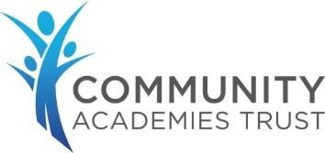

Child on Child Abuse Policy



Member of leadership team with lead responsibility for oversight and update of policy | Mrs L Connelly
Approved at SLT | October 2024
Approved at School Standards Committee | November 2024
Policy review cycle | Triennially
Policy review date | October 2027

Education is for improving lives and for leaving your community and world better than you found it.

Table of Contents

Introduction 3
Understanding child-on-child abuse 4
What is Contextual Safeguarding? 5
How prevalent is child-on-child abuse? 6
Sexual behaviours 6
How can a child who is being abused by another child be identified? 6
Are some children particularly vulnerable to abusing or being abused by their peers? 7
A whole school approach 8
Multi-agency working 9
Responding to concerns or allegations of child-on-child abuse 9
What should you do if you suspect a child may be experiencing or involved in child-on-child abuse? 10
How will the school respond to concerns or allegations of child-on-child abuse? 10
Risk Assessments 11
Information sharing, data protection and record keeping 12
Sanctions 12
Review and Action Planning 13

Introduction
At Kingsway Community Primary School our governors, strategic leadership team and all staff are committed to the prevention, early identification, and appropriate management of child-on-child abuse both within and beyond the school.
We believe that in order to protect children, all schools should:
- be aware of the nature and level of risk to which their pupils are or may be exposed, and put in place a clear and comprehensive strategy which is tailored to their specific safeguarding context;
- take a whole-school community ‘Contextual Safeguarding’ approach to preventing and responding to child-on-child abuse.

As a school we are committed to:
- tackling child-on-child abuse proactively, focusing on:
o systems and structures; o prevention;
o identification;
o response/intervention;

- recognising and responding to the increasing national concern about this issue in order to mitigate harmful attitudes and child-on-child abuse in the school setting;
- encouraging parents to hold us to account on this issue, so that if their child is feeling unsafe as a result of the behaviour of any of their peers, they inform the school so that we can ensure that appropriate and prompt action is taken in response.

This policy:

- is the school’s overarching policy for any issue that could constitute child-on-child abuse. It relates to, and should be read alongside our Child Protection and Safeguarding Policy and any other relevant policies including the behaviour, anti-bullying, online safety and exclusions policies;
- sets out our strategy for preventing and identifying and managing child-on-child abuse;
- applies to all members of our school community. It is reviewed biennially and updated in the interim, as required, to ensure that it continually addresses the risks to which pupils are or may be exposed;
- recognises that abuse is abuse and should never be passed off as ‘banter’, ‘just having a laugh’, or ‘part of growing up’;
- is compliant with the latest statutory guidance on child-on-child abuse as set out in Keeping Children Safe in Education;
- does not use the term ‘victim’ and/or ‘perpetrator’. This is because our school takes a safeguarding approach to all individuals involved in concerns or allegations about child-on child abuse, recognising that many children who present with harmful behaviour towards others, in the context of child-on-child abuse, are themselves vulnerable and may have been victimised themselves prior to their abuse of other children;
- uses the terms ‘child’ and ‘children’, which is defined for the purposes of this policy as a person aged under 18. The school’s response to incidents involving the exchange of youth involved sexual imagery will differ depending on the age of the pupils involved
- should, if relevant, be read in conjunction with the DfE’s advice on Sexual Violence and Sexual Harassment Between Children in Schools and Colleges (DfE - May 2018), and any other advice and guidance referred to within it;
- should be read in conjunction with the Local Safeguarding Partnership’s Safeguarding Policy and Procedures, and any relevant Practice Guidance issued by it.

Understanding child-on-child abuse
Child-on-child abuse is any form of physical, sexual, emotional and financial abuse and coercive control, exercised between children, and within children’s relationships (both intimate and non- intimate), friendships and wider peer associations. By definition, it applies regardless of the age, of stage of development, or any age differential between them.

A visual overview of child-on-child abuse:
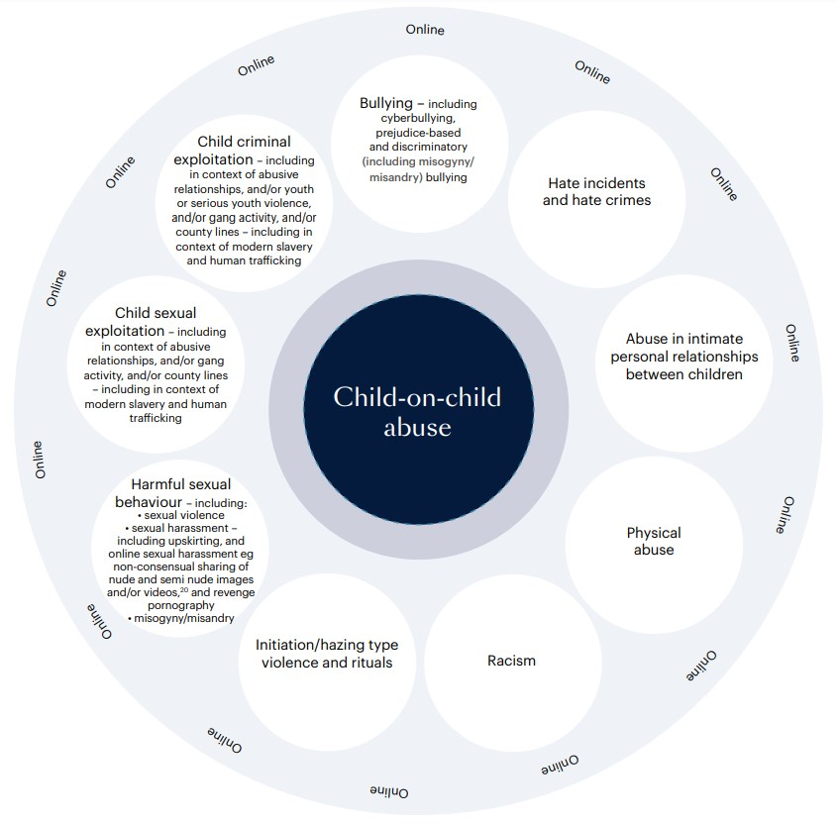

Child-on-child abuse can take various forms, including (but not limited to):

- Bullying, including cyber-bullying, prejudice-based and discriminatory (including misogyny/misandry) bullying;
- Hate incidents and hate crimes – which may also include an online element;
- Abuse in intimate personal relationships between children (sometimes known as ‘teenage relationship abuse’) – which may also include an online element;
- Physical abuse – such as hitting, kicking, shaking, biting, hair pulling, or otherwise causing physical harm. This may include an online element which facilitates, threatens and/or encourages physical abuse;
- Racism – occurs when a person is treated less favourably because of their skin colour, nationality, ethnicity, or cultural group. It can occur in person or online;
- Initiation/hazing type violence and rituals – this could include activities involving harassment, abuse or humiliation used as a way of initiating a person into a group and may also include an online element;
- Harmful sexual behaviour (HSB) – developmentally inappropriate sexual behaviour which is displayed by children and young people which is harmful or abusive. HSB can occur online and/or face to face, and can also occur simultaneously between the two. It can include sexual violence, sexual assault and/or sexual harassment, online sexual harassment, misogyny, misandry;
- Child sexual exploitation; ▪ Child criminal exploitation.

What is Contextual Safeguarding?
All staff should consider the context within which incidents/behaviours occur. This is known as ‘contextual safeguarding’, which simply means assessments of children should consider whether wider environmental factors are present in a child’s life that pose a threat to their safety or wellbeing.

This policy:

- encapsulates a contextual safeguarding approach, which is about changing the way that professionals approach child protection when risks occur outside of the family, known as extra-familial harm.
- adopts a whole-school community Contextual Safeguarding approach, which means:

  - being aware of the impact that these wider social contexts may be having on pupils; o creating a safe culture in the school by implementing policies and procedures that address child-on-child abuse, promoting healthy relationships and attitudes to gender/sexuality, hotspot-mapping to identify risky areas in school and training on potential bias and stereotyped assumptions;
  - being alert to and monitoring changes in pupils’ behaviour and/or attendance; o contributing to local child protection agendas by, for example, challenging poor threshold decisions and referring concerns about contexts to relevant local agencies.

How prevalent is child-on-child abuse?
Research suggests that child-on-child abuse is one of the most common forms of abuse affecting children in the UK. In 2015, more than four in ten teenage schoolgirls aged between 13 and 17 in England had experienced sexual coercion, while two thirds of contact sexual abuse experienced by children aged 17 or under was committed by someone who was also aged 17 or under.

Sexual behaviours
The following continuum model demonstrates the range of sexual behaviours presented by children, which may be helpful when seeking to understand a child’s sexual behaviour and deciding how to respond to it.

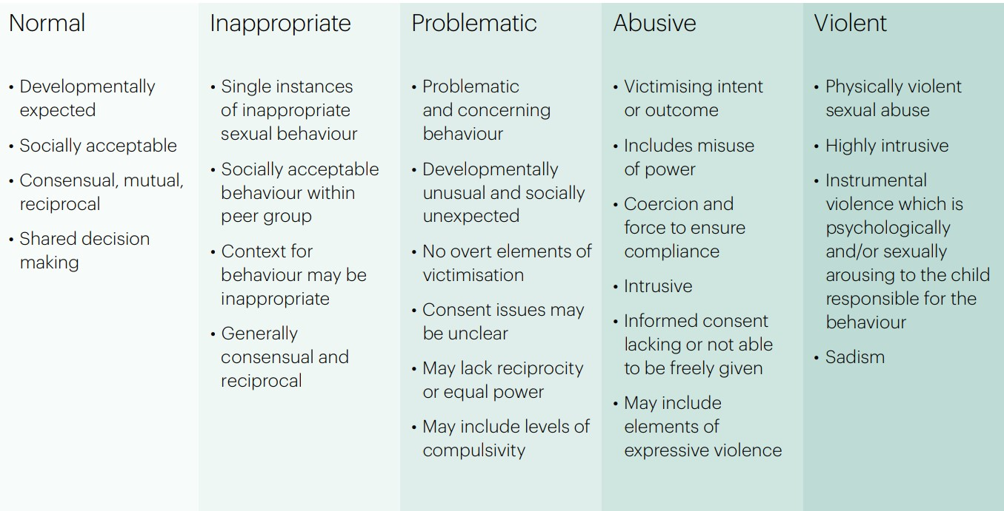

This continuum relates exclusively to sexual behaviours and is not exhaustive. The Brook Sexual Behaviours Traffic Light Tool can also help professionals working with children to distinguish between three levels of sexual behaviour – green, amber and red, and to respond according to the level of concern.

How can a child who is being abused by another child be identified?

All staff should be alert to the well-being of pupils and to signs of abuse, and should engage with these signs, as appropriate, to determine whether they are caused by child-on-child abuse.
However, staff should be mindful of the fact that the ways in which children will disclose or present with behaviours will differ as a result of their experiences.
Things to look out for in victims of child-on-child abuse:
- Regularly feeling sick or unwell in the morning;
- Reluctance to make the journey to and from school;
- Money or possessions going missing;
- Clothes or school bag torn;
- Wanting extra pocket money for no particular reason;
- Unexplained cuts and bruises;
- Taking different routes to school;
- Unexplained behaviour changes, e.g. moody, bad tempered, tearful;
- Unhappiness;
- Nightmares;
- Not wanting to leave the house;
- Reluctance to talk openly about school friends and playtimes.

The school’s safeguarding team should regularly review behaviour incident logs which can help to identify any changes in behaviour and/or concerning patterns or trends at an early stage.
If a parent thinks their child may be the victim of child-on-child abuse, they should contact the school as soon as possible to report the issues through the appropriate channels. Sometimes children do not report the issues to anyone in school.

Are some children particularly vulnerable to abusing or being abused by their peers?

Any child can be vulnerable to child-on-child abuse due to the strength of peer influence and staff should be alert to signs of such abuse amongst all children. Situational factors can increase a child’s vulnerability to abuse by their peers. For example, an image of a child could be shared, following which they could become more vulnerable to child-on-child abuse due to how others now perceive them, regardless of any characteristics which may be inherent in them and/or their family.

Peer group dynamics can also play an important role in determining a child’s vulnerability to such abuse. For example, children who are more likely to follow others and/or who are socially isolated from their peers may be more vulnerable to child-on-child abuse. Children who are questioning or exploring their sexuality may also be particularly vulnerable to such abuse.

Research suggests that:
- child-on-child abuse may affect boys differently from girls, which may result from societal norms rather than biological make-up. Barriers to disclosure will also be different.
- children with Special Educational Needs and/or Disabilities (SEND) are three times more likely to be abused than their peers without SEND, and additional barriers can sometimes exist when recognising abuse in children with SEND. These can include:
  - assumptions that indicators of possible abuse such as behaviour, mood and injury relate to a child’s disability without further exploration;
  - the potential for children with SEND to be disproportionately impacted by behaviours such as bullying and harassment, without outwardly showing any signs;
  - communication barriers and difficulties; o overcoming these barriers.
- some children may be more likely to experience child-on-child abuse than others as a result of certain characteristics such as sexual orientation, ethnicity, race or religious beliefs.

A whole school approach
The school actively seeks to raise awareness of and prevent all forms of child-on-child abuse by:
- educating all governors, its strategic leadership team, staff, pupils and parents about this issue, including training at all levels on the nature, prevalence and effect of child-on-child abuse and how to prevent, identify and respond to it. This includes:
  - Contextual Safeguarding; o the identification and classification of specific behaviours, including digital behaviours;
  - the importance of taking seriously all forms of child-on-child abuse, no matter how ‘low-level’ they may appear, and ensuring that no form of child-on-child abuse is ever dismissed as teasing or banter;
  - social media and online safety, including how to encourage children to use social media in a positive, safe and responsible way, how to enable them to identify and manage abusive behaviour online, and how to critically assess the content they may be exposed to, including recognising and challenging negative influences`.
- educating children about the nature and prevalence of child-on-child abuse, positive, responsible and safe use of social media, and the unequivocal facts about consent and about healthy relationships, via PSHE and the wider curriculum. They are regularly informed about the school’s approach to such issues, including its zero-tolerance response towards all forms of child-on-child abuse.
- engaging parents on these issues by:
  - publicising the possible signs and symptoms of child-on-child abuse and encouraging them to report concerns to the school immediately;
  - encouraging parents to hold the school to account on this issue, in part as a result of visibility of this policy.
- Supporting and promoting the ongoing wellbeing and mental health of pupils by drawing on multiple resources that prioritise pupil wellbeing, resilience and mental health, and by providing in-school counselling to address underlying mental health needs.
- creating conditions in which our pupils can aspire to, and realise, safe and healthy relationships fostering a whole-school culture:
  - which is founded on the idea that every member of our school community is responsible for building and maintaining safe and positive relationships, and helping to create a safe school environment in which violence and abuse are never acceptable;
  - in which pupils are able to develop trusting relationships with staff and in which staff understand, through regular discussion and training, the importance of these relationships in providing pupils with a sense of belonging, which could otherwise be sought in problematic contexts;
  - in which pupils feel able to share their concerns openly, in a non-judgmental environment, and have them listened to;
- responding to cases of child-on-child abuse promptly and appropriately;
- ensuring that all child-on-child abuse issues are fed back to the school’s safeguarding team so that they can spot and address any concerning trends and identify pupils who may be in need of additional support.

Multi-agency working
The school actively engages with its Local Safeguarding Partnership in relation to child-on-child abuse and works closely with a range of external agencies in accordance with the Local Safeguarding Partnership’s procedures.
The school actively refers concerns and allegations of child-on-child abuse where necessary to children’s social care, the police and other relevant agencies in accordance with the Local Safeguarding Partnership’s procedures.

Responding to concerns or allegations of child-on-child abuse
It is essential that all concerns and allegations of child-on-child abuse are handled sensitively, appropriately and promptly.
Our response will:
- include a thorough investigation of the concern(s) or allegation(s), and the wider context in which it/they may have occurred (as appropriate) – depending on the nature and seriousness of the alleged incident(s), it may be appropriate for the police and/or children’s social care to carry out this investigation;
- treat all children involved as being at potential risk – while the child allegedly responsible for the abuse may pose a significant risk of harm to other children, s/he may also have considerable unmet needs and be at risk of harm themselves. The school should ensure that a safeguarding response is in place for both the child who has allegedly experienced the abuse, and the child who has allegedly been responsible for it, and additional sanctioning work may be required for the latter;
- take into account that the abuse may indicate wider safeguarding concerns for any of the children involved, and consider and address the effect of wider sociocultural contexts such as the child’s peer group, family, the school environment, the potential for victimisation in the local community and the child’s online presence;
- consider the potential complexity of child-on-child abuse and of children´s experiences, and consider the interplay between power, choice and consent. While children may appear to be making choices, if those choices are limited they are not consenting;
- ensure an intersectional approach is followed, specifically ensuring adultification does not lead to a failure to recognise victims of child-on-child abuse and particularly those from ethnic minority groups;
- obtain the views of the child/children affected. Unless it is considered unsafe to do so the DSL should discuss the proposed action with the child/children and their parents and obtain consent to any referral before it is made. The school should manage the child’s

expectations about information sharing, and keep them and their parents informed of developments, where appropriate and safe to do so. It is particularly important to take into account the wishes of any child who has allegedly been abused, and to give that child as much control as is reasonably possible over decisions regarding how any investigation will be progressed and how they will be supported.

What should you do if you suspect a child may be experiencing or involved in child-on-child abuse?

If a member of staff thinks for whatever reason that a child may be at risk of or experiencing abuse by their peer(s), or that a child may be at risk of abusing or may be abusing their peer(s), they should discuss their concern with the DSL without delay, following the procedure detailed in the Child Protection and Safeguarding Policy, so that a course of action can be agreed.
Where a child is suffering, or is likely to suffer from harm, it is important that a referral to children’s social care (and, if appropriate, the police) is made immediately. Anyone can make a referral. Where referrals are not made by the DSL, the DSL should be informed as soon as possible that a referral has been made.
If a child speaks to a member of staff about child-on-child abuse that they have witnessed or are a part of, the member of staff should listen to the child and use open language that demonstrates understanding rather than judgement.

How will the school respond to concerns or allegations of childon-child abuse?

The DSL will discuss the concern(s) or allegation(s) with the member of staff who has reported it/them and will, where necessary, take any immediate steps to ensure the safety of the child/all children affected.
Where any concern(s) or allegation(s) indicate(s) that indecent images of a child or children may have been shared online, the DSL should consider what urgent action can be taken in addition to the actions and referral duties set out in this policy.
DSLs will always use their professional judgement to:
- assess the nature and seriousness of the alleged behaviour;
- determine whether it is appropriate for the alleged behaviour to be to be dealt with internally and, if so, whether any external specialist support is required. In borderline cases the DSL may wish to consult with children’s social care and/ or other relevant agencies in accordance with the Local Safeguarding Partnership’s procedures to determine the most appropriate response.
Where the DSL considers or suspects that the alleged behaviour in question might be abusive or violent or where the needs and circumstances of the individual child/children in question might otherwise require it, the DSL should contact children’s social care and/or the police immediately and, in any event, within 24 hours of the DSL becoming aware of the alleged behaviour. The DSL will discuss the concern(s) or allegation(s) with the agency and agree on a course of action, which may include:
- Manage internally with help from external specialists where appropriate and possible. This would usually be where the alleged behaviour between peers is inappropriate or problematic, as opposed to abusive or violent. In such cases, utilising the behaviour policy and providing pastoral support may be the most appropriate route.

- Undertake/contribute to an inter-agency early help assessment, with targeted early help services provided to address the assessed needs of the child/children and their family. These services may, for example, include family and parenting programmes, responses to emerging thematic concerns in extra familial contexts, a specialist harmful sexual behaviour team, CAMHS and/or youth offending services.

- Refer the child/children to children’s social care for a section 17/47 statutory assessment. Where a child is suffering, or is likely to suffer from harm, it is important that a referral to children’s social care (and, if appropriate, a report to the police) is made immediately. This referral will be made to children’s social care in the area where the/each child lives.

- Report alleged criminal behaviour to the police. Alleged criminal behaviour will ordinarily be reported to the police. However, there are some circumstances where it may not be appropriate to report such behaviour to the police. For example, where the exchange of youth involved sexual imagery does not involve any aggravating factors. All concerns or allegations will be assessed on a case-by-case basis, and in light of the wider context.

Risk Assessments
In line with KCSiE guidance a risk assessment bwill always be carried out by the school in respect of:
- any child who is alleged to have behaved in a way that is considered to be abusive or violent;
- any child who has reportedly been abused or affected by the alleged abusive or violent behaviour by another child; or
- any child who may be at risk due to the alleged abusive or violent behaviour by another child as deemed appropriate by the DSL.
Consideration may need to be given to having separate but aligned risk assessments for the alleged perpetrator(s), and the victim(s), and any other child/children who may be affected by the alleged abusive or violent behaviour.
Where other children have been identified as witnesses to the alleged abusive or violent behaviour, consideration should also be given by the DSL to the impact on them, and whether there might be any risks posed to those children, and whether a risk assessment for them would be appropriate in the circumstances.
In the vast majority of circumstances and where it is possible that such behaviour may be repeated, a risk assessment should be completed.
Where it is alleged that a child has behaved in a way that is considered to be inappropriate or problematic (as opposed to abusive or violent), the DSL will use their professional judgment to determine whether it would be appropriate to contact children’s social care and to carry out a risk assessment.
Careful judgment and consideration are required as to whether alleged behaviour which might be judged to be inappropriate by an adult might actually be harmful to another child. The school may refer to Hackett’s continuum and/or the Brook Sexual Behaviours Traffic Light Tool to identify and assess the sexual behaviour in question. Consultation is also recommended with the trust’s Director of Safeguarding and Behaviour or children’s social care if there remains any doubt about this. Careful consideration should also be given to the context, severity of the alleged behaviour, impact of the alleged behaviour on others, risk to others, and whether there are any patterns of behaviour occurring.
Where other children have been identified as witnesses to alleged abuse or violence, consideration should also be given by the DSL to whether there might be any risks to those children.
In all cases where a risk assessment is not considered to be appropriate, the school should nonetheless take steps to safeguard and support the children involved and continue to monitor the situation, reviewing the need for a risk assessment if risk increases.

Information sharing, data protection and record keeping
When responding to concern(s) or allegation(s) of child-on-child abuse, the school will:
- always consider carefully, in consultation with other relevant agencies, how to share information about the concern(s) or allegation(s) with the pupil(s) affected, their parents, staff, and other pupils and individuals,
- record the information that is necessary for the school and other relevant agencies (where they are involved) to respond to the concern(s) or allegation(s) and safeguard everyone involved,
- act in accordance with its safeguarding and data protection duties, including those set out by the DfE in Working Together to Safeguard Children (December 2023) and Information Sharing: Advice for practitioners (May 2024).

Sanctions
The school may wish to consider whether sanctions may be appropriate for any child/children involved. This may be appropriate to:
- ensure that the child/children take(s) responsibility for and realise(s) the seriousness of their behaviour;
- demonstrate to the child/children and others that child-on-child abuse can never be tolerated;
- ensure the safety and wellbeing of other children.
However, these considerations must be balanced against any police investigations, the child’s/children’s own potential unmet needs, and any action or intervention planned regarding safeguarding concerns. Before deciding on appropriate action the school will always consider its duty to safeguard all children in its care from harm; the underlying reasons for a child’s behaviour; any unmet needs, or harm or abuse suffered by the child; the risk that the child may pose to other children; and the severity of the child-on-child abuse and the causes of it.
The school will, where appropriate, consider the potential benefit, as well as challenge, of using managed moves or exclusion as a response, and not as an intervention, recognising that even if this is ultimately deemed to be necessary, some of the measures referred to in this policy may still be required, in relation to other pupils who have been involved with and/or affected by childon-child abuse.
Exclusion will only be considered as a last resort and only where necessary to ensure the safety and wellbeing of the other children in the school. Engaging in Fair Access Panel Processes to assist with decision-making associated to managed moves and exclusions can also be beneficial. In the event of any managed move, consideration must be given to sharing information with the receiving school regarding the child-on-child abuse in order to allow best protection of children in the new school.

Review and Action Planning
The school’s response to concerns or allegations of child-on-child abuse should be part of on-going proactive work by the school to embed best practice and in taking a whole-school community Contextual Safeguarding approach to such abuse.
This response could also include the school asking itself a series of questions about the context in which an incident of child-on-child abuse occurred in the school, the local community in which the school is based, and the wider physical and online environment – such as:
- What protective factors and influences exist within the school and how can the school bolster these?
- How (if at all) did the school’s physical environment or the pupils’ routes to and from the school contribute to the abuse, and how can the school address this going forwards
- How (if at all) did the online environment contribute to the abuse, and how can the school address this going forwards?
- Did wider gender norms, equality issues, and/or societal attitudes contribute to the abuse?
- Does the abuse indicate a need for staff training on, for example, underlying attitudes or the handling of particular types of abuse?
- How have similar cases been managed in the past and what effect has this had?
- Does the case identify areas for development in the way in which the school works with children to raise their awareness of and/or prevent child-on-child abuse, including by way of the school’s PSHE curriculum and lessons that address underlying attitudes or behaviour such as gender and equalities work, respect, boundaries, consent, children’s rights and critical thinking and/or avoiding victim-blaming narratives?
- Are there any lessons to be learnt about the way in which the school engages with parents to address child-on-child abuse issues?
- Are there underlying issues that affect other schools in the area and is there a need for a multi-agency response?
- Does this case highlight a need to work with certain children to build their confidence, and teach them how to identify and manage abusive behaviour?
- Were there opportunities to intervene earlier or differently?
Answers to these questions may be developed into an action plan which is reviewed on a regular basis by the DSL and the school’s leadership team.

https://www.farrer.co.uk/globalassets/clients-and-sectors/safeguarding/addressing-child-on-child-abuse.pdf, p5
Barter, Christine, Aghtaie, N., Larkins, C., et al., Safeguarding Teenage Intimate Relationships (STIR) Connecting online and offline contexts and risks, Briefing Paper 2: Incidence Rates and Impact of Experiencing Interpersonal Violence and Abuse in Young People’s Relationships, 2015: http://stiritup.eu/wp-content/uploads/2015/02/STIR-Briefing-Paper-21.pdf
Professor Simon Hackett’s harmful sexual behaviour framework, 2019, p 15: https://learning.nspcc.org.uk/researchresources/2019/harmful-sexualbehaviour-framework/
https://www.brook.org.uk/your-life/courses/traffic-light-tool/
Our zero-tolerance practice means that we will never do nothing in response to knowledge of child-on-child abuse and will always support those who report, taking all allegations seriously. The school will take a proportionate and appropriate response to every alleged incident.
Suggested contents/ format of a risk assessment can be found in https://www.farrer.co.uk/globalassets/clientsand-sectors/safeguarding/addressing-child-on-child-abuse.pdf, p50-51
https://www.gov.uk/government/publications/data-protection-toolkit-for-schools

