Year 3, summer 2, 2024.

Welcome back!

I hope you had a fantastic break and enjoyed some much-needed rest and relaxation.

I cannot believe that we are about to embark on our last half term this academic year! The children will continue to learn about Ancient Rome through our topic ‘Emperors and Empires’ and will be kept busy until the end of term.

Please look out for important dates via our newsletters regarding sports day, transition day and other school events.

English    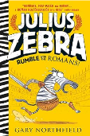 | We will continue to read our class text ‘Julius Zebra: Rumble with the Romans’ by Gary Northfield. As we continue to explore this text, the children will be completing their biographies. We will then use the text to write playscripts and narratives. The children will be continuing to write using cursive handwriting and will need to pay close attention to spelling common exception words, applying their grammar skills and remembering to use punctuation correctly.  Reading is an important area of learning – as a class, we will be focusing on improving our fluency, by reading familiar texts repeated. So, increasing word recognition and pace of reading.
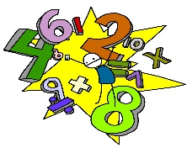  Maths | This half term we will recapping and consolidation all the four operations (-,+,x, ÷) using various manipulatives so we can visualise and explain our methods clearly. We will continue to practise our times tables, any practice at home is always greatly appreciated and completing the weekly homework will support with this.
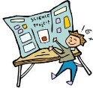  Science | ‘Plant Nutrition and Reproduction’ is our topic for this half term. This project teaches children about the requirements of plants for growth and survival. They describe the parts of flowering plants and relate structure to function, including the roots and stem for transporting water, leaves for making food and the flower for reproduction.
  Computing | This half term children will begin their computing journey by learning how to keep save online, with a focus on health, well-being and lifestyle. Following this, we will complete our ‘Voice over’ project which teaches the children to add audio to a video.
Geography/History | Our History curriculum continues to focus on the topic of ‘Emperors and Empires’. It teaches children about the history and structure of ancient Rome and the Roman Empire, including a detailed exploration of the Romanisation of Britain.
  D&T and Art | ‘Beautiful Botanicals’ is our topic this half term. This project teaches children about the genre of botanical art. They create natural weavings, two-colour prints and beautiful and detailed botanical paintings of fruit.
  PE | This half term, the children will continue to receive weekly PE sessions with a health and fitness. The children will develop and apply their ball chasing and stance through focused skill development sessions, healthy competition, cooperative games and Personal Best challenges. They will also benefit from a weekly Dance session; the children will be learning to respond to choreography and building towards a structured dance routine, as well as an offsite Tennis event.
  Music | This half term the children will explore the unit: Reflect, Rewind and Replay. This Unit of Work consolidates the learning that has occurred during the year. All the learning is focused around revisiting songs and musical activities, a context for the History of Music and the beginnings of the Language of Music.
RE   | In RE, we will be looking at Hinduism and the key question: Would visiting the River Ganges feel special to a non-Hindu? We are learning to understand the significance of the River Ganges both for a Hindu and non-Hindu.
PSHE  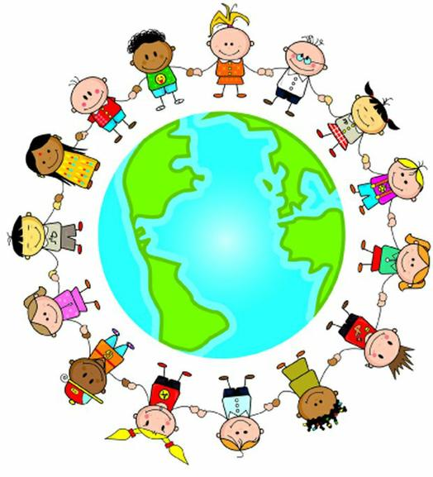 | Our Jigsaw topic is ‘Changing Me’ and children will identify how a baby grows into an adult. They will also discuss appropriate ways our bodies change and family stereotypes.

Homework will be sent home on Thursdays and should be returned by the following Wednesday. Each week your child will have spellings to learn. Children will be also asked to complete a topic-based activity as detailed on the weekly homework sheet which is stuck into your child’s homework book.

PE kit – in on Monday please and to remain in school for the week.
Dance and PE days – these will be on Mondays and Wednesdays.
Water bottles – these should contain plain, unflavoured water. Label them please!
Uniform – please label all uniform as it makes it much easier for us to return any lost items to your child!

As always, if you have any questions or would like to know more about how you can help at home, please come and ask me; I am always happy to help.

If you have any questions or would like to know more about how you can help at home, please come and ask.

Mrs Shambrook: Class Teacher
Mrs Sidwell: Learning Support Assistant
Mrs Pabla: Learning Support Assistant

