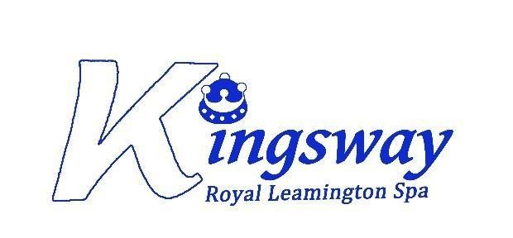

Kingsway Community Primary School

DRAFT
Complaints Policy
Local Arrangements

Policy owner | Sara Hartshorn
Version | 1.0 – October 2025
Approved Date
Approving Body
Next Review Date
As a school, we adopt the Community Academies Trust Complaints Policy. This policy will outline the local arrangements relating to the policy.
The CAT Complaints policy can be located in the following places:
- On the school website – www.kingswayprimaryschool.org
- On the CAT website https://www.communityacademiestrust.org/en-GB/trust-information
- By asking for a paper or electronic copy from the school office – admin@kingswayprimaryschool.org

Stage 1 – Informal Procedure
The class teacher and other members of staff can deal with many concerns to the satisfaction of the complainant, without needing to deal with it formally.
Kingsway values informal meetings and telephone discussions as a way of improving its procedures and relations with parents. The contact details for senior members of staff are listed below.
Headteacher | Deputy Headteacher
Miss S Hartshorn  admin@kingswayprimaryschool.org  01926 426896 | Mrs S Finch  admin@kingswayprimaryschool.org  01926 426896

Stage 2 – Formal Complaint Investigated by a Member of School
If the complainant is unhappy with the way in which the concern was dealt with at Stage 1, the complainant should complete the formal complaint form found in Annex 3 of the main policy.
Complaints should be addressed to the Headteacher who will decide who will investigate the complaint.
Headteacher
Miss S Hartshorn
admin@kingswayprimaryschool.org
01926 426896

If the complaint concerns the Headteacher, the complaint will be referred to the Chair of Governors.
Chair of Governors - TBC
Chair of Education Advisory Board
Mrs A Brown
admin@kingswayprimaryschool.org

Stage 3 – Formal Complaint Investigated by Headteacher
If the complainant is unhappy with the outcome of the complaint under Stage 2, the complainant should write to the Headteacher, asking for the complaint to be investigated under Stage 3 of the CAT Complaints Policy.
Headteacher
Miss S Hartshorn
admin@kingswayprimaryschool.org
01926 426896

If the complaint concerns the Headteacher, the complaint will be referred to the Chair of the Governors.
Chair of Governors - TBC
Chair of Education Advisory Board
Mrs A Brown
admin@kingswayprimaryschool.org

Stage 4 – Complaint Heard at an Independent Complaint Panel
If the complainant is unhappy with the outcome of the complaint under Stage 3, the complainant should write to the Clerk to the Local Governors asking for the complaint to be heard before an Independent Complaint Panel. Guiding principles and information on the appointment of an Independent Complaint Panel can be found in Annex 4 of the CAT Complaints Policy.
Clerk to Local Governors
Mrs S Beatty
sallybeatty@warwickshire.gov.uk

