Reception, summer 2, 2025.
Welcome back!
I hope you had a lovely break and enjoyed some special family time.
This half term our topic is ‘On the Beach’. To start the topic, we will be having a beach experience morning, bringing the beach to the classroom and learn about animals that live in rock pools and on the seashore. They will explore days out at the beach and compare their experiences with beach holidays in the past. Throughout this topic, we will learn about the animals that live in the sea and find out about worldwide seas and oceans. They will explore the importance of looking after the environment to keep living things safe. Finally, they will learn about staying safe at the beach and find out about people who help us.
We continue to focus on phonics this half term and will be focusing on set 3 sounds. Daily sessions will help children become successful readers, spellers and writers which will benefit all areas of the curriculum.
Here is a reminder of the sounds in each set:
Set 1 sounds | m, a, s, d, t, i, n, p, g, o, c, k, u, b, f, e, l, h, r, j, v, y, w, z, q, x
Set 2 sounds | ay, ee, igh, ow, oo (zoo), oo (book), ar, or, air, ir, ou, oy
Set 3 sounds | ea, oi, ie, au, e-e, a-e, i-e, o-e, u-e, aw, are, ur, er, ow, ai, oa, ew, ire, ear, ure, wh, ph, kn, ue

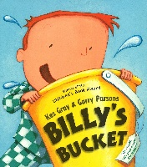    Literacy | Our class text this half term is ‘Billy’s Bucket’ by Kes Gray. As we explore this text, the children will be learning how to write in different genres including lists, story maps, captions, labels, and poetry. We will also be completing shared writes and role play. The children will be continuing to write applying their phonics skills; using finger spaces and will be carrying on with a focus on capital letters and full stops.  Reading is an important area of learning – we will read with the children every day. Please practise reading at home every day with the books that are sent home and make a note of this in their reading diary. To further develop your child’s understanding of the story ensure you ask a few comprehension questions after reading. Red words checks will take place this half term and these will be sent home with your child’s reading diary.  We will have daily phonics sessions following our Read Write Inc scheme. Children will continue to learn to segment, and blend sounds which will support their reading fluency. Over the half term, we may provide phonic resources that you can practise at home with your child (please ask for a replacement if you misplace any of these).
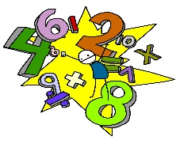  Maths | In Reception we follow Maths Mastery. This half term the children will begin to look at exploring money with a focus on coin recognition and values, combinations to total 20p and change from 10p. We will then also learn about measurements for example to describe capacities, compare weights and volumes and estimate lengths.  In our Maths meetings, we will continue to practice our number formation along with number pronunciation and the ability to count forward and backwards.
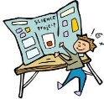  Communication and Language | The children this half term will continue to learn a wide range of vocabulary linked to our new topic. This vocabulary will be referred to regularly and be visible on our classroom working wall. This half term the children will be challenged by talking in full sentences when asking for something instead of giving a one-word statement and they may also be asked to extend upon their ideas using a sentence stem. They will also be taking part in role play with other peers to help with overall confidence when speaking and we have created stage/ roleplay areas which can support this play.
  Understanding the world | Through our topic we will be learning about the natural world as well as the past and present and different people, cultures, and communities. Our role play area will be converted into a pirate ship where the children can communicate with each other by playing different roles/dressing up as different characters. Outside we will also have an under the sea roleplay, stage and beach hut where the children can interact with each other exploring through play.
  Expressive Art and Design | Children will continue to have access to paints, pens, crayons, pencils, chalk, and whiteboards to show their learning. As well as this, the children will be encouraged to respond to our story ‘Billys Bucket’ through art. Music and dance remain a key focus in Reception and is encouraged in all areas of the curriculum. The children will continue to enjoy weekly Dance sessions on a Tuesday morning.
  Physical Development | PE and Dance will continue once a week to help develop the children’s physical development and motor skills. Alongside this, the children will have access to bikes and scooters in our outdoor provision to further these skills. The children’s fine motor skills will continue to develop through our fine motor provision sessions which encourages the development of hand muscles to create a better pencil grip ready for Year 1.  PE this term will be focused on games for understanding which focusses on understanding why it is important to take turns when playing a game. We will then learn about why games have rules and understand the consequences if the rules of the game are not followed.
Personal Social emotional development   | Children will continue to be encouraged to learn collaboratively and to be aware of their own and other’s feelings. Children will continue to talk about their feelings, starting to understand why they may be feeling a certain way and what they can do to change this. We also encourage the children to be kind towards everyone at school, and this is instilled continuously through praise and PSHE lessons.
  Music | This half term the children will learn about the interrelated dimensions of music through singing, improvising, and playing classroom instruments. We will also have the opportunity to share and perform the learning in lesson and during provision.
RE | In RE, our theme for this half term is ‘Special Places’. We will be looking at different religious buildings/ places across different religions including Christianity, Islam, and Judaism. Answering questions such as what makes a place special and why?
PSHE  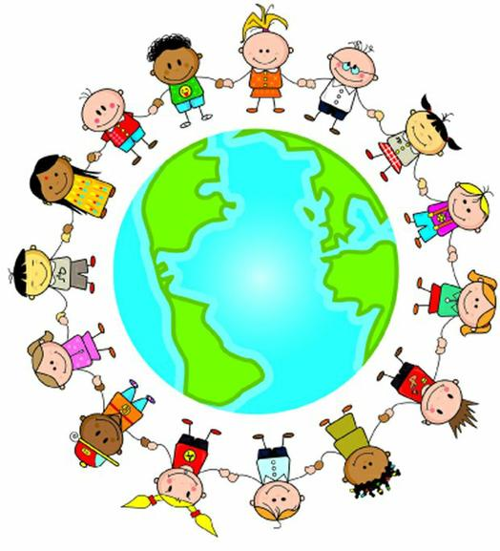 | Our Jigsaw topic is ‘Changing Me’ and children will be discussing topics such as their body, how they can respect it through eating healthy foods and exercising, growing up, and finally we will be discussing any worries or things they may be looking forward to about being in Year 1.
Homework will be sent home on Thursdays and should be returned by the following Wednesday. A polite reminder that as the weather gets hotter it is important to send your child to school with a sunhat, suncream and a water bottle to ensure they are as safe as possible. We have plenty of shaded areas of school for when the children are playing at break/lunchtimes and children will be reminded of sun safety.
PE kit – in on Monday please and to remain in school for the week.
Dance and PE days – these will be on Tuesdays and Wednesdays
Water bottles – these should contain plain, unflavoured water. Label them please!
Uniform – please label all uniform as it makes it much easier for us to return any lost items to your child!
If you have any questions or would like to know more about how you can help at home, please come and ask us. Please continue to check on Tapestry to see the children engaged and enjoying their learning as this is updated frequently.
Miss McLoughlin: class teacher
Mrs Potts: Learning Support Assistant
Mrs Bradley: Learning Support Assistant

