Year 4, summer 2, 2025

I hope that your child will enjoy their summer term in Year 4. We will be exploring ancient Egypt and the Indus Valley, looking at patterns in art and going swimming!

English    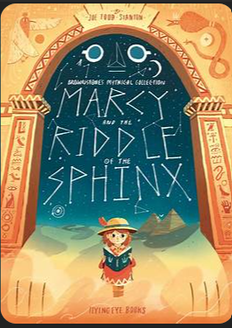 | We will carry on using ‘Marcy and the Riddle of the Sphinx’. Through this we will be exploring different writing types and creating our own work based on this book. We have already created character descriptions and looked at the setting. We will be creating our own version and creating non-fiction writing such as letters and newspaper articles.  Every Tuesday, we will be focussing on spelling, punctuation and grammar. This is usually linked to the rest of the week’s writing, e.g. fronted adverbials to inform narrative writing.  We also have several handwriting sessions throughout the week to ensure that all children are forming their letters and joining correctly and consistently.
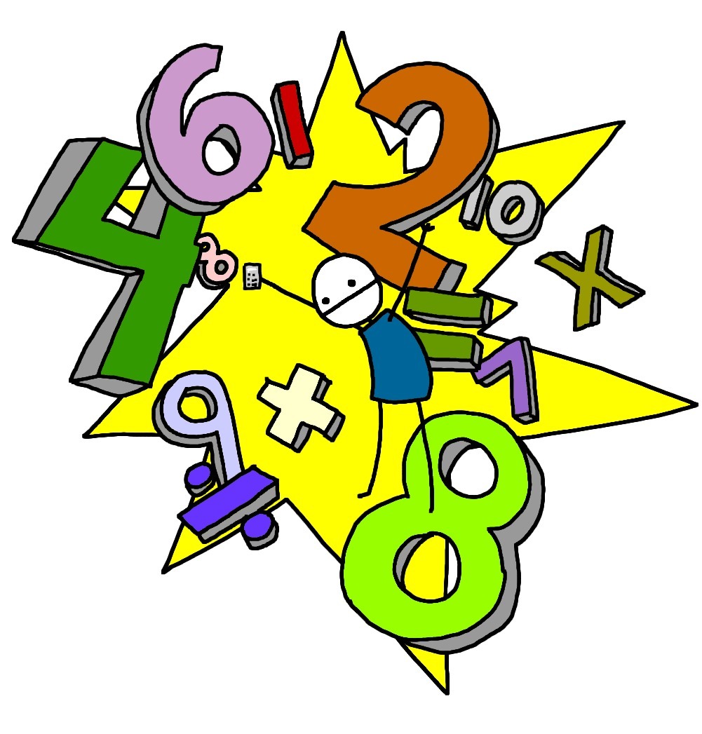  Maths | We have already started our work on patterns. We will be looking at Roman numerals, patterns and 3D shape as well as recap important sections of maths from Year 4.
Science  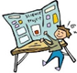 | Electrical Circuits and Conductors - Sources of electricity; Electrical devices; Electrical components; Series circuits; Complete and incomplete circuits; Conductivity; Conductors and insulators; Wired plugs; Incandescent light bulbs; Future of electricity; Working scientifically – Identifying and classifying, Pattern seeking, Comparative test, Research and present using ICT.
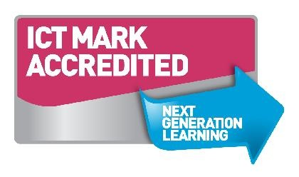  Computing | Year 4 will be creating presentations to compare Ancient Sumer and Ancient Egypt.
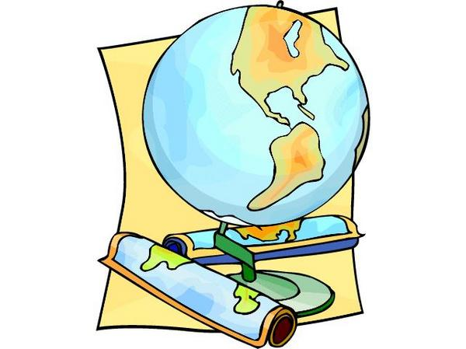  Geography/History | As you’d expect given our Ancient Civilizations topic we will be exploring timelines, looking at replicas of ancient artefacts, investigating Ancient Egyptian hierarchies, inventions and then moving onto the Indus Valley.
D&T (Design & technology) and Art | Art this half term is linked to our new topic of Ancient Civilizations. We will be building our sketching techniques, and we learn about ancient sculptures in order to create our clay sculptures as well as look at patterns in art.
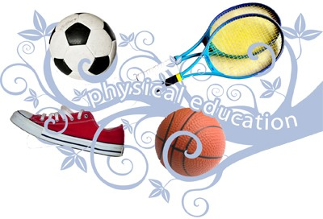  PE | This term we’re using swimming is the focus of our learning. We’ll see how effectively we can build our swimming skills as well as ball skills in outdoor PE.
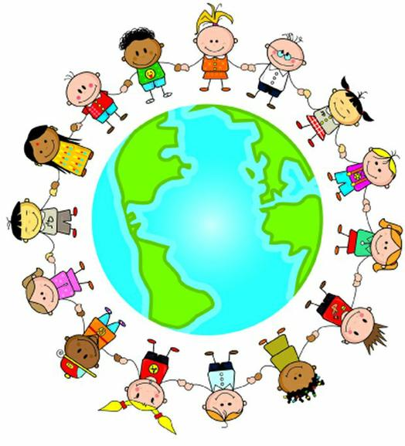  PSHE | Our PSHE lessons continue to follow the highly effective Jigsaw series. This term’s focus is on  Changing Me in which children will learn to safely explore our individual characteristics that we have inherited, how their body changes, life changes and looking forward to Year 5.
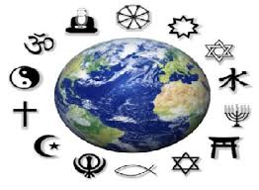  RE | Summer 2 we will be looking at Christianity, the Christian church and worship.
  Music | This term we will be finishing our focus of the song The Blackbird by the Beatles. We will then move onto reflecting on our music learning from Year 4.

Homework will be sent home on Thursdays and should be returned by the following Wednesday. Each week your child will have spellings to learn. Children will be also asked to complete a topic-based activity as detailed on the weekly homework sheet which is stuck into your child’s homework book.

PE kit – in on Monday please and to remain in school for the week.
Dance and PE days – these will be on Tuesdays and Thursdays.
Water bottles – these should contain plain, unflavoured water. Label them please!
Uniform – please label all uniform as it makes it much easier for us to return any lost items to your child!

Please remember that we are available to speak with you at the beginning and end of each day at the door if you have any concerns or questions.

Many thanks,

Miss Wheatcroft: Class Teacher
Mrs Cummings: Learning Support Assistant
Mr Hemming: Learning Support Assistant
Miss Rockcliffe: Learning Support Assistant

