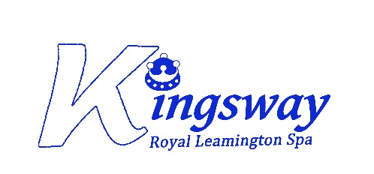

***Kingsway Community Primary School, Baker Avenue, Leamington Spa, CV31 3HB***

**Class Teacher (Maternity cover)**

**Full time fixed term contract from September 2024**

**Teacher Main Scale M1 to M6 – ECT’s are encouraged to apply**

**Salary: £30,000 to £41,333**

**A unique opportunity has arisen to join a passionate team of staff in a growing Multi Academy Trust.**

We are seeking an excellent class teacher to join a friendly and supportive team. Staff are ably supported by well-established staff within school. This post is made more exciting by the opportunities within a whole primary age range experience and collaboration.

Kingsway Primary School is a warm and friendly school with high aspirations for children and staff. We are proud of our committed staff at all levels; they take great pride in their school and are driving on improving outcomes for our pupils. Support and professional development for all teachers is a high priority.

The successful candidate will have high expectations, a commitment to raising standards of attainment and up-to-date knowledge of teaching and behaviour management strategies. We are seeking passionate and driven individuals with good communication and organisational skills and a desire to make a difference to the lives of our pupils and their communities.

Kingsway Community Primary School is part of the Community Academies Trust, a multi-academy trust with the express purpose of transforming schools in community hubs, through applying a holistic view of education.

The successful candidate will:

• be an excellent classroom practitioner or an ECT aspiring to this, who ensures that all children whatever their ability make great progress

• be a dedicated professional with the ability to inspire children and their colleagues

• set the highest standards for themselves and others

• work successfully and positively in partnership with staff, parents and our community

You will benefit from:

• Innovative colleagues who are great ‘team players’ and are always welcoming and supportive

• Highly regarded professional development opportunities for teachers at all stages in their career

• A school that fully supports you to become an outstanding practitioner

Visits to the school are strongly encouraged and welcomed, please contact Miss Cara Henn, School Business Manager on 01926 426896 to arrange a visit.

For more information or to download application details please visit: [www.kingswayprimaryschool.org](http://www.kingswayprimaryschool.org) or [www.communityacademiestrust.org](http://www.communityacademiestrust.org) and complete the Application Form and Equal Opportunities Monitoring Form.

Submit application forms to [admin@kingswayprimaryschool.org](mailto:admin@kingswayprimaryschool.org) no later than 9am on Monday 3rd June.

Closing date for applications is: **9am Monday 3rd June**

Interviews will take place on: **Wednesday 5th June**

The Trust Child Protection Policies and Recruitment of Ex-Offenders Statement can be found at: <https://www.communityacademiestrust.org/en-GB/trust-information>.

Community Academies Trust is committed to safeguarding and promoting the welfare of children and young people. Community Academies Trust is exempt from the Rehabilitation of Offender Act 1974. We expect all staff to share our safeguarding commitments and to undergo appropriate safer recruitment checks, including enhanced DBS checks and a willingness to demonstrate commitment to the standards which flows from Community Academies Trust vision and values.

The role is covered by part 7 of the Immigration Act 2016 and therefore the ability to speak fluent spoken English is an essential requirement for this role.

Community Academies Trust supports Equal Opportunities Employment.

Community Academies Trust Company Registration No. 0747273-6

***“Education is for improving lives and for leaving your community and world better than you found it****”*