Year 2, autumn 1, 2024

Welcome to the start of a new and exciting school year in Year 2! We hope you had a fantastic break and enjoyed some much-needed rest and relaxation.

English    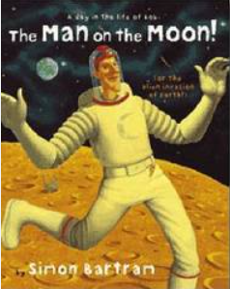 | This term, the children will be exploring Simon Bartram’s ‘Man on the Moon’. Genres we are covering this term include:  - Stories about fantasy worlds  - Labels, lists and captions  - Instructions  - Recounts  - Poetry  On Mondays, children will be developing their comprehension skills. For this, we will be using the book ‘Chicken Licken’.
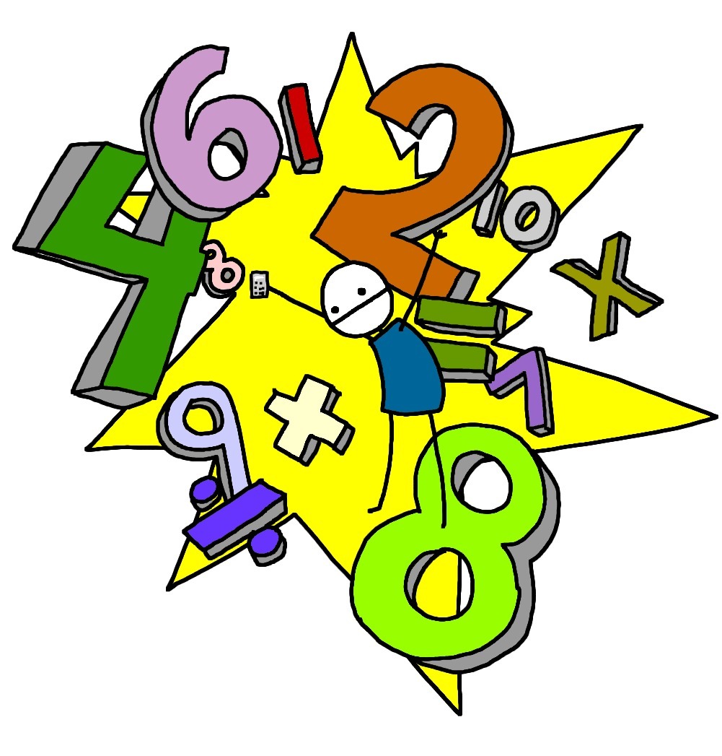  Maths | We will be starting this half term with our first topic focussing on numbers within 100. The children will be developing their skills and knowledge on things such as place value, partitioning, writing numbers in words and comparing and ordering numbers. After the completion of this topic, the children will move on to addition and subtraction of 2-digit numbers and word problems.
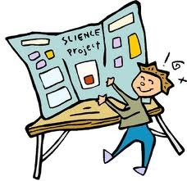  Science | We begin the year with our topic ‘Human Survival’. This teaches children about the basic needs of humans for survival, including the importance of exercise, nutrition and good hygiene. They learn how human offspring grow and change over time into adulthood. After half term, our new topic will be ‘Habitats’. This topic teaches children about habitats and what a habitat needs to provide. They explore local habitats to identify and name living things and begin to understand how they depend on one another for food and shelter.
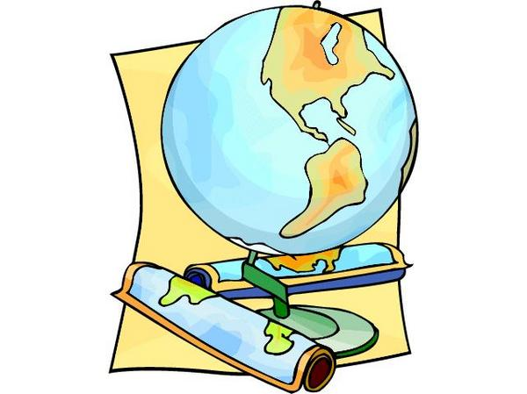  Computing | Our focus for computing is ‘Programming’. Children will be learning skills such as debugging algorithms, following precise instructions and creating programmes using different digital devices such as a Bee Bot. The children will create their animations using ScratchJr.
Geography/History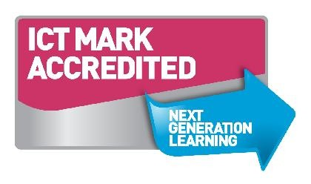 | The first half term of the year has a history focus, with the topic being ‘Movers and Shakers’. This knowledge-rich project teaches children about historically significant people who have had a major impact on the world. They will learn to use timelines, stories and historical sources to find out about the people featured and use historical models to explore their significance.  After half term, the focus will shift to Geography, with the focus ‘Let’s Explore the World’. The children will learn about atlases, maps and cardinal compass points. They will learn about the characteristics of the four countries of the United Kingdom and find out why there are hot, temperature and cold places around the world. They will also be making comparisons between England and Somalia. Children will have the opportunity to carry out fieldwork, collecting primary data in their locality to answer geographical questions.
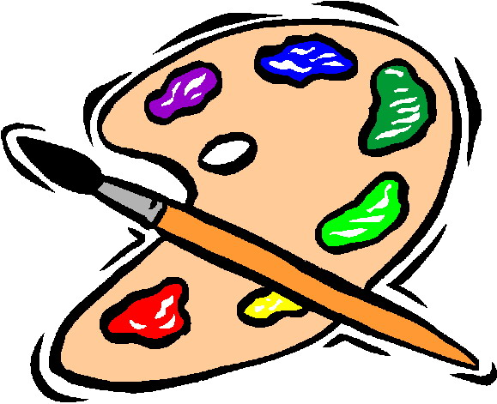  D&T and Art | We begin the school year by focusing on ‘Still Life’ in art. The children will learn about the work of significant still life artists and still life techniques. They explore a wide variety of still lifes and learn about the use of colour and composition. The children will have the opportunity to create their own still life arrangements and artwork. After half term, we will be looking at ‘Exploring colours’ in art.  In Autumn 2, we will also be exploring ‘Remarkable Recipes’ as part of our D&T. This project will teach the children about sources of food and tools used for food preparation. They will also discover why some foods are cooked and learn to read a simple recipe. They will choose and make a new school meal that fulfils and specific design criteria.
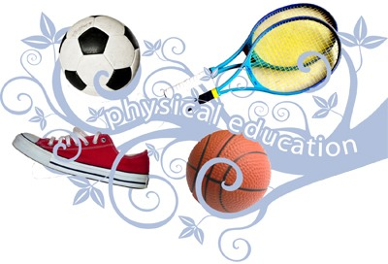  PE | Our PE unit is focused on the children developing their dodging skills. By the end of the topic, the children will be applying their skills and knowledge of how, where and why to dodge, into a level 1 competition.  Dance lessons are on a Tuesday morning.
  Music | All of the learning in our Music unit this half term is focused around the main unit song ‘Hands, Feet, Heart’ by Joanna Mangona. This is a song that celebrates South African Music. Children will learn to sing the song and play instruments with the song with or without notation. Children will also be given the opportunity to improvise with the song using their voices and instruments.
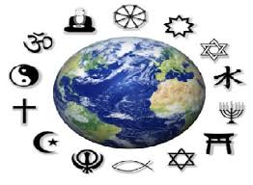  RE | This half term’s Religious Education question is: ‘What does it mean to be good? What does it mean to be bad?’. The religion that is covered during this topic is Hinduism. Children will be focussing on the story of the battle between Goddess Durga and the Demon Mahishasura.
PSHE  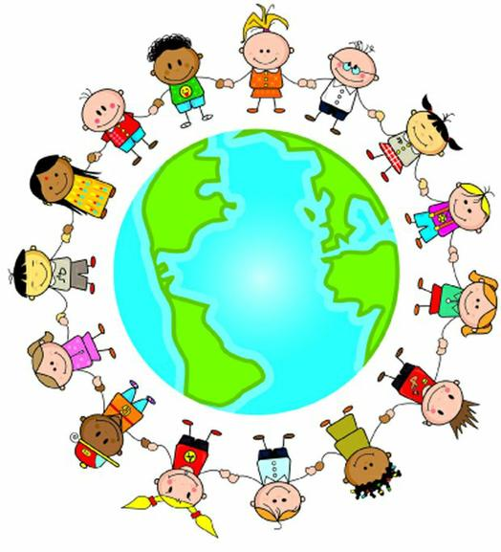 | Our first Jigsaw topic is ‘Being me in my world’. The children will consider their hopes and fears for the year, recognising their differences, rights and responsibilities as a member of our school. They will collaboratively create a learning charter and understand how following this will help them and their peers to learn in order to make their classroom and school a safe place.

Homework will be sent home on Fridays and should be returned by the following Wednesday. Each week your child will have spellings to learn. Children will be also asked to complete a topic-based activity as detailed on the weekly homework sheet which is stuck into your child’s homework book.

PE kit – in on Monday please and to remain in school for the week.
Water bottles – these should contain plain, unflavoured water. Children with packed lunches may bring a still, fruit-based drink for consumption at lunch time.

Please remember that we are available to speak to, for whatever reason, at the end of each day or by enquiring at the school office. If you have any questions or would like to know more about how you can help at home, please come and ask.

As always, if you have any questions or would like to know more about how you can help at home, please come and ask us.

Miss Farmer: Class Teacher
Mrs Birdi: Learning Support Assistant

