Year 5, autumn 1, 2024

Hello everyone! While I’m slowly getting to know you all at the Year 5 door, I’d like to take this opportunity to introduce myself and express how much I am looking forward to working with you all, and the Year 5 children throughout the year ahead.

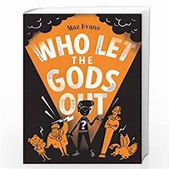    English | In English, we are starting this academic year with a focus on the brilliant children’s novel ‘Who Let the Gods Out?’ by Maz Evans. This book is based on Greek mythology and follows the character Elliot who encounters demi-gods and Zeus the god of lightning. This half term we will be practising a variety of writing skills we have acquired this year and in previous years such as diary entries, playscript writing and newspaper reports. We will also be practicing our responses to the reading domains and understanding the importance of delivering our answers with consideration and succinctly.
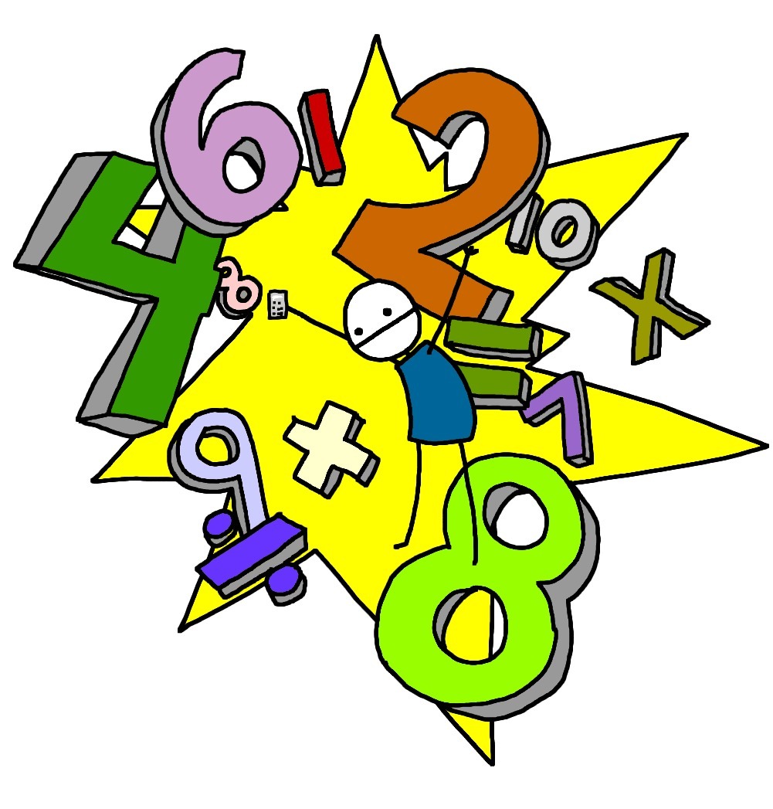  Maths | This half term we will be reading, writing, and comparing numbers up to one million! We will be honing our rounding skills to the nearest power of ten (10 / 100 / 1,000 / 10,000 / 100,000 / 1,000,000) and look at ordering large numbers from least to greatest. The children will progress from this and begin applying this learnt knowledge to calculations. This half term, we will focus on addition and subtraction – with a large focus on the written method of column addition and subtraction - and use our rounding skills and mental calculation strategies to select the most efficient strategies to solve mathematical problems.  We will end the half term by looking at line graphs and timetables (not be confused with multiplication times tables!). Maths will be put into a real-world environment where the children will be encouraged to read and interpret data and present this in line graphs and in answer to relevant questions.
Science  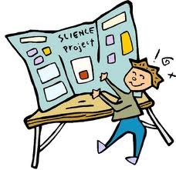 | Throughout Year 5, will we be dedicating an entire afternoon to science each week! This will allow us the time to explore ideas in more detail and put our scientific enquiry skills to good use in class experiments. The topic for this half term is Forces and Mechanisms which will see the children revisit prior learning about forces, identifying what a force is and discussing the two types, including contact and non-contact forces. They will learn that gravity is a force of attraction and follow instructions to observe gravity in action. They will learn the meanings of the term’s 'mass' and 'weight' and their units of measurement, following instructions to record the mass and weight of various everyday objects using a piece of equipment called a force meter. This will also provide a great opportunity to link to our learning in Maths about line graphs. The children will revisit previous learning about friction, discussing situations where it can be helpful or where we need to minimise its effects. New learning will be developed about frictional forces called air and water resistance and we will conduct investigations to observe these frictional forces in action!  Finally, we will learn about mechanisms, including gears, pulleys and levers and follow instructions to investigate how these simple machines use forces to make tasks easier. The children will then generate their own scientific questions which they wish to study further on the theme of forces and mechanisms, and we will work together to research, explore and find the answers!
Computing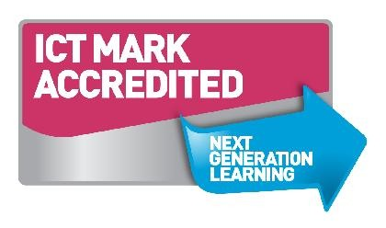 | This half term’s topic in computing is Coding. The children will build on their prior knowledge of coding and follow the PRIMM approach:  Predict… what this code will do  Run… the code to check your prediction  Investigate… trace thought the code to see if you were correct  Modify... the code to add detail, change actions/outcome  Make… a new program that uses the same ideas in a different way. Get creative!  We will look at how coding is used in real life situations, and work towards creating a string of code that completes the action they have requested efficiently.
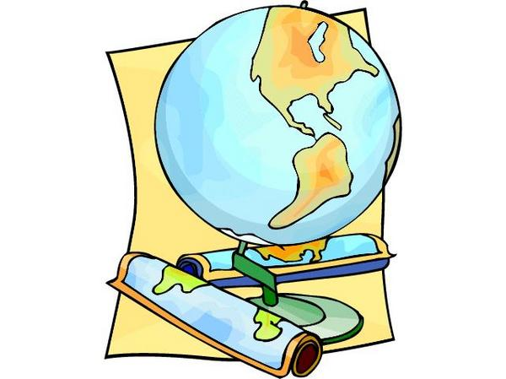  Geography/History | Our topic for the Autumn term has been ‘Ground-breaking Greeks’, which will conclude this term with the study of how the people of Athens went about their everyday lives. Pupils will study the Classical Age and the lasting legacy the Athenians have had on how we live today. We will study key historical figures and the contribution they made to society, such as Hippocrates, Plato, Thales, Pythagoras and Archimedes and their subjects of Mathematics, Medicine and Philosophy. We will also study the Ancient and Modern Olympic games, with Year 5 participating in a version of the Olympic Games – Kingsway Style!
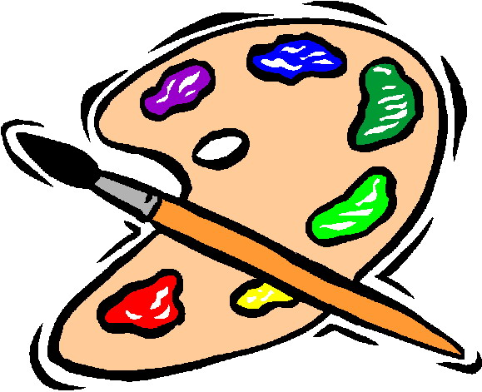  D&T and Art | This half term will be studying Art & Design, in our Expression project. This project will teach children about the Expressionist art movement and the 'Father of Expressionism', Edvard Munch. They will explore different ways to portray feelings and emotions in art to create an imaginative self-portrait. In D&T we will be looking at architecture and how architectural style and technology has developed over time and then use this knowledge to design a building with specific features.
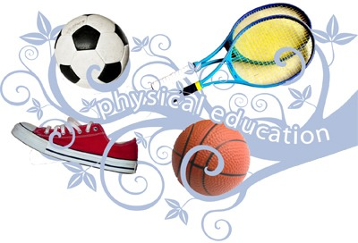  PE | PE will have a health-related focus this half term, looking to hone their understanding of cardio, flexibility and strength. The children will challenge themselves at the start of the year with four circuit challenges, and then develop their understanding and skills over the half term, before revisiting the four circuit challenges and reflecting on how they have progressed.  PE will be every Monday and Dance will continue on Tuesdays.
  Music | This half term we will have a classic rock focus, and we’ll be rocking out to Bon Jovi’s ‘Livin’ On A Prayer’. We will appraise the rock classic (alongside some of other rock anthems!) considering the lyrics chosen and what this tells us about life in the 1980s, as well as considering its structure and instruments used. We will also be practicing the song, building towards an end of half term performance.
RE  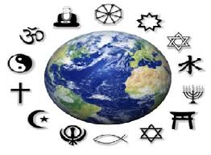 | The school theme for RE this half term is ‘Change’. In Year 5 we will be focusing on the religions of Sikhism, Hinduism, Christianity and Islam. We will be working around the key question: Are religious stories important today?
PSHE  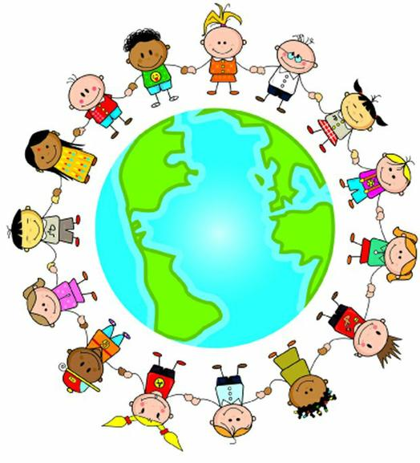 | This half term we’ll be focussing on the topic of ‘Me in my World’. In this topic we will discuss how we face new challenges positively and set personal goals for the year ahead. There will also be a big focus on understanding the rights and responsibilities citizens of the United Kingdom have and as a student at the school. This will link with the topic of democracy and how having a voice is a benefit, and how this could benefit the school community. In line with this, we will be introducing Kingsway’s school parliament and be voting democratically for the ministers we want to represent Year 5.

Homework will be sent home on Fridays and should be returned by the following Wednesday. Each week your child will have spellings to learn. Children will be also asked to complete a topic-based activity as detailed on the weekly homework sheet which is stuck into your child’s homework book.

PE kit – in on Monday please and to remain in school for the week.
Water bottles – these should contain plain, unflavoured water. Children with packed lunches may bring a still, fruit-based drink for consumption at lunch time.

As always, if you have any questions or would like to know more about how you can help at home, please come and ask me; I am always happy to help.

Many thanks,

Miss Cowley: Class teacher
Mr Hemming: Learning Support Assistant

