Year 6 Summer 2 2025

With SATs behind us, we continue with our term-long topic Maafa, a Swahili word which translates as great disaster or indeed holocaust. This project teaches children about Africa past and present and the development of the slave trade. Children have now learned a huge amount about the event itself and, as if not more importantly, the ways in which the slave trade fashioned the Britain in which we live – for good and ill.

English  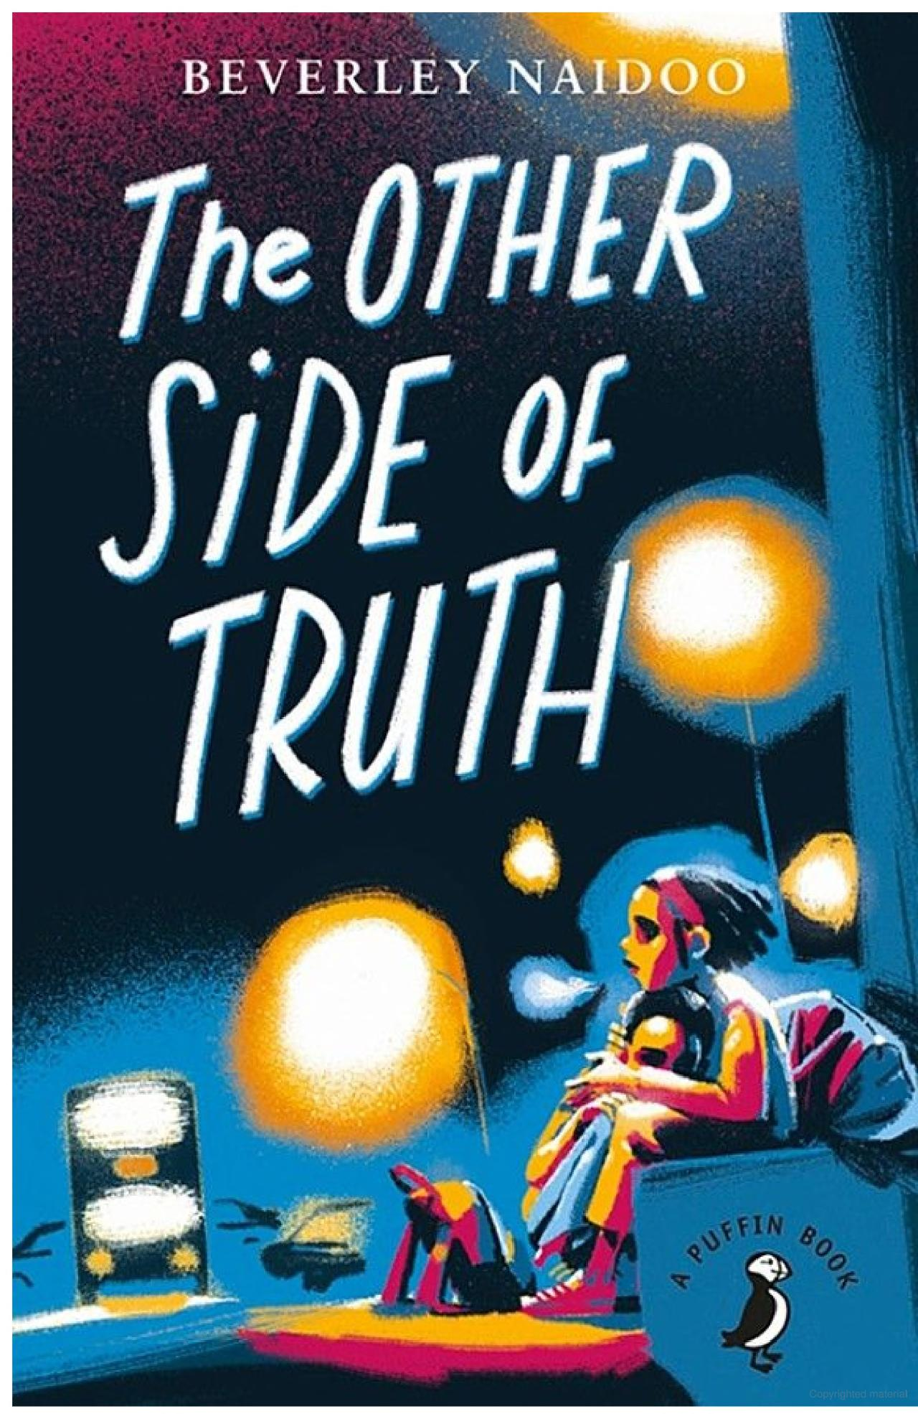   |  | ‘The Other Side of Truth’ continues to allow us to explore the legacy of the slave trade in modern times, specifically through the eyes of the children of an outspoken journalist in Nigeria. The children arrive in England to seek safety after their father has chosen to ‘speak truth to power…’ This text will form the basis of lessons from Wednesday to Friday.  The children have produced some excellent letters inspired by the text and have also written some very moving free verse poems in the voices of the two main child characters in the book. Newspaper reports and narrative writing will form the bulk of our remaining English work.
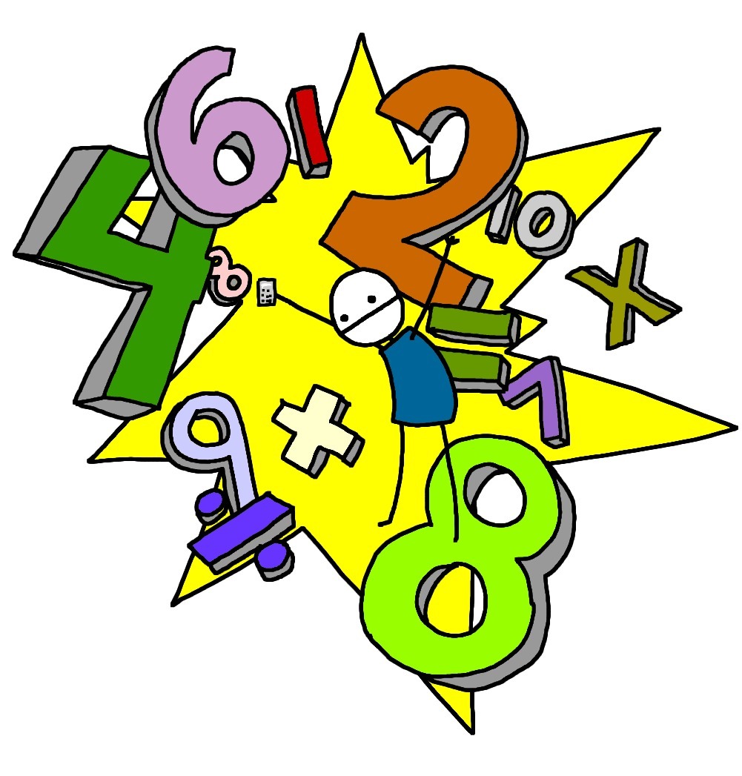  Maths |  | Advanced measure problems are our focus in the term’s initial stages, with area and perimeter being our first revision points. We soon move on to volume. Remaining areas in Mathematics coverage then include  • Compare and classify a range of geometric shapes  • Use angle facts to find unknown angles  • Draw a range of geometric shapes using given dimensions and angles  • Describe, draw, translate and reflect shapes on a co-ordinate plane  • Recognise and construct 3-D shapes  • Name parts of a circle  Finally, children will be taken step by step through their own remaining areas for development to get them as ‘secondary ready’ as possible.
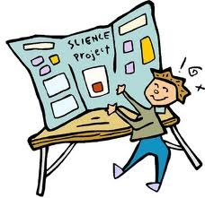  Science |  | Circulatory Systems are the focus of Science this term; the nervous system and respiratory system are two of the nine – can you name the others? We have already been looking at how these relate to and support the seven features required for an organism to be defined as living – discuss these with your child as see what you can learn. I promised that this topic becomes more hands-on as it progresses; by the time you read this, dissections will have been carried out by some children, observed by others.
Computing  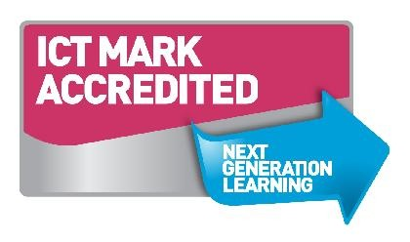 |  | Much of our computing time has been absorbed by topic-based research. We will be including movie-making and green screen technology over the course of the remaining weeks.
  Geography/History |  | Both are informed by our ‘Maafa’ topic. In History, students can learn about the origins, events, and consequences of the slave trade, including its impact on African societies and the development of the Americas. Geography lessons can focus on mapping the triangular trade routes, understanding the movement of people and goods, and examining how geography influenced the locations of ports, plantations, and resistance. This integrated approach fosters critical thinking and empathy, while deepening students’ understanding of global interconnections and historical injustices.
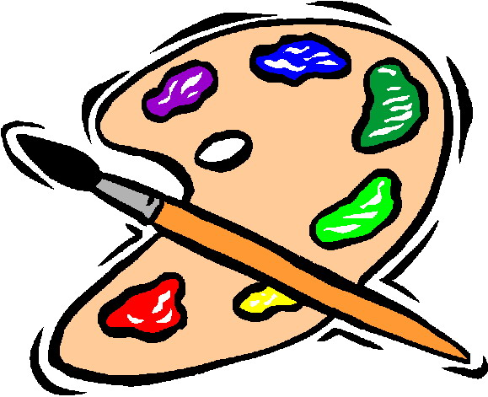  D&T and Art |  | Tints, Tones, and Shades underpins our landscape painting by helping them explore how colour can create depth, mood, and atmosphere. Pupils can learn how to mix colours with white to create tints, with grey for tones, and with black for shades, applying these techniques to paint skies, hills, water, and shadows in a landscape scene. This hands-on approach not only develops their painting skills and colour theory knowledge but also encourages creativity and self-expression as they experiment with how light and dark can transform a setting.
  PE | Dance lessons continue to go very well indeed, taking place on Tuesdays. Thursdays have seen PE devoted to team building through invasion games such as dodgeball and benchball. A more coached approach will involve rounders and volleyball as the term progresses.
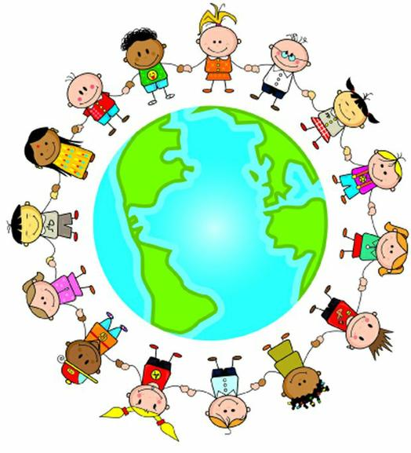  PSHE | The Year 6 PSHE topic ‘Changing Me’ in the Jigsaw curriculum supports pupils in understanding and preparing for the physical, emotional, and social changes associated with puberty and the transition to secondary school. Through age-appropriate discussions and activities, children learn about body changes, human reproduction, managing emotions, and building self-confidence. The topic also encourages respectful attitudes, personal responsibility, and open communication, helping pupils feel more secure and informed as they approach a new phase in their lives.
  RE | The Year 6 RE topic ‘Eternity’ in the Discovery RE curriculum invites pupils to explore a range of religious beliefs about life after death, focusing on the concept of eternity and what it means to followers. Through discussions, reflection, and enquiry-based learning, children consider questions such as what happens when we die, why some people believe in eternal life, and how these beliefs influence the way people live. This topic encourages deep thinking, empathy, and respect for different perspectives, while helping pupils reflect on their own beliefs and values.
  Music | In the Year 6 Charanga music curriculum for summer 2, the topic is ‘Reflect, Rewind and Replay’. This unit allows pupils to consolidate their learning by revisiting key musical concepts such as rhythm, pitch, dynamics, and structure. Through listening, appraising, and performing a variety of musical styles from different periods, children reflect on their progress and understanding. They also have the opportunity to improvise, compose, and perform, building confidence and celebrating their musical journey as they prepare to transition to secondary school.

Homework will be sent home on Fridays and should be returned by the following Wednesday. Each week your child will have spellings to learn. Much of the homework this term will be related to Maths and English SATs preparation and revision. Children will each be given a SATS practice book to complete based on the Maths and English curriculum and work related to any relevant topics we may be working on over the term.

PE kit – in on Monday please and to remain in school for the week.
Dance and PE days – these will be on Tuesdays and Thursdays.
Water bottles – these should contain plain, unflavoured water. Label them please!
Uniform – please label all uniform as it makes it much easier for us to return any lost items to your child!

Please remember that we are available to speak to, for whatever reason, at the end of each day or by enquiring at the school office.

Many thanks,

Mr Atkinson: Class Teacher
Mrs Osborne: Learning Support Assistant
Miss Parit: Learning Support Assistant

