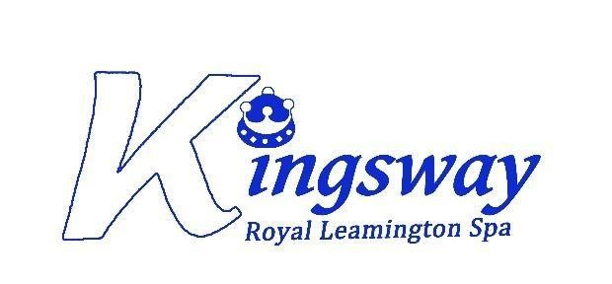

Kingsway Community Primary School

Complaints Policy
Local Arrangements

As a school, we adopt the Community Academies Trust Complaints Policy. This policy will outline the local arrangements relating to the policy.
The CAT Complaints policy can be located in the following places:
- On the school website – www.kingswayprimaryschool.org
- On the CAT website https://www.communityacademiestrust.org/en-GB/trust-information
- By asking for a paper or electronic copy from the school office – admin@kingswayprimaryschool.org

Stage 1 – Informal Procedure
The class teacher and other members of staff can deal with many concerns to the satisfaction of the complainant, without needing to deal with it formally.
Kingsway values informal meetings and telephone discussions as a way of improving its procedures and relations with parents. The contact details for senior members of staff are listed below:
Headteacher | Deputy Headteacher
Miss S Hartshorn  admin@kingswayprimaryschool.org  01926 426896 | Mrs S Finch  admin@kingswayprimaryschool.org  01926 426896

Stage 2 – Formal Complaint Investigated by a Member of School
If the complainant is unhappy with the way in which the concern was dealt with at Stage 1, the complainant should complete the formal complaint form found in Annex 3 of the main policy.
Complaints should be addressed to the Headteacher who will decide who will investigate the complaint.
Headteacher
Miss S Hartshorn
admin@kingswayprimaryschool.org
01926 426896

If the complaint concerns the Headteacher, the complaint will be referred to the Chair of Governors.
Chair of Governors
Chair of Governors
Mr C Clarke
admin@kingswayprimaryschool.org

If the complaint concerns the Chair of Governors or any individual governor, the complaint should be addressed to the Clerk to the School Standards Committee.
Clerk to the School Standards Committee
Clerk to the School Standards Committee
Mrs S Beatty
admin@kingswayprimaryschool.org

If the complaint concerns the Clerk to the School Standards Committee or the School Standards Committee as a whole, the complaint should be sent to the Executive Assistant to the Directors/Governance Manager.
Executive Assistant to the Directors/Governance Manager
Executive Assistant to the Directors/
Governance Manager
c/o Community Academies Trust
Dimbleby House
Stoneydelph Primary School
Crowden Road
Wilnecote
Tamworth
Staffordshire
B77 4LS

Stage 3 – Formal Complaint referred to the Complaints Committee
If the complainant is unhappy with the outcome of the complaint under Stage 2, the complainant may request a Complaints Committee to be convened to consider how the complaint was handled at the previous stages but has the discretion to review any other aspects of the complaint as it sees fit. To request a hearing, the complainant should write to the Executive Assistant to the Directors/Governance Manager.
Executive Assistant to the Directors/Governance Manager
Executive Assistant to the Directors/
Governance Manager
c/o Community Academies Trust
Dimbleby House
Stoneydelph Primary School
Crowden Road
Wilnecote
Tamworth
Staffordshire
B77 4LS

Stage 4 – Formal Complaint referred to the Department for Education (DfE)
If the complainant is unhappy with the outcome of the complaint under Stage 3, they are entitled to refer their complaint to the Department for Education (DfE). The DfE will only investigate whether the complaint was handled properly and in accordance with education legislation and any statutory policies connected with the complaint – they cannot change and academy’s decision about a complaint.
Department for Education
Department for Education
School Complaints Compliance Unit
Piccadilly Gate
Store Street
Manchester
M1 2WD

Link also below:
How DfE handles complaints about academies - GOV.UK

