Year 1, summer 2, 2025.

Welcome back!

I hope you had a fantastic break and were able to enjoy the sunshine as a family. I hope the children have managed to rest and relax before their last seven-weeks in Year 1! I can’t believe how quick this year has gone. We continue to explore our topic ‘School Days’ this half term, looking closely at schools in the Victorian era and comparing them with our experiences today.

All children will complete a national phonics screening this half term which will check their phonics knowledge. Please follow this link for more information: https://www.gov.uk/government/publications/phonics-screening-check-information-for-parents/phonics-screening-check-2023-information-for-parents-text-only-version#:~:text=The%20phonics%20screening%20check%20is,week%20commencing%20Monday%2012%20June.

Here is a reminder of the sounds in each set:

Set 1 sounds | m, a, s, d, t, i, n, p, g, o, c, k, u, b, f, e, l, h, r, j, v, y, w, z, q, x, sh, ch, th, qu, nk, ng
Set 2 sounds | ay, ee, igh, ow, oo (zoo), oo (book), ar, or, air, ir, ou, oy
Set 3 sounds | ea, oi, ie, au, e-e, a-e, i-e, o-e, u-e, aw, are, ur, er, ow, ai, oa, ew, ire, ear, ure, wh, ph, kn, ie, ue, au, oe, e-e

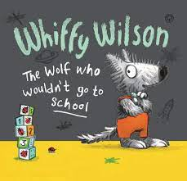    English | Our class text this half term is ‘Whiffy Wilson: The Wolf who wouldn’t go to school’ by Caryl Hart. As we continue to explore this text, the children will be learning how to write formal letters, invitations, explanation texts and write a traditional tale-based narrative. The children will be continuing to write using pre-cursive handwriting and will need to pay close attention to spelling common exception words; applying their phonics skills; using finger spaces and remembering to use capital letters, full stops, question marks and exclamation marks.  Reading is an important area of learning – we will continue to read with the children as a whole class, every day and on an individual basis too. Please practise reading at home every day with the books that are sent home. Your child must be able to explain what they are reading and make predictions and inferences from the texts.  We will continue to have daily phonics sessions following our Read Write Inc. scheme. Children will learn to segment and blend sounds which will support their reading fluency. Over this half term, children will complete their end of year phonics screening test which will assess all that they have learnt.
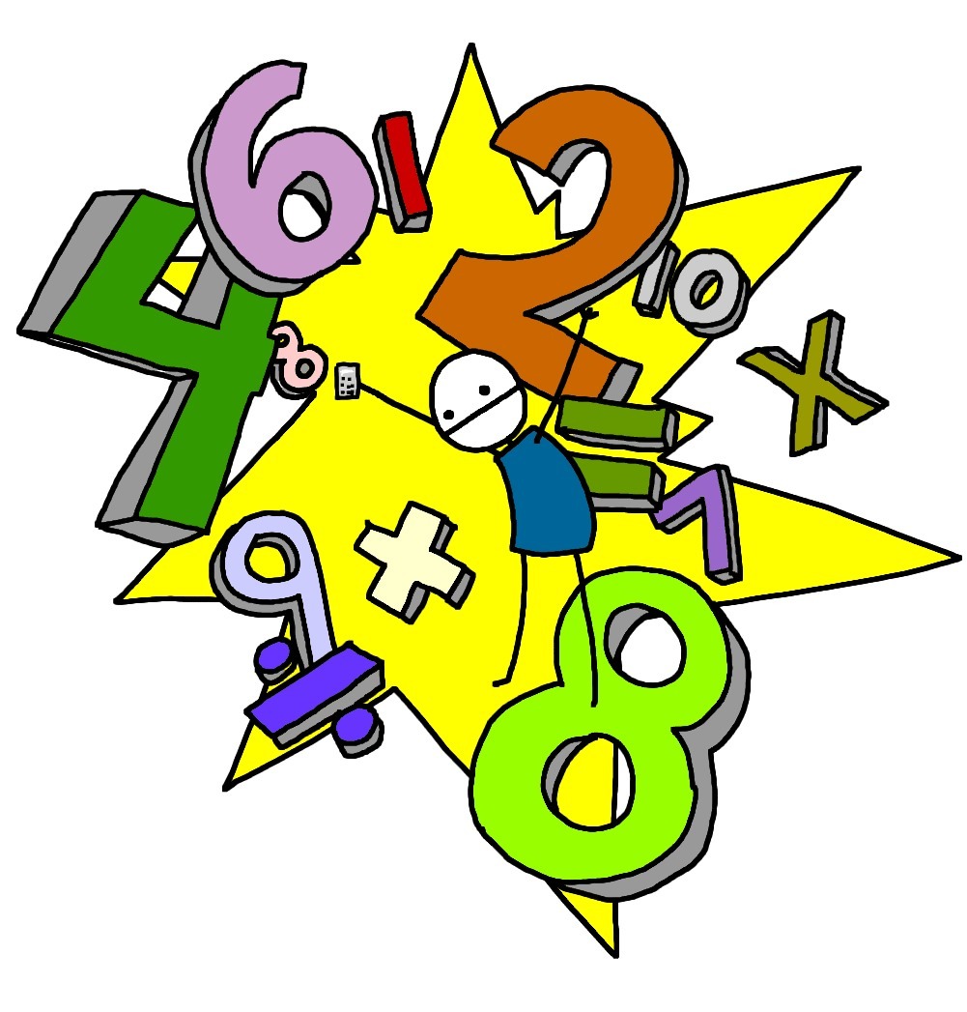  Maths | This half term the children will look at multiplication and division which focusses on, exploring arrays, sharing equally into groups, doubling and linking halving to fractions.  We will also be exploring measures: capacity and volume. The children will compare capacities, volumes and lengths and explore litres. They will then apply their understanding of fractions to capacity. Any practice at home is always greatly appreciated and completing the weekly homework will support with this.
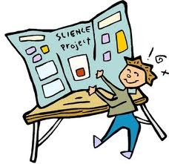  Science | ‘Animal Parts’ is our topic for this half term. This topic teaches children about animals, including fish, amphibians, reptiles, birds, mammals and invertebrates. They will identify and describe their common structures, diets, and how animals should be cared for.
  Computing | This half term, children will begin their computing journey by learning how to keep save online with a focus on copyright and ownership. Following this, we will begin our ‘Video Creation’ project which teaches the children to create videos using Shadow Puppets Edu. They will learn to select images and record a voiceover and zoom into images as they record.
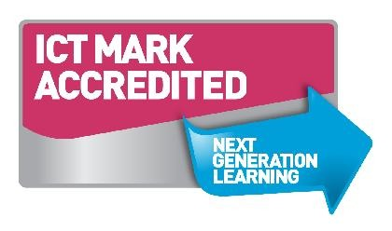  Geography/History | Our History curriculum focuses on the topic of ‘School Days’. Children will continue to learn about life in the Victorian era and explore what schools were like during this period. They will look at Victorian school artefacts and compare the differences and similarities of schools today.
  D&T and Art | ‘Chop, Mash and Slice’ is our topic this half term. The topic teaches children about sources of food and the preparatory skills of peeling, tearing, slicing, chopping, mashing and grating. They use this knowledge and techniques to design and make a supermarket sandwich according to specific design criteria.
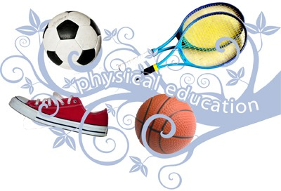  PE | This half term, our focus of learning is to explore ‘Team Building’ which focusses on teamwork.  Children will understand why it is important to include everyone when working as a team and how it feels to be left out. They will start to learn and understand what makes an effective team.
  Music | This half term the children will explore the song reggae song, ‘Zootime’ by Joanna Mangona. The material presents an integrated approach to music where games, the dimensions of music (pulse, rhythm, pitch etc), singing and playing instruments are all linked.
RE   | In RE, we will be looking at Judaism, and particularly the ‘shabbat’. We will be learning to empathise and understand Jewish children and why the Shabbat is important to them.
PSHE  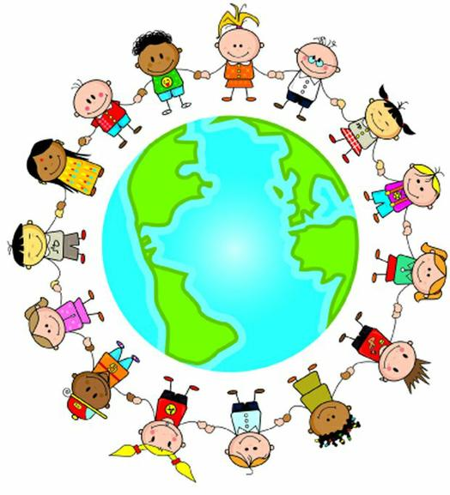 | Our Jigsaw topic is ‘Changing Me’ and children will learn to express how they feel when change happens. They will begin to understand and respect the changes that they see in themselves and who to ask for help if they are worried about change.

Homework will be sent home on Fridays and should be returned by the following Wednesday. Each week your child will have spellings to learn. Children will be also asked to complete a topic-based activity as detailed on the weekly homework sheet which is stuck into your child’s homework book.

PE kit – in on Monday please and to remain in school for the week.
Dance and PE days – these will be on Mondays and Wednesdays
Water bottles – these should contain plain, unflavoured water. Label them please!
Uniform – please label all uniform as it makes it much easier for us to return any lost items to your child!

If you have any questions or would like to know more about how you can help at home, please come and ask.

Miss Perks: Class Teacher
Mrs Dougherty: Learning Support Assistant

