Reception, autumn 1, 2024.

Welcome to Kingsway Primary School! I hope you had a lovely break and enjoyed some special family time this summer. This half term our topic is ‘Let’s Explore’. To start this topic your child will explore their class environment and school grounds so that they feel settled and happy in their new surroundings. They will learn about the local environment and find out about places they have visited on holiday. Finally, we will look at and create maps for journeys.
Throughout this year we will be focusing on Phonics following the Read Write Inc. scheme. The children will have daily sessions which will help them to become successful readers, spellers and writers and benefit all areas of the curriculum. We will be starting with Set 1 sounds in the order they are presented below.
Here is a reminder of the sounds in each set:
Set 1 sounds | m, a, s, d, t, i, n, p, g, o, c, k, u, b, f, e, l, h, r, j, v, y, w, z, q, x
Set 2 sounds | ay, ee, igh, ow, oo (zoo), oo (book), ar, or, air, ir, ou, oy
Set 3 sounds | ea, oi, ie, au, e-e, a-e, i-e, o-e, u-e, aw, are, ur, er, ow, ai, oa, ew, ire, ear, ure, wh, ph, kn, ue

  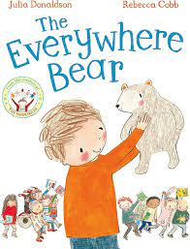  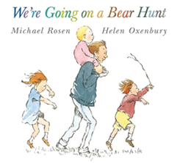  Literacy | We are lucky to have two class texts this half term which are, ‘We’re Going on a Bear Hunt’ by Michael Rosen and ‘The Everywhere Bear’ by Julia Donaldson. As we explore these texts, the children will be learning how to respond to a text through illustration, role play and shared writing as a class. We will also be completing story mapping and speech and thought bubbles. The children will be applying their phonics skills but with a strong focus on letter formation when writing.  Reading is an important area of learning – we will read with the children every day. Please practise reading at home every day with the books that are sent home and make a note of this in their reading diary. To further develop your child’s understanding of the story ensure you ask a few comprehension questions after reading.  We will have daily phonics sessions following our Read Write Inc scheme. Children will continue to learn to segment and blend sounds which will support their reading fluency. Over the half term, we will provide phonic resources that you can practise at home with your child (please ask for a replacement if you misplace any of these).
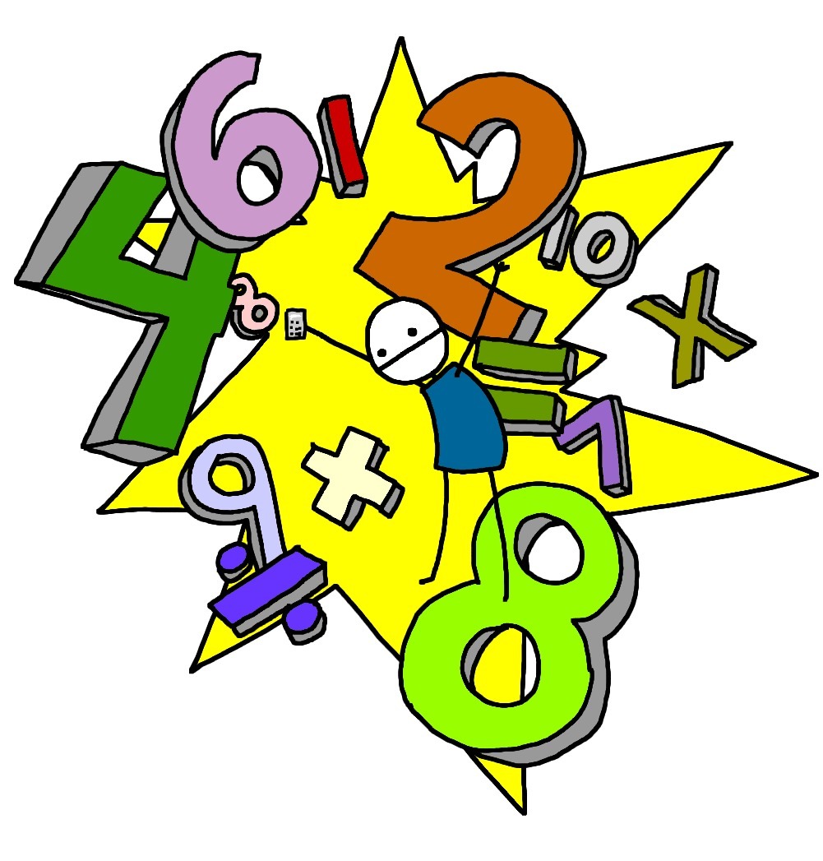  Maths | In Reception we follow Mathematics Mastery. This half term, the children will begin to explore ordering, sequencing, matching and comparing numbers to 10. We will then also be using Ten Town to promote good number recognition.  In our Maths meetings we will continue to practice our number formation along with number pronunciation and the ability to count forward.
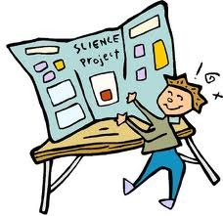  Communication and Language | The children this half term will learn a wide range of vocabulary linked to our new topic. This vocabulary will be referred to regularly and be visible on our classroom working wall. This half term the children will be challenged to work on their speaking and listening skills which will be modelled extensively when listening to stories and applied throughout the school day.  They will also be taking part in role play with other peers to help with overall confidence when speaking and we have created a home corner roleplay area which can support this play.
  Understanding the world | Through our topic we will be learning about different people, cultures, and communities as well as the past and present and the natural world. Our role play area has converted into a home corner where the children can communicate with each other by playing different roles/ dressing up as different characters. Outside we also have a mud kitchen and construction role play where the children can interact with each over exploring through play.
  Expressive  Art and Design | Children will have access to paints, pens, crayons, pencils, chalk, and whiteboards to show their learning. The children will also be encouraged to respond to both ‘We’re Going on a Bear Hunt’ and ‘The Everywhere Bear’ through art.  Music and dance remain a key focus in Reception and is encouraged in all areas of the curriculum and so we encourage children to perform and express their ideas. They will also benefit from a weekly singing assembly to enhance their performing skills.
  Physical Development | PE and Dance will both take place once a week to help develop the children’s physical development and motor skills. Alongside this, the children will have access to scooters in our outdoor provision to further these skills. The children’s fine motor skills will continue to develop through our fine motor provision sessions which encourage the development of hand muscles to create a better pencil grip for writing.  PE this term will be focused on walking, working on their special awareness. The children will explore walking using different body parts in different directions, at different levels and at different speeds.
Personal  Social Emotional development   | Children will be encouraged to learn collaboratively and to be aware of their own and other’s feelings. Children will have opportunities to talk about their feelings, starting to understand why they may be feeling a certain way and what they can do to change this. We also encourage the children to be kind towards everyone at school and this is instilled continuously through praise and PSHE lessons.
  Music | This half term the children will explore music through nursery rhymes and action songs we will complete as a class. They will also have the opportunity to share and perform their learning in lesson and during provision.
RE | In RE, our theme for this half term is ‘Special People’. We will be looking at different religions including Christianity and Judaism. Answering questions such as what makes a person special and why?
PSHE   | Our Jigsaw topic is ‘Being me in my World’ and children will be discussing topics such as their families, friends, feelings and our responsibilities.
Please check on Tapestry to see your children engaged and enjoying their learning as this is updated frequently.
PE kit – in on Monday please and to remain in school for the week.
Water bottles – these should contain plain, unflavoured water only. Children with packed lunches may bring a still, fruit-based drink for consumption at lunch time.
If you have any questions or would like to know more about how you can help at home, please come and ask me; I am always happy to help.
Miss McLoughlin: Class Teacher
Mrs Bradley: Learning Support Assistant

