Year 2, summer 2, 2025

Welcome back! I hope you had a lovely half term. A big well done to the children for completing their assessments last half term .

English  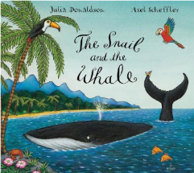   | This term, the children will continue their focus book, The Snail and the Whale by Julia Donaldson.  Genres that we are covering this half term are as follows:  - Explanation text  - Stories with predictable and patterned language  - Newspaper reports
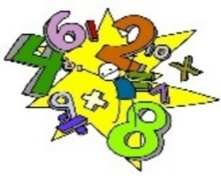  Maths | We will begin this half term by completing and revising capacity and volume and mass units. Our topic after this is ‘exploring calculation strategies’, where the children will be using method such as partitioning, rounding, ‘make 10’, near doubles etc. After this, our final topic will be ‘exploring multiplicative thinking’.
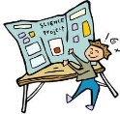  Science | Our topic for this half term is ‘Uses of Materials’. This project teaches children about the uses of everyday materials and how materials' properties make them suitable or unsuitable for specific purposes. They will begin to explore how materials can be changed.
  Computing | Our next Computing project is ‘Speech bubble pictures’. The children will be able to add speech bubbles to an image to show what a character thinks. We will also be looking at ‘Online reputation’ and recognising that things we share online will be there for a long time
Geography/History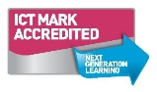 | Our topic this term continues to be ‘Coastline’. In the Coastline project, your child will use maps to learn about the location of the world’s seas and oceans and keys to learn about map symbols. They will also find out about the directions on a compass. They will learn about the human and physical features of a coastline, including the effects of erosion and how to stay safe when visiting the coast. They will have the opportunity to learn about the work of the RNLI, what happened to the SS Rohilla and about the coastal town of Whitby, including how Captain Cook is linked to the town. They will research the tourism industry and consider what features make a place a successful tourist destination.
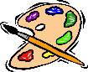  D&T and Art | Our DT focus for this half term is ‘Beach hut’. This project teaches children about making and strengthening structures, including different ways of joining materials.
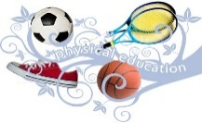  PE | Our PE focus is ‘fitness’. We will be identifying the ways in which our bodies are affected by exercise. We will also be looking at ball chasing.
  Music | All the learning in our music unit this half term is focused around ‘Reflect, Rewind and Replay’. The children will listen and appraise the songs heard, learn to sing, play, improvise and compose with this song, and using instruments also to play along with the song.
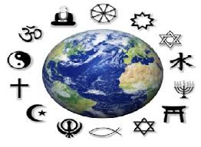  RE | The theme for our RE is special journeys. The key question for our learning this half term is ‘Does completing Hajj make a person a better Muslim?’
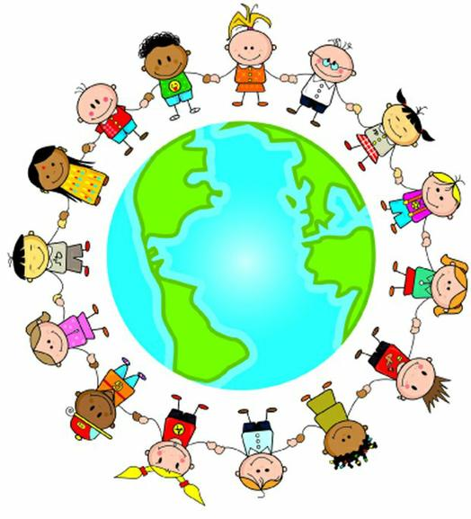  PSHE | Our Jigsaw topic is ‘Changing me’. We will be looking at changes that are out of our control and what we can do if this worries us. We will be looking at different life cycles and how our bodies will change as we get older.

Homework will be sent home on Fridays and should be returned by the following Wednesday. If for any reason homework is delayed, the deadline be adjusted accordingly. The year 2 common exception words can be found in the back of your child’s homework book along with their weekly spelling scores.

PE kit – in on Monday please and to remain in school for the week.
Dance and PE days – these will be on Tuesdays and Mondays.
Water bottles – these should contain plain, unflavoured water. Label them please!
Uniform – please label all uniform as it makes it much easier for us to return any lost items to your child!

Please remember that we are available to speak to, for whatever reason, at the end of each day or by enquiring at the school office. If you have any questions or would like to know more about how you can help at home, please come and ask.

As always, if you have any questions or would like to know more about how you can help at home, please come and ask us.

Miss Farmer: Class Teacher
Mrs Birdi: Learning Support Assistant

