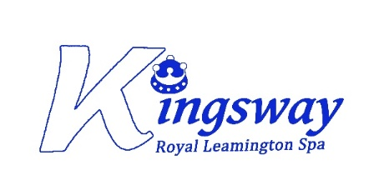
Music development plan summary

Overview
Detail | Information
Academic year that this summary covers | 2024-2025
Date this summary was published | September 2024
Date this summary will be reviewed | September 2025
Name of the school music lead | Chris Bain
Name of school leadership team member with responsibility for music (if different) | Lorna Connelly
Name of local music hub | Warwickshire Music Hub

This is a summary of how our school delivers music education to all our pupils across three areas – curriculum music, co-curricular provision and musical experiences – and what changes we are planning in future years. This information is to help pupils and parents or carers understand what our school offers and who we work with to support our pupils’ music education.

Part A: Curriculum music
This is about what we teach in lesson time, how much time is spent teaching music and any music qualifications or awards that pupils can achieve.
Information about our school curriculum for music for each year group can be found on our website Kingsway Community Primary School - Home (eschools.co.uk).
Pupils in all year groups receive a minimum of one hour of music teaching per week through timetabled lessons in year groups and whole school singing assemblies. Pupils in Reception are also regularly provided with opportunities to explore music as part of their Expressive Arts curriculum. In Years 1 to 6, there is a different theme/unit per half term, covering a range of genres and styles:

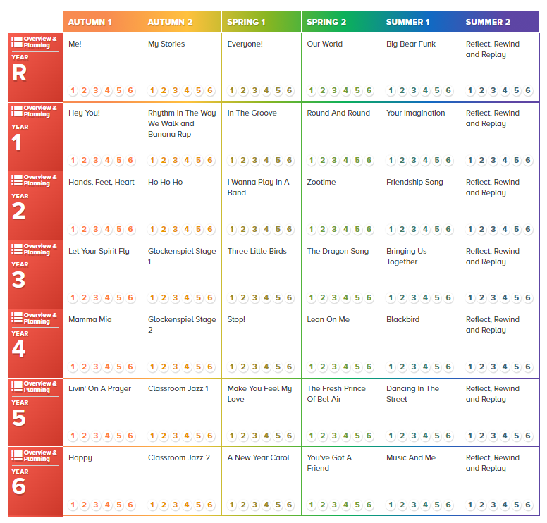

We use “The Original Scheme” from Warwickshire Music Hub’s Charanga platform, which is informed by the National Curriculum. In line with the curriculum for music and guidance from Ofsted, this scheme moves away from the previous levels and learning objective/outcome concepts to an integrated, practical, exploratory and child-led approach to musical learning. It is a spiral curriculum where the key musical skills and learning are repeated across the Units of Work. This repetition enables more secure, deeper learning and mastery of musical skills across a breadth of repertoire. The interrelated dimensions of music are at the heart of all the learning activities.
Each Unit of Work comprises the of strands of musical learning which correspond with the national curriculum for music:
- Listening and Appraising
- Musical Activities (warm-up games, optional flexible games, singing, playing instruments, improvisation and composition)
- Performing
Furthermore, all pupils have the opportunity to explore a different instrument each years, through whole-class ensemble teaching such glockenspiels, untuned classroom percussion, recorders and ukuleles.
All year groups participate in whole-school singing assemblies each week, delivered by the music lead. Pupils learn how to sing a range of unison and two-part or three-part songs, expressively and in tune. Pupils are given opportunities to perform in front of their peers, during school assemblies and at each end of unit class performance.
Pupils across all year groups are able to watch live performances from school, local and national ensembles. These opportunities to witness live music-making complement their own experiences of composing and performing during whole-class lessons and deepen their understanding of what it means to be a ‘whole musician’.
We have joined partnership with Warwickshire Music Hub to support curriculum music at Kingsway.

Part B: Extra-curricular music
This is about opportunities for pupils to sing and play music, outside of lesson time, including choirs, ensembles and bands, and how pupils can make progress in music beyond the core curriculum.
A Key Stage 2 school choir lunchtime club is available for pupils to join, free of charge.

Part C: Musical Experiences
This is about all the other musical events and opportunities that we organise, such as singing in assembly, concerts and shows, and trips to professional concerts.
Across the school, we have a number of musical experiences planned for the academic year. This includes:
Assemblies
Each week, pupils engage in a whole school singing assembly every Wednesday which is led by the music lead and all children learn and perform songs together as a whole school.
Musical Performances
In the Autumn term, all pupils in Reception Year 1 and Year 2 will perform in a Christmas performance whereby all children will learn and perform a number of songs to the rest of the school and parents/families.
In the Spring term, all pupils in Years 3, 4 and 5 will perform in an Easter show, with all children learning and performing and number of songs to the rest of the school and parents/families.
In the Summer term, Year 6 pupils will perform in their end of year/leavers performance, learning and perform a number of songs to the rest of the school and parents/families.
In the Autumn Term, all children will also be partaking in the “Advent Adventures Programme” which is led by the Warwickshire Hub. All children will learn the songs provided in schools in the Autumn term to then perform in a virtual assembly/live event in December alongside other schools across Warwickshire.
Concerts and Shows
All pupils have the opportunity to enjoy live performance at least once a year.
In the Autumn term, all pupils attend a Christmas show/performance at local theatres.
The children will also partake in a String Quartet workshop in the Autumn term.
In the Summer term, pupils across Years 3 and 6 attend and partake in the national event “Young Voices”, where children and teachers unite in an electrifying choir experience, having learnt and performed the songs in school in preparation to perform at the event.

In the future
This is about what the school is planning for subsequent years.
Looking forward, we are hoping to facilitate a wide range of string and brass instrument lessons ( one to one or small-group ) which are delivered in school by external music specialists from Warwickshire Music Hub, with the aim to begin this in Autumn 2 of this year. The school website will direct parents to the Warwickshire Music Hub about lessons and promotional posters will be available to parents in the school office. All eligible students who are in receipt of benefits receive 50% remission on their fees.
We look to move away from “The Original Scheme” and move to the “English Music Model Curriculum Scheme” which is informed by the National Curriculum and Model Music Curriculum (MMC) Guidance published by the DfE in 2021. Professional development/teacher training will be scheduled to take place to upskill teachers in the delivery the “English Music Model Curriculum Scheme” in preparation to implement the new curriculum in 2025-2026.

English Model Music Curriculum Scheme unit overview:
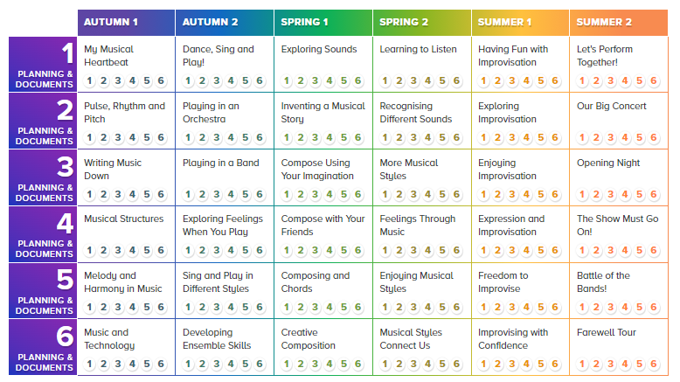

Following completion of current building works in the school in 2025-2026, we are going to be looking at options to create an allocated space for rehearsals and individual practice.
A school ensemble, band or group??

Further information (optional)
Warwickshire Music Hub:
Warwickshire Music Hub

The Department for Education:
The power of music to change lives: a national plan for music education - GOV.UK (www.gov.uk)

