Year 4, autumn 1, 2024

Here we are in Year 4! How did that happen?! We are hugely excited to be getting you ready for the final phase of primary school – Upper Key Stage 2 - and there will be a huge amount to get through. It will all be challenging… and great fun at the same time.

English  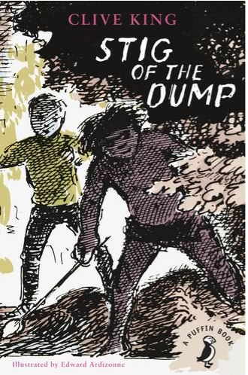   | Our Love to Read text is ‘The Demon Dentist’ by David Walliams. A hugely entertaining tale, this also teaches children a great deal about inference, dialogue in literature and the use of graphics to enhance meaning and understanding. Look out for various accents and different voices when we are engaged in shared reading. Every Tuesday, we will be focussing on spelling, punctuation and grammar and learning about writing in the past tense, prefixes, plural possessive apostrophes, subordinate clauses and organisational devices.  We also have several handwriting sessions throughout the week to ensure that all children are forming their letters and joining correctly and consistently.  The rest of the week will be driven by the text ‘Stig of the Dump. This text will be used as a stimulus for writing a range of genres, including newspaper reports, instruction writing and recounts such as diary entries. An absolute classic, it is even older than Mr A and has even more plot twists.
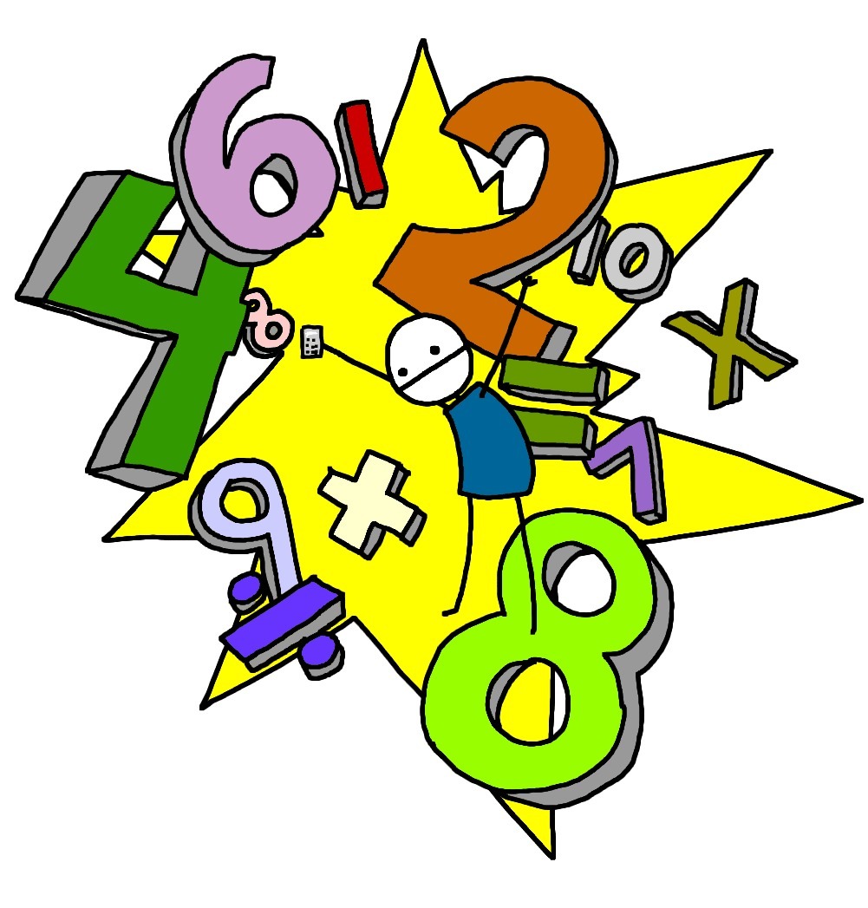  Maths | The beginning of this term is all about place value…how can a 4 be worth four thousand?!  4,000…that’s how! An absolute bedrock of mathematical understanding, place value makes up the start of each year’s learning. Children will learn to:  - count in multiples of 6, 7, 9, 25 and 1,000  - find 1,000 more or less than a given number  - count backwards through 0 to include negative numbers  - recognise the place value of each digit in a four-digit number (1,000s, 100s, 10s, and 1s)  - order and compare numbers beyond 1,000  - identify, represent, and estimate numbers using different representations  - round any number to the nearest 10, 100 or 1,000  - solve number and practical problems that involve all the above and with increasingly large positive numbers  - read Roman numerals to 100 (I to C) and know that over time, the numeral system changed to include the concept of 0 and place value
Science  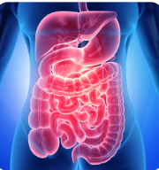 | Our ‘Food and the Digestive System’ project teaches children about the human digestive system. They explore the main parts, starting with the mouth and teeth, identifying tooth types and their functions. They link this learning to animals' diets and construct food chains to show the flow of energy., explain the importance or a healthy, balanced diet and identify and group a range of animals.
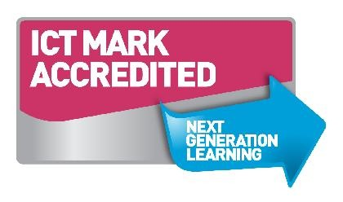  Computing | This term we will be learning about, or in some cases deepening, our knowledge of the following areas: the internet; online questionnaire; Adobe movie maker Digital Literacy: self-image and identity; online relationships.
  Geography/History | Our Humanities focus this half term is largely Historical: Roman withdrawal from Britain; chronology of invasion; Anglo-Saxon invasion; Anglo-Saxon kingdoms, beliefs and customs; religion; everyday life in Anglo-Saxon Britain; Viking invasion; everyday life in Viking Britain; significant people – King Athelstan; Norman invasion; legacy.
  D&T (Design & technology) and Art | Colour theory and how colours relate to each other form the basis of this half term’s learning. Children have already enjoyed using shade and different pressures to produce varied effects.
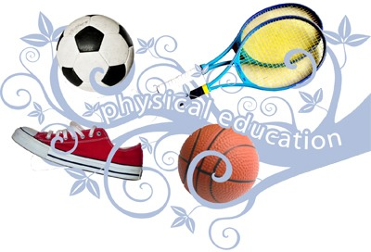  PE | Initially, the focus of the learning is for pupils to develop their own sprinting technique. Pupils will learn to self-analyse their performance to help to improve their own personal best. This is merely the basis for a systematic approach by which children may start to understand sporting areas which they may wish to pursue.
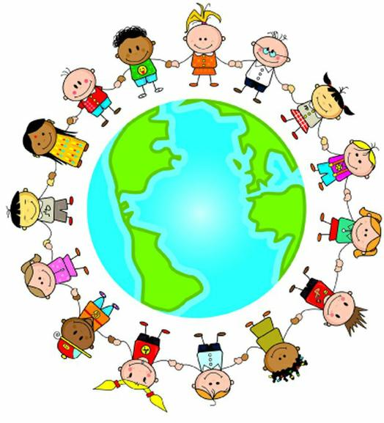  PSHE | This half term’s unit is called ‘Being me in my World.’ This unit helps children to ‘locate’ themselves in their different environments, be that school, home or wider social settings, and to understand the varied complex relationships therein.
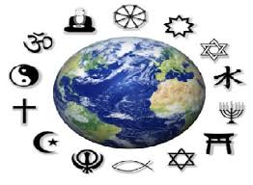  RE | Key questions this term: How special is the relationship between Jews and God? And what is the best way for a Jew to show commitment to God? Is it possible for everyone to be happy?  Whilst in the context of Judaism, these questions will of course encompass other religions and the differing ways of handling reverence.
  Music | We are very excited to have extended music sessions this term. Our weekly Singing Assembly has been boosted and a variety of choral techniques will be explored.

Homework will be sent home on Fridays and should be returned by the following Wednesday. Each week your child will have spellings to learn. Children will be also asked to complete a topic-based activity as detailed on the weekly homework sheet which is stuck into your child’s homework book.

PE kit – in on Monday please and to remain in school for the week.
Water bottles – these should contain plain, unflavoured water. Children with packed lunches may bring a still, fruit-based drink for consumption at lunch time.

Please remember that we are available to speak with you at the beginning and end of each day at the door if you have any concerns or questions.

Many thanks,

Mr Atkinson: Class Teacher
Miss Rockliffe and Mrs Potts: Learning Support Assistants

