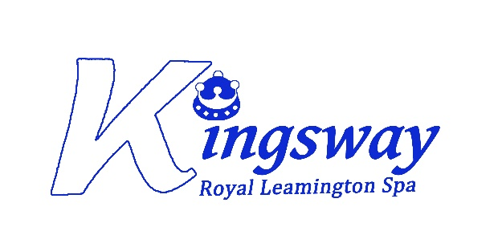

Kingsway Community Primary School

Document Reference Number (if already used) | 2
Title | Admissions Policy 2026-2027
Policy Owner | Sara Hartshorn
Version | 2.1
Approved Date | .25
Approving Body | School Standards Committee
Next Review Date | November 2026

Version Control
Version | Last Modified | Last Modified By | Document Changes
2.1 | November 2025 | Sara Hartshorn

