Kingsway
Teaching Sequence for English

  Immerse | - Read, enjoy and explore the text – mind mapping plot, characters etc  - Familiarisation activities e.g. comprehension, role play, text mapping, personal responses  - Could include a short write based on the text  - Art Gallery – prompting discussion
  Analyse | - Share example text (WAGOLL) as appropriate  - Identify genre / text type  - Identify text structure and language features (sentence level / vocabulary/grammar) – success criteria  - Determine purpose and audience
  Skills | - Focused grammar and/or vocabulary sessions linked to text and success criteria  - Could include a short write to practise the skill that links to the text  - Avoid stand alone exercises that do not link to the text
  Plan | - Gather ideas e.g. finding information, hot seating, organise information into paragraphs etc.  - Complete planning grid e.g. skeleton diagram  - Share and display ideas / plans  - Oral rehearsal as appropriate
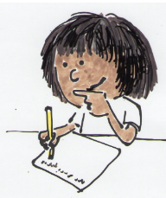  Write | - Use modelled/shared writing throughout  - Draft writing outcome  - Proof-read  - Edit  - Publish and/or share as appropriate for purpose/audience  - This process will need to be spread across a number of lessons to ensure consistent quality across the writing outcome. Chunking the writing helps!
Writing Outcome:
- Outcome – what the children are writing
- Purpose – why they are writing it
- Audience – who they are writing it for

