Year 1, autumn 1, 2024

Dear Year 1 parents and carers,

The children have made a great start to their first week in Year 1 and have been working hard to get used to their new routines at school. They are already showing a real enthusiasm for learning and are looking forward to starting our new topic – ‘Childhood’. This topic looks at everyday life and families from the past to the present day.

We will be continuing with phonics this half term and will begin by recapping Set 1 and 2 sounds; before moving onto Set 3. Daily sessions will help children become successful readers, spellers and writers which will benefit all areas of the curriculum.

Here is a reminder of the sounds in each set:

Set 1 sounds | m, a, s, d, t, i, n, p, g, o, c, k, u, b, f, e, l, h, r, j, v, y, w, z, q, x, sh, th, ch, qu, nk, ng
Set 2 sounds | ay, ee, igh, ow, oo (zoo), oo (book), ar, or, air, ir, ou, oy
Set 3 sounds | ea, oi, ie, au, e-e, a-e, i-e, o-e, u-e, aw, are, ur, er, ow, ai, oa, ew, ire, ear, ure, wh, ph, kn, ue

All children will complete a national phonics screening in the Summer term which will check their phonics knowledge. Please follow this link for more information: https://www.gov.uk/government/publications/phonics-screening-check-information-for-parents/phonics-screening-check-2023-information-for-parents-text-only-version#:~:text=The%20phonics%20screening%20check%20is,week%20commencing%20Monday%2012%20June.

  English  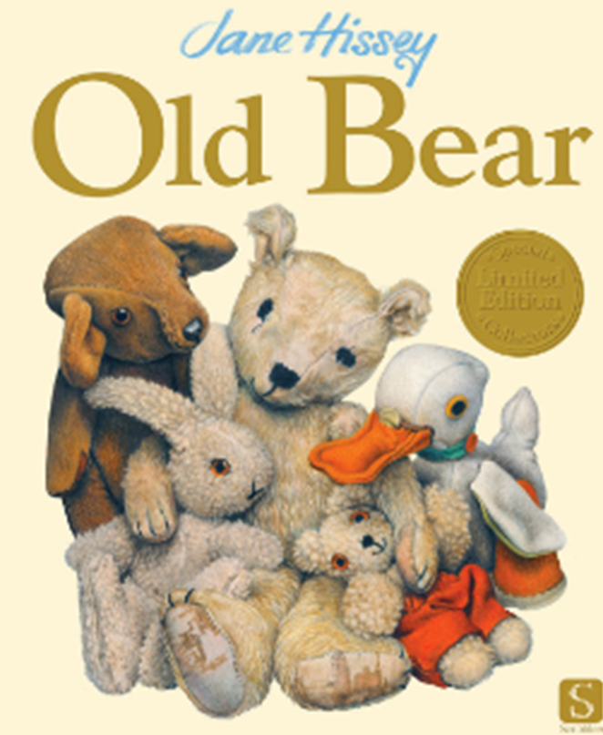 | Our class text this half term is ‘Old Bear’ by Jane Hissey. As we explore this text, the children will be learning how to write a list, captions and a recount. The children will be writing using pre-cursive handwriting and will need to pay close attention to spelling common exception words, applying their phonics skills, using finger spaces and remembering to use capital letters, full stops, question marks and exclamation marks.  Reading is a key focus – we will read with the children as a whole class, every day and on an individual basis too. Please practise reading at home every day with the books that are sent home. Your child must be able to explain what they are reading and make predictions and inferences from the texts.  We will have daily phonics sessions following our Read Write Inc. scheme. Children will learn to segment and blend sounds which will support their reading fluency.
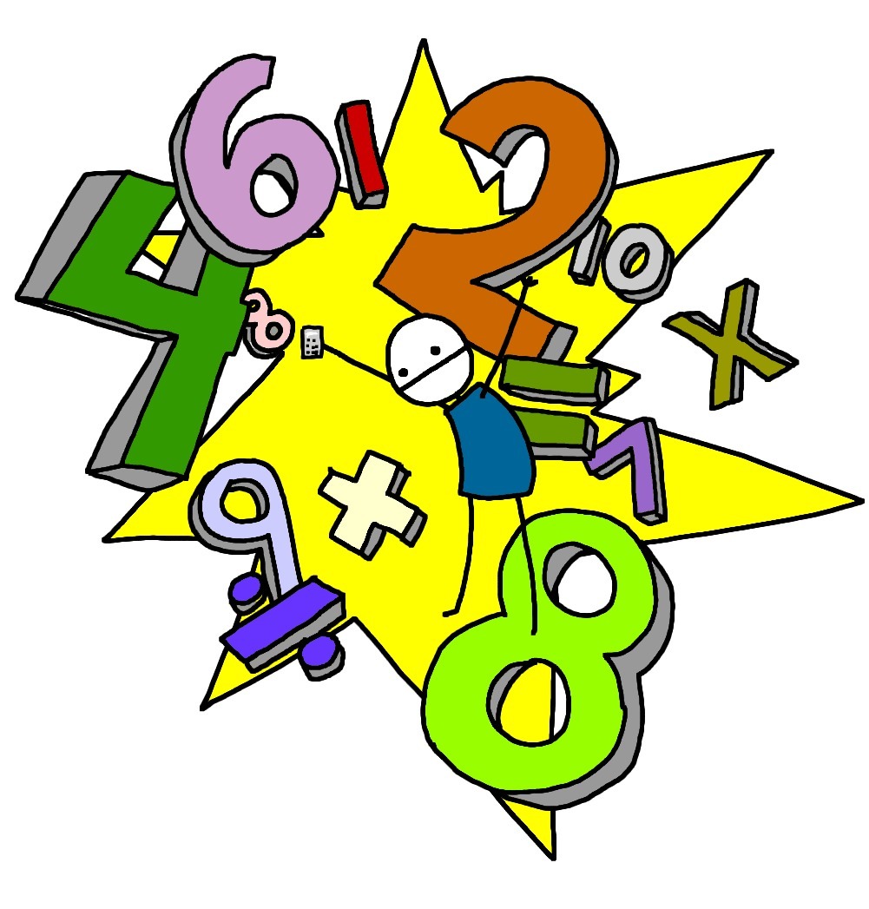  Maths | This half term we will learn to identify, represent, compare and explore numbers within 10. This includes one more and one less, doubling and halving. We will also learn about addition and subtraction within 10. Representing and explaining addition and subtraction strategies. We will use known facts to add and subtract and explore commutativity.  We will then learn about shape and patterns. Exploring, describing, sorting and classifying 2-D and 3-D shapes which will lead us to investigating repeating patterns. Following this, we will use and follow instructional and positional language.  Any practice at home is always greatly appreciated and completing the weekly homework will support with this.
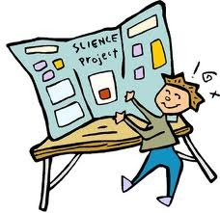  Science | ‘Everyday Materials’ is our topic for this half term. The children will learn about objects that are made from different materials. They will identify a range of everyday materials and their sources, investigating their properties and begin to recognise that a material's properties define its use.
  Computing | This half term children will begin their computing journey by learning how to keep safe online. Following this, we will start our ‘Podcasting’ project which teaches the children to write and record a script using a teleprompter tool. They will use a digital device to record and add different effects.
Geography/History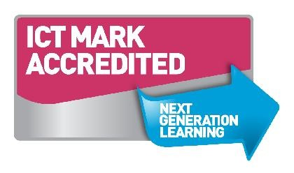 | Our History curriculum focuses on the topic of ‘Childhood’. This topic teaches children about everyday life and families today, including comparisons with childhood in the 1950s, using artefacts and a range of different sources.
  D&T and Art | ‘Mix It’ is our topic this half term. The children will be learning about basic colour theory by studying the colour wheel and colour mixing. It includes an exploration of primary and secondary colours and how artists use colour in their artwork.
  PE | This half term our focus of learning is to explore running. The children will explore running using different body parts and different techniques and begin to understand how to run efficiently. They will develop their understanding of where we need to run and why, applying this knowledge to different racing speeds and contexts.
  Music | This half term the children will explore the song ‘Hey You!’ It is written in an Old-School Hip Hop style for children to learn about the differences between pulse, rhythm and pitch and to learn how to rap and enjoy it in its original form. As well as learning to sing, play, improvise and compose with this song, children will listen and appraise other Old-School Hip Hop tunes.
RE   | In RE, we will be looking at Judaism and exploring the theme of Yom Kippur. We will be learning to empathise with Jewish children and families by exploring what Yom Kippur means to them. Empathy is an important skill to develop as it helps children to understand how others think and feel which is an important part of life.
PSHE  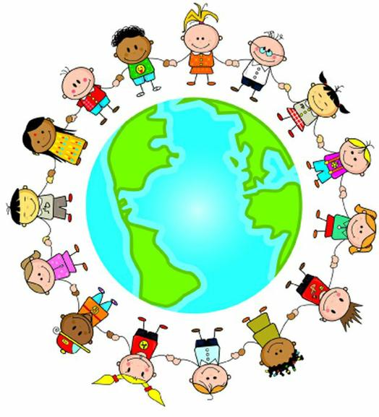 | Our Jigsaw topic is ‘Being Me in My World’ and children will begin to understand rights and responsibilities, choices and consequences. They will talk about being special and how to make everyone feel safe in their class as well as recognising their own safety.

Homework will be sent home on Fridays and should be returned by the following Wednesday. Each week your child will have spellings to learn. Children will be also asked to complete a topic-based activity as detailed on the weekly homework sheet which is stuck into your child’s homework book.

PE kit – in on Monday please and to remain in school for the week.
Water bottles – these should contain plain, unflavoured water. Children with packed lunches may bring a still, fruit-based drink for consumption at lunch time.

Please remember that we are available to speak to, for whatever reason, at the end of each day or by enquiring at the school office. If you have any questions or would like to know more about how you can help at home, please come and ask.

Miss Perks: Class Teacher
Mrs Dougherty and Mrs James: Learning Support Assistants

