From the moment children start at Kingsway, they engage with books and stories right away—either during story time or via our systematic phonics scheme, Super Sonic Phonic Friends.
We aim to give every child the best possible start in reading and writing. The Supersonic Phonic Friends scheme allows us to provide clear, consistent and engaging approach to phonics and early reading.
By the end of Key Stage 1, most children will be able to decode unfamiliar words, spell accurately, and enjoy reading for pleasure and learning, giving them a strong foundation for future success across the curriculum.
Early reading is a fundamental building block to learning and it's never too early to start exploring books with your children. Miss Farmer leads the teaching of Phonics and Early Reading at Kingsway.
We have recently transitioned to the Supersonic Phonic Friends phonics programme to give children at Kingsway the very best start with learning how to read.
Lessons build children’s knowledge of sounds and spelling patterns step by step, nurture a love of reading, and lay the foundations for confident, fluent readers and writers. Teaching is multi-sensory, using actions, rhymes and characters to make learning memorable.
'This programme is a fully systematic, synthetic phonic approach ranging from the simple to the complex spellings of the alphabetic code. Supported by their Supersonic Phonic friends, this approach will ensure children develop confidence and apply each skill to their own reading and writing'.
Phonics is taught daily throughout Reception and Key Stage 1 in 30-minute sessions. These follow the model: Revisit and Review, Teach, Practise and Apply.
Children are taught letters using 'pure sounds'. Please watch the videos from the Supersonic Phonic Friends YouTube channel if you would like support with sound pronunciation. These have also been added to the Phonics page on our website.
The Basics 2
Listen, Recognise, Build, Read and Write
The Basics 2 teaches children at least one spelling for 18 of the 44 sounds of the English language. Children will use their auditory processing and memory skills from Firm Foundations in Phase 1 to start to recognise the spellings for the sound with Sam, segment and build with Seb and Bill, read and blend with Rex and Ben and write with Ron.

At the end of this phase:
- Children will be able to hear up to 3 sounds in words, recognise spellings and read and write simple CVC words with the 18 spellings for sounds.
- They will be able to read decodable texts with The Basics 2 spellings and make phonetically plausible attempts in their emerging stages of spelling in their writing journey.
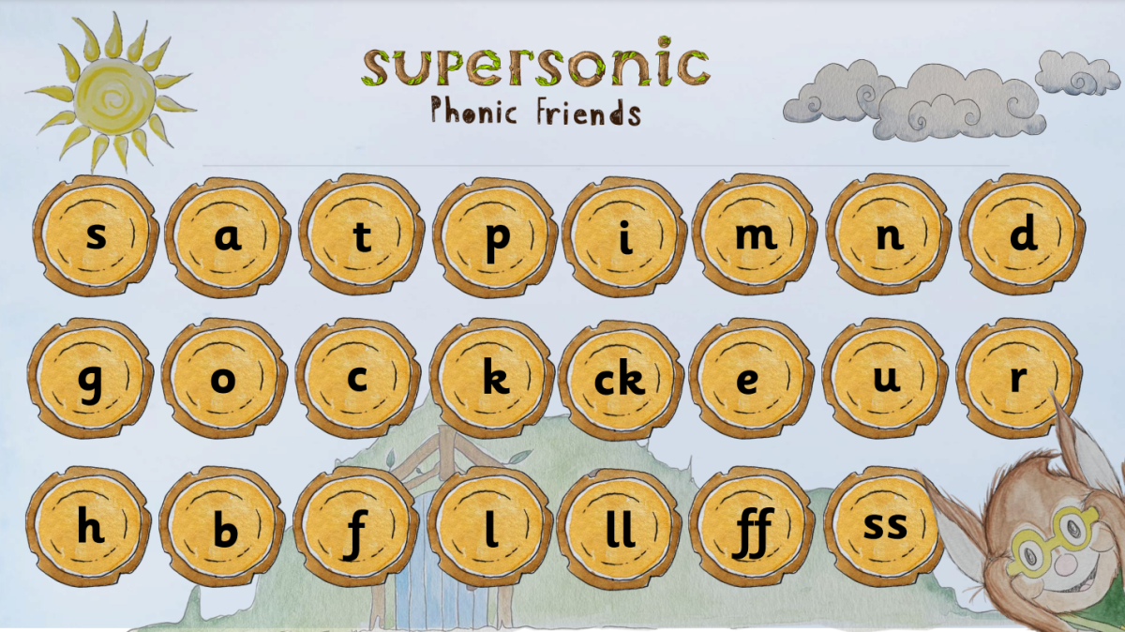

The Basics 3

Recognise, Build, Read and Write
The Basics 3 teaches children the spellings for the further 26 of the 44 sounds of the English language. Children will use their auditory processing and memory skills from Firm Foundations in Phonics 1 to start to recognise the spellings for the sound with Sam, segment and build with Seb and Bill, read and blend with Rex and Ben and write with Ron.
They will continue to learn the early concepts of Choose to Use with Suze for some further multiple spellings for sounds and an introduction to Switch it with Mitch for alternative pronunciations of spellings for sounds. Children will learn their tricky words with Tess and read nonsense words with Nan.

At the end of this phase:
- Children will be able to hear up to 3 sounds in words, recognise spellings and read and write simple and complex CVC with the 44 spellings for sounds.
- They will be able to read decodable texts with The Basics 2 and 3 spellings and make phonetically plausible attempts in their early stages of spelling in their writing journey.
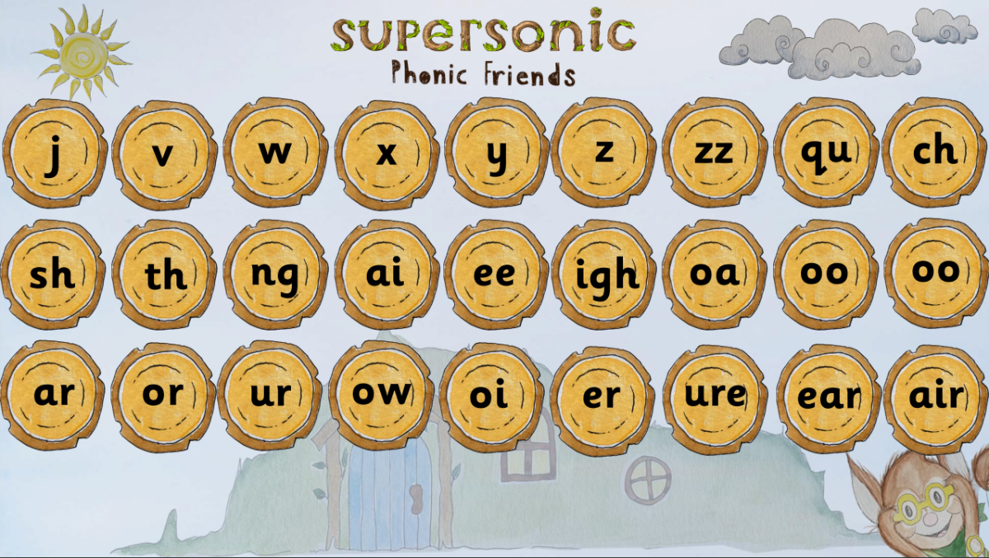

The Basics 4

Recognise, Build, Read and Write
Moving from 3 sounds (CVC) to four plus (CVCC,CCVC,CCVCC,CCCVCC)
The Basics 4 teach children to be able to hear more than 3 sounds in a word. They will continue to embed their mastery of The Basics 2 and 3 spellings for sounds in words and progress to 4, 5 and 6 sounds in a word. The children will be supported by Magic Mack and Jazzy Jack; who will help them hear the tricky, adjacent consonants that are challenging to hear in words of more than 3 sounds. Children will learn their tricky words with Tess and read nonsense words with Nan.
At the end of this phase:
- Children will be able to hear more than 3 sounds in a word, recognise spellings and read and write CVC, CVCC, CCVC, CCVCC,CCCVC words with the 44 spellings for sounds of the English language.
- They will be able to read decodable texts with The Basics 2 and 3 spellings and adjacent consonants and make phonetically plausible attempts in their evolving stages if spelling in their writing journey.
The Higher Levels- Choose to Use and Switch It
Choose to Use and Switch It
The Higher Levels of Phonics teaches children the concept that there are more than one spelling for a sound that they hear in a word. With the help of Choose to Use Suze, they will find out all about 'sounds the same but looks different' and cool and not so cool choose to use spelling rules for the 44 sounds of the English Language.

With the help of Switch it Mitch, they will also find out all about 'looks the same, sounds different' and switch it spelling sounds where one spelling can make up to 2 different sounds in words. Children will learn their tricky words with Tess and nonsense words with Nan.

At the end of this phase:
- Children will be able to choose to use the spellings of the 44 sounds of the English language.
- They will also be able to switch spellings and sounds for alternative pronunciations.
- They will be able to read decodable texts with The Basics to The Higher Levels spellings including adjacent consonants and make more accurate attempts in their further stages of spelling in their writing journey.
