Year 6, autumn 1, 2024

Welcome back to school – we hope that you had a restful holiday and that your child is raring to go for Year 6! Our Topic this term is ‘Britain at War’. This is the reason we will be visiting the War Memorial in Leamington soon.

English  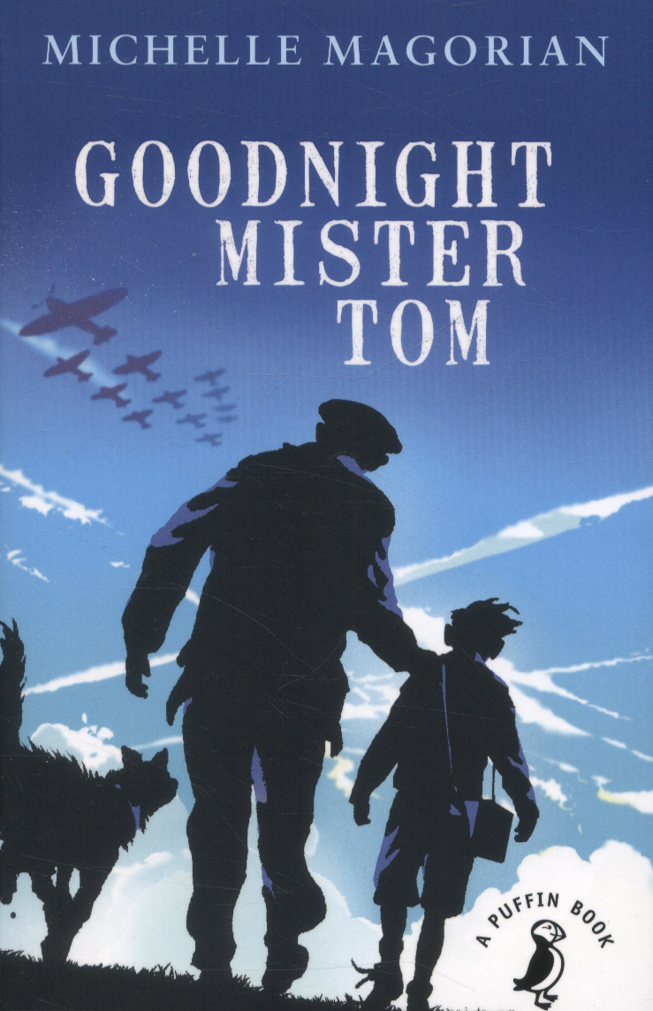   | In keeping with our topic, our main book this term is ‘Goodnight Mr Tom’. This book is a serious look at evacuees and a difficult home life for the hero, before he arrives at the home of Mr Tom. It gives a lovely ordinary view of the world war that was happening around the sleepy East Anglian village.  Our Love to Read text is, and I am sorry to start mentioning the word this early, ‘A Christmas Carol’. This is one of Charles Dickens’ greatest book and the characters portrayed are brilliantly developed, making the twist at the end even more dramatic.
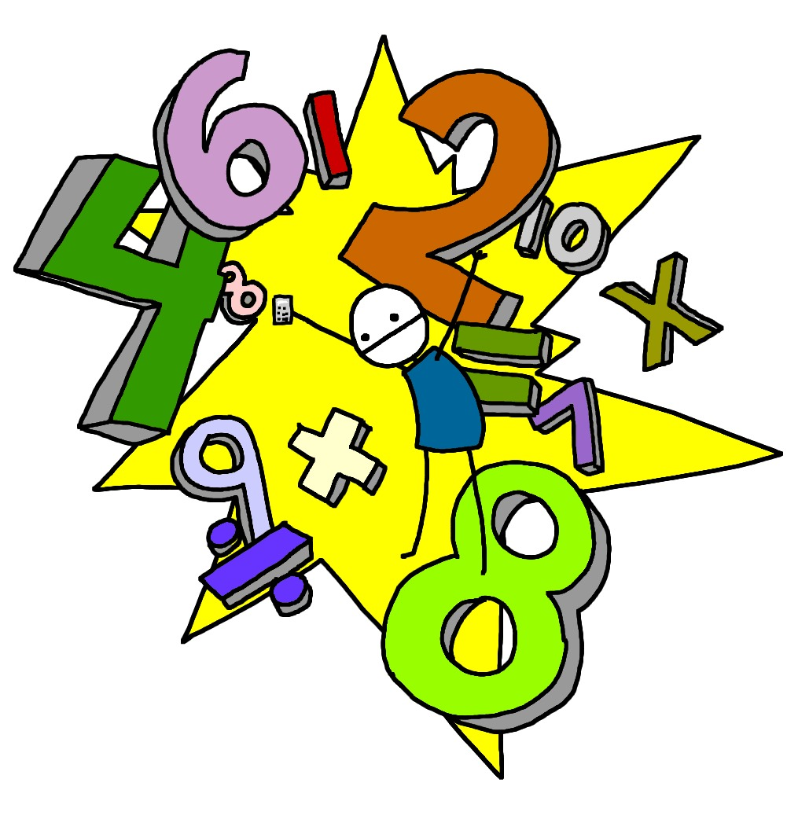  Maths | Maths starts, as always, with place value but we are now dealing with numbers up to 10 million. As with every other time, we have looked at place value, we start with estimating and rounding and then moving on to addition and subtraction of these very large numbers. The next unit is multiplication and division where we hope to secure the bus stop method of division. And lastly, we will be moving onto BODMAS or BIDMAS which looks at brackets and how they are used in mathematical calculations.
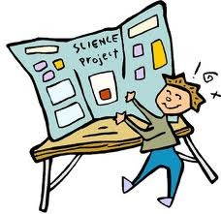  Science | For Science this term, we are looking at our sight. There are some lovely experiments with colour and some rather real videos to look at about how our eye is put together. We also discover that we actually see upside down and that our brain cleverly inverts the image!
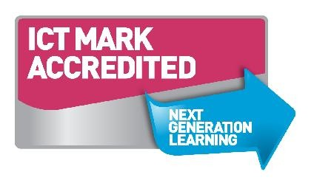  Computing | As always, we begin this term by looking at online safety and then we will be taking a look at HTML, the backbone of the internet. HTML stands for Hyper Text Mark-up Language and is the code that websites are made from. The children will get to unpick this and see the skeleton behind the webpages they love.
  Geography/History | Obviously, our focus is all about World War One and Two and Britain’s role in both. We will look at the causes and whether both were inevitable. One horrible history book put it as two gangs squaring off against each other, which is why they developed so fast and so far. Empire will also be looked into.
  D&T and Art | Taking our lead from the topic, our title of Art and DT is ‘Make do and Mend’ which was the slogan for Britons during World War Two. The children will get to look at how a garment is put together and how you could repair and make new clothes from what you have. It is a great life skill and an antidote to fast fashion. Speaking of which – any clothes donations are gratefully received.
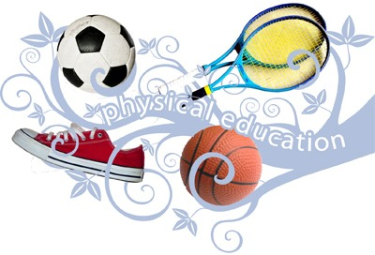  PE | For Year 6, we have swimming all the way through this very long term which is a real bonus. Our PE sessions this term will focus on netball. Please ensure that children bring their PE kit in at the start of the week. It is perfectly safe in their named locker and available then for any sessions, both planned and spontaneous.
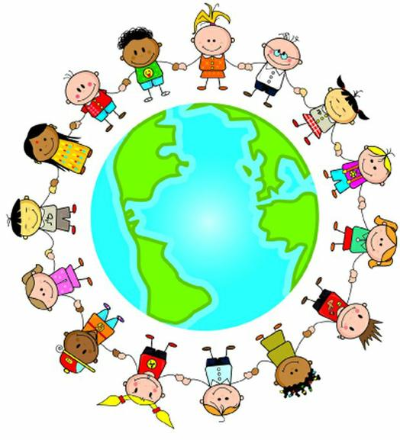  PSHE | We will focus on ‘Being me in my World’. which looks at how we can be a global citizen. We will promote positive thinking, goal setting and how to achieve those aims.
  RE | In RE this term, we will be looking at the beliefs and practices of one of the three main monotheistic religions – Christianity. We will look to see its relevance in the 21st century, persecution of Christians and those charities that it supports. In addition, there will be a focus on two festivals that fall during this term; Yom Kippur and Diwali.
  Music | With Young Voices only 3 months away, we will soon be practicing all the tracks we need to perfect before the big performance. I am hoping to take an even bigger and better choir this time.

Homework will be sent home on Fridays and should be returned by the following Wednesday. Each week your child will have spellings to learn. Children will be also asked to complete a topic-based activity as detailed on the weekly homework sheet which is stuck into your child’s homework book.

PE kit – in on Monday please and to remain in school for the week.
Water bottles – these should contain plain, unflavoured water. Children with packed lunches may bring a still, fruit-based drink for consumption at lunch time.

As you can see, Mrs Cook is teaching alongside Mr for the first 9 weeks. This way we can boost maths and English, with Mrs Cook focussing on Maths and Mr Bain doing the same for English. Please remember that we are available to speak to, for whatever reason, at the end of each day or by enquiring at the school office.

Many thanks,

Mrs Cook and Mr Bain: Class Teachers
Mrs Osbourne: Learning Support Assistant

