Year 3, autumn 1 2024

Hello everyone! While I will slowly get to know you all at the Year 3 door, I’d like to take this opportunity to introduce myself and express how much I am looking forward to working with you all, and the Year 3 children throughout the year ahead.

We have lots of fun learning planned for this half term, but I also want to take the time to get to know each child and work alongside Mrs Sidwell to ensure they are progressing and being challenged at their appropriate pace.

Below is a breakdown of what we’ll be learning in each subject, but our overarching theme this half term is ‘Through the Ages’ where we’ll be exploring the world of the Stone Age through to the Bronze Age! You’ll notice lots of links to this below.

  English  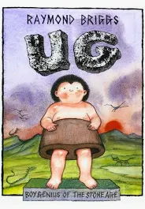 | Our English text this half term is ‘Ug’ by Raymond Briggs. Raymond Briggs is the author of ‘The Snowman’ and this beautiful illustration is continued in ‘Ug’. In this multi-layered graphic text, the concept of ‘stone age’ is taken to extremes with everything, including trousers made of stone. The story follows the quest of a Stone Age boy, Ug, in his search for softer trousers. Throughout the autumn term we will be exploring the writing genres of Instructions, recounts, journalistic writing, poetry, play scripts, stories with historical settings, all of which will be linked with this text. Alongside this, we will also be developing our reading skills through our Love to Read text which is ‘Sheep Pig’ by Dick King Smith. We will begin reading this text in detail, practicing our inference, prediction, explanation, retrieval and summarising skills, alongside exploring any unfamiliar vocabulary.  Finally, every Tuesday we will be completing our grammar and punctuation lessons where we explore in detail the structure of the English language and skills Year 3 should be employing in their written work. This half term we will be looking at topics such as consonants and vowels, present tense, organisational devices, adverbs to show frequency, appropriate use of ‘a or ‘an’, past tense and using place and cause conjunctions.
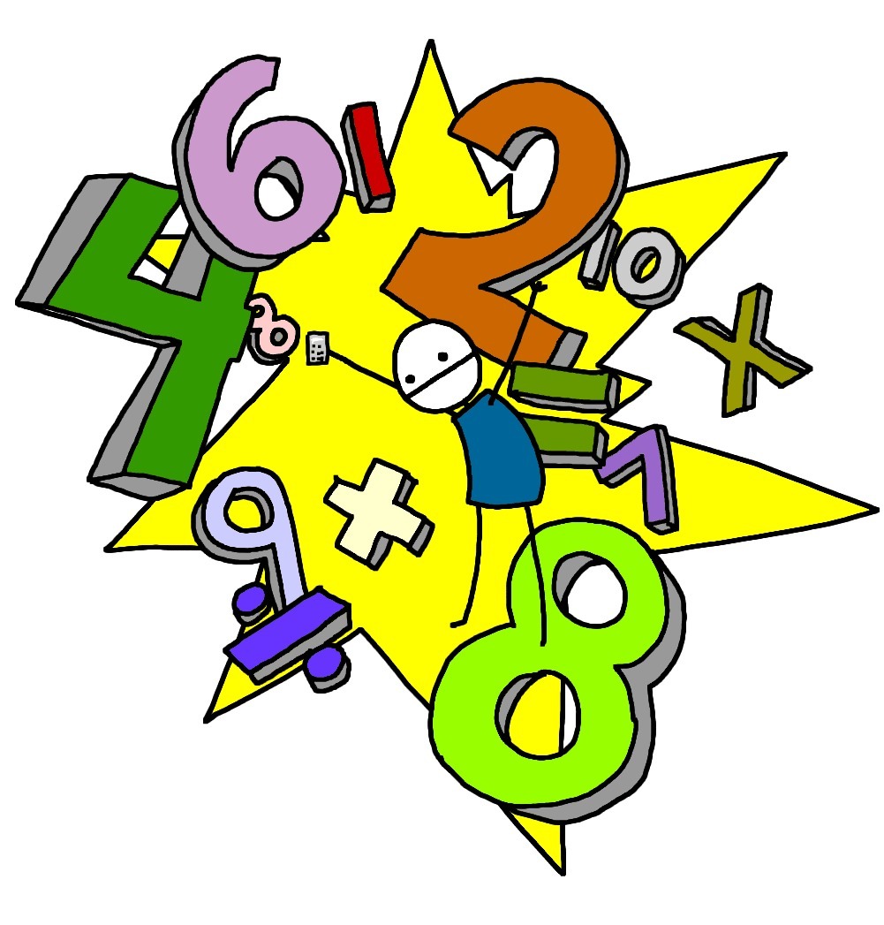  Maths | Autumn 1’s Maths topics see us revisiting and building upon the fantastic work Year 3 did whilst in Year 2 about understanding the relationships between numbers, the value of numbers as well as important calculation strategies. We will begin with the topic ‘Number Sense and Exploring Calculation Strategies’. In this topic, Year 3 will read, write, order and compare numbers to 100, calculate mentally using known facts, round and adjust, near doubles, and adding on to find the difference. We will finish off the topic with a key mathematical skill of deriving new facts from a known fact. After this, Year 3 will revisit place value focussing on reading, writing, representing, partitioning, ordering and comparing 3-digit numbers. These are vital skill which will be used throughout KS2. We will also find 10 and 100 more or less and finally round to the nearest multiple of 10 and 100. Finally, we will end the half term with the topic of graphs. Here we will collect, interpret and present data using charts and tables.  Alongside all of this we will be regularly practising our times tables as well as progressing to learning new ones. Each pupil has a TT Rockstars login which can be used at home. This will support their learning in the classroom considerably so would advise doing this for a few minutes at least 3 times a week.
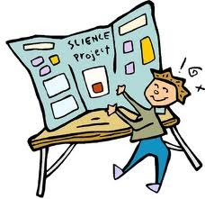  Science | Our topic this half term is ‘Animal Nutrition and the Skeletal Systems’. Year 3 will revisit prior learning about living things, including how animals can be carnivores, herbivores or omnivores, needing food, water, air, shelter, sleep and space to reproduce and survive. They will use the term 'nutrition', learning that it is a life process by which all living things get or make food. We will learn that humans are omnivores because of their teeth and ask scientific questions about the human diet and research to find the answers. We will explore how and why humans need a balanced diet, discussing the various foods groups, and comparing our diet to that of other animals.  After this we will learn about the function of the human skeleton, observing and then labelling the location of its major bones. Year 3 will learn what joints are and investigate how they allow us to bend and move easily. They will learn the function of muscles and identify how they work in pairs before observing firsthand the movements their muscles bring about. We will again compare the human skeleton to that of other animals.
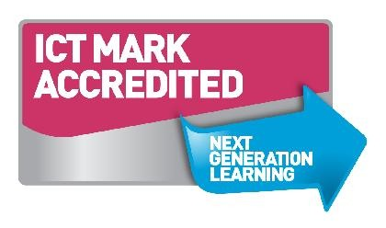  Computing | In Computing, our project for this half term is ‘Animations’. As a team, Year 3 will work together to create a moving animation. They will use their programming skills to create a sequence of code which we will showcase to the rest of the class at the end of the term.
  Geography/History | As mentioned previously, our topic for the Autumn term is ‘Through the Ages’. This half term will be predominantly History based. Year 3 will learn about three different periods of British prehistory: the Stone Age, Bronze Age and Iron Age. They will discover terminology relating to time and sequence dates to make a timeline. They explore the changes to people, homes and lifestyle throughout the different periods and investigate examples of prehistoric settlements, monuments, burials and artefacts in detail. They will also study how technology improved over time, including how the discovery of different metals changed the way that people lived.
  D&T and Art | We will begin the autumn 1 Term with a D&T topic entitled ‘Cook Well, Eatwell’. This project teaches children about food groups and the Eatwell guide. They learn about methods of cooking and explore these by cooking potatoes and ratatouille. The topic will end with the children designing and making a taco filling according to specific design criteria. After this, we will begin an Art project which links closely to a specific part of our Humanities project – ‘Prehistoric Pots’. This project teaches children about Bell Beaker pottery. It allows the children to explore different clay techniques, which they use to make and decorate a Bell Beaker-style pot.
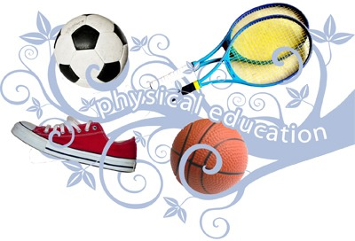  PE | In autumn 1, Year 3 will be completing Dance lessons every Tuesday. They will developing their co-ordination, balance, and rhythmic skills. In our other PE lesson, which will take place every Thursday afternoon, Year 3 will be completing a unit called ‘Game Sense’. The unit of work will explore how to apply the principles of attack vs defence, with a particular focus on passing, moving and shooting. There is no particular sport being focused on but will allow pupils to develop an understanding of the important skills of attacking, defending, space, possession, passing, control and shooting.
  Music | In Music, our learning is focused around one song: ‘Let Your Spirit Fly’. The material presents an integrated approach to music where games, the dimensions of music (pulse, rhythm, pitch etc), singing and playing instruments are all linked.
  RE | In RE, we will be exploring the religion of Hinduism with a specific focus on investigating what happens during the festival of Diwali and whether the celebrations bring a sense of belonging to Hindus.
PSHE  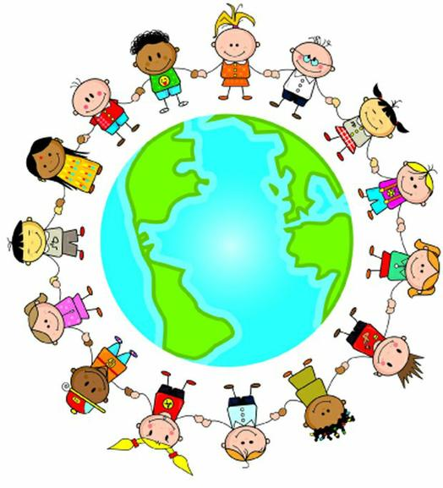 | We will be exploring the theme of ‘Being Me in My World’ in PSHE this term. They will explore where, who and how to feel safe, how to respect and be kind to one another, as well as challenges we may face in our day-to-day life and strategies for dealing with these.

Homework will be sent home on Fridays and should be returned by the following Wednesday and each week your child will have spellings to learn.

PE kit – in on Monday please and to remain in school for the week.
Water bottles – these should contain plain, unflavoured water only. Children with packed lunches may bring a still, fruit-based drink for consumption at lunch time.

If you have any questions or would like to know more about how you can help at home, please come and ask me; I am always happy to help. My main ask is that you please keep encouraging reading at home – it will have an immense impact on their learning in all subjects!

Mrs Sidwell and I are excited for the year ahead and look forward to getting to know all of Year 3 better in the coming weeks .

Mrs Shambrook: Class teacher
Mrs Sidwell: Learning Support Assistant

