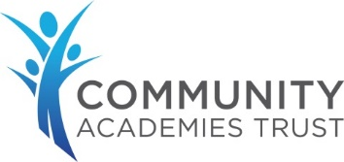

Child on Child Abuse Policy
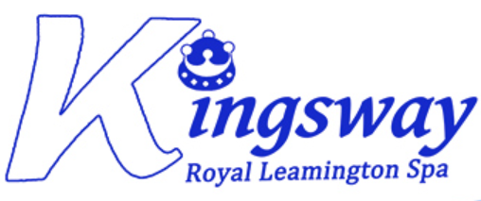

Document Reference Number (if already used) | 1
Title | Child on Child Abuse Policy
Policy Owner | Jo Howell
Version | 1.1
Approved Date | 01.07.26
Approving Body | SSC
Next Review Date | July 2027

Version control
Version | Last modified | Last modified by | Document changes
1.1 | May 2026 | Jo Howell | Updated language in line with latest KCSiE and other DfE guidance; restructure to remove repetition and inconsistencies and improve flow;

Education is for improving lives and for leaving your
community and world better than you found it.
Table of Contents

1. Introduction 3
2. Understanding child-on-child abuse 4
3. Contextual Safeguarding 5
4. Prevalence of child-on-child abuse 6
5. Sexual behaviours 6
6. Identifying a child who is being abused by another child 6
7. Vulnerability to abusing or being abused by other children 7
8. Our whole school approach 8
9. Multi-agency working 9
10. Responding to concerns and allegations of child-on-child abuse 9
11. The school safeguarding response 9
12. Nude or semi-nude images and online concerns 10
13. Support provision 11
14. Risk Assessments 11
15. Information sharing and data protection 12
16. Record keeping 12
17. Sanctions 12
18. Prevention and protective education 14
19. Review and action planning 14
20. Embedding safeguarding practice 15

- Introduction
At Kingsway Community Primary School, our governors, strategic leadership team and all staff are committed to the prevention, early identification, and appropriate management of child-on-child abuse both within and beyond the school.
We believe that in order to protect children, all schools should:
- be aware of the nature and level of risk to which their pupils are or may be exposed, and put in place a clear and comprehensive strategy which is tailored to their specific safeguarding context;
- take a whole-school community ‘Contextual Safeguarding’ approach to preventing and responding to child-on-child abuse.

The school recognises that child-on-child abuse can occur both inside and outside of school, online and offline, and may take place between individuals or groups. The school is aware that technology can facilitate abuse, including harassment, coercion, exploitation, bullying and harmful sexual behaviour. Furthermore, the school recognises emerging safeguarding risks linked to Artificial Intelligence (AI), including the creation or sharing of manipulated sexual imagery, impersonation, coercion, harassment and online exploitation. All concerns will therefore be considered within the wider social, environmental and online contexts in which children live.

As a school we are committed to:
- tackling child-on-child abuse proactively, focusing on:
  - systems and structures;
  - prevention;
  - identification;
  - response/intervention;

- recognising and responding to the national concern about this issue in order to mitigate harmful attitudes and child-on-child abuse in the school setting;
- encouraging parents to hold us to account on this issue, so that if their child is feeling unsafe as a result of the behaviour of other children, they inform the school so that we can ensure that appropriate and prompt action is taken in response.

This policy:
- is the school’s overarching policy for any issue that could constitute child-on-child abuse. It relates to, and should be read alongside our Child Protection and Safeguarding Policy and any other relevant policies including the behaviour, anti-bullying, online safety and exclusions policies;
- sets out our strategy for preventing and identifying and managing child-on-child abuse;
- applies to all members of our school community. It is reviewed biennially and updated in the interim, as required, to ensure that it continually addresses the risks to which pupils are or may be exposed;
- recognises that abuse is abuse and should never be passed off as ‘banter’, ‘just having a laugh’, or ‘part of growing up’;
- is compliant with the latest statutory guidance on child-on-child abuse as set out in Keeping Children Safe in Education;
- should, if relevant, be read in conjunction with the DfE’s advice on Sexual Violence and Sexual Harassment Between Children in Schools and Colleges (DfE - May 2018), and any other advice and guidance referred to within it;
- should be read in conjunction with the Local Safeguarding Partnership’s Safeguarding Policy and Procedures, and any relevant Practice Guidance issued by it.

- Understanding child-on-child abuse
Child-on-child abuse is any form of physical, sexual, emotional and financial abuse and coercive control, exercised between children, and within children’s relationships (both intimate and non- intimate), friendships and wider associations with others. By definition, it applies regardless of the age, of stage of development, or any age differential between them.

The school recognises that children who experience abuse should never be blamed for what has happened and will always be treated with dignity, respect and support. The terms ‘victim’, ‘alleged perpetrator’ and ‘person harmed’ may be used where appropriate for clarity within safeguarding processes, whilst recognising that children involved in incidents of child-on-child abuse may themselves have unmet needs, vulnerabilities or safeguarding concerns.

A visual overview of child-on-child abuse:

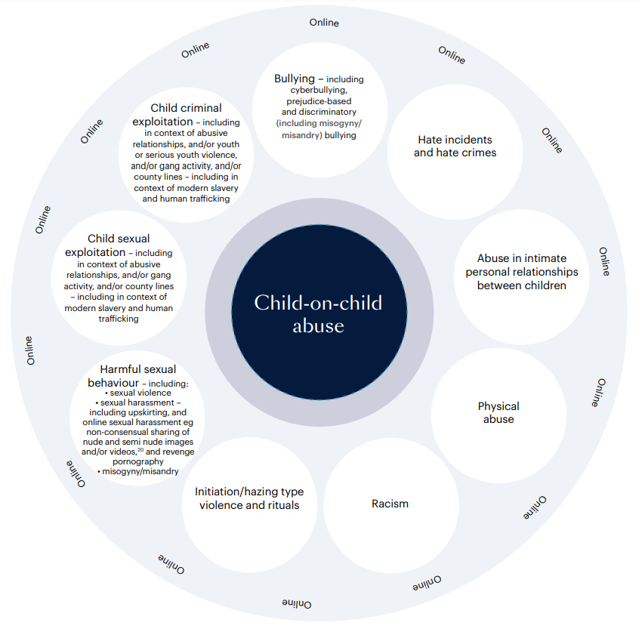

Child-on-child abuse can take various forms, including (but not limited to):

- bullying, including cyber-bullying, prejudice-based and discriminatory (including misogyny/misandry) bullying;
- hate incidents and hate crimes – which may also include an online element;
- abuse in intimate personal relationships between children (sometimes known as ‘teenage relationship abuse’) – which may also include an online element;
- image-based abuse, including the non-consensual sharing of nude or semi-nude images and videos;
- coercive behaviour, intimidation and emotional manipulation;
- physical abuse – such as hitting, kicking, shaking, biting, hair pulling, or otherwise causing physical harm. This may include an online element which facilitates, threatens and/or encourages physical abuse;
- initiation/hazing type violence and rituals – this could include activities involving harassment, abuse or humiliation used as a way of initiating a person into a group and may also include an online element;
- harmful sexual behaviour (HSB) – developmentally inappropriate sexual behaviour which is displayed by children and young people which is harmful or abusive.
- sexually harmful behaviour facilitated through artificial intelligence (AI), online platforms or digital technology;
- abuse linked to protected characteristics including sexism, misogyny, misandry, homophobia, biphobia, transphobia, racism, ableism and faith-based prejudice;
- upskirting;
- child sexual and/or child criminal exploitation.

- Contextual Safeguarding
All staff should consider the context within which incidents/behaviours occur. This is known as ‘contextual safeguarding’, which simply means assessments of children should consider whether wider environmental factors are present in a child’s life that pose a threat to their safety or well-being.

This policy:
- encapsulates a contextual safeguarding approach, which is about changing the way that professionals approach child protection when risks occur outside of the family, known as extra-familial harm.
- adopts a whole-school community Contextual Safeguarding approach, which means:

  - being aware of the impact that these wider social contexts may be having on children;
  - creating a safe culture in the school by implementing policies and procedures that address child-on-child abuse, promoting healthy relationships and attitudes to gender/sexuality, hotspot-mapping to identify risky areas in school and training on potential bias and stereotyped assumptions;
  - being alert to and monitoring changes in children’s behaviour and/or attendance;
  - contributing to local child protection agendas by, for example, challenging poor threshold decisions and referring concerns about contexts to relevant local agencies.

- Prevalence of child-on-child abuse
Research suggests that child-on-child abuse is one of the most common forms of abuse affecting children in the UK. National data suggests that around 29% of adults report experiencing some form of abuse before the age of 18, and evidence shows that much of this abuse is perpetrated by other children and young people rather than adults. Police and sector analysis highlight that approximately half (around 52%) of recorded child sexual abuse and exploitation offences in England and Wales involve child perpetrators. This reinforces that harmful behaviours between children are not rare incidents but form a substantial element of overall abuse cases.

- Sexual behaviours
The following continuum model demonstrates the range of sexual behaviours presented by children, which may be helpful when seeking to understand a child’s sexual behaviour and deciding how to respond to it.

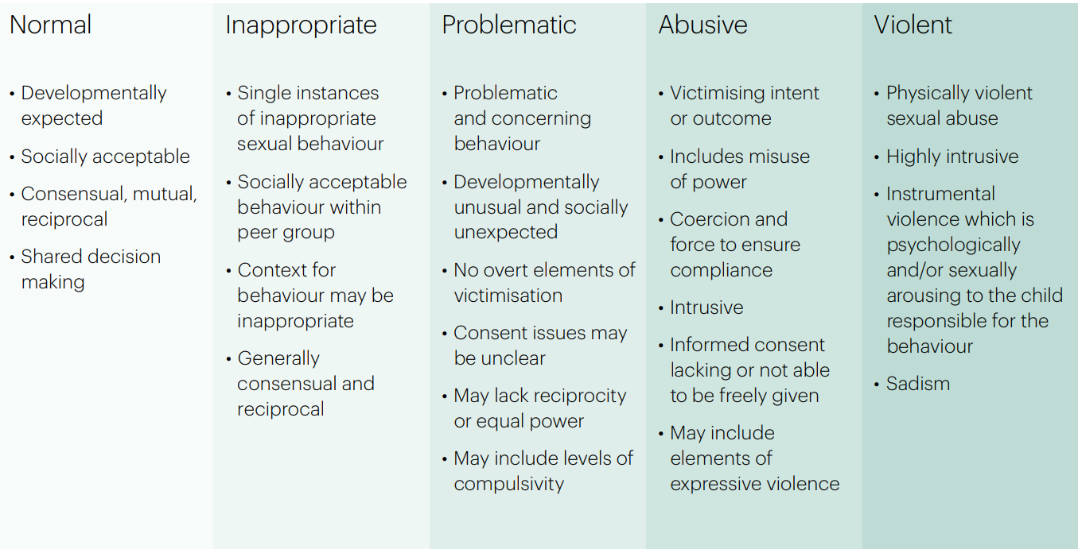

This continuum relates exclusively to sexual behaviours and is not exhaustive. The Brook Sexual Behaviours Traffic Light Tool can also help professionals working with children to distinguish between three levels of sexual behaviour – green, amber and red, and to respond according to the level of concern.

- Identifying a child who is being abused by another child

All staff should maintain professional curiosity and be alert to the well-being of children and to signs of abuse, engaging with these signs, as appropriate, to determine whether they are caused by child-on-child abuse. However, staff should be mindful of the fact that the ways in which children will disclose or present with behaviours will differ as a result of their experiences. Staff should also recognise that seemingly low-level concerns, patterns of behaviour or repeated incidents may indicate more serious safeguarding risks. All concerns should therefore be reported in accordance with safeguarding procedures.
Things to look out for in victims of child-on-child abuse:
- Regularly feeling sick or unwell in the morning;
- Reluctance to make the journey to and from school;
- Money or possessions going missing;
- Clothes or school bag torn;
- Wanting extra pocket money for no particular reason;
- Unexplained cuts and bruises;
- Taking different routes to school;
- Unexplained behaviour changes, e.g. moody, bad tempered, tearful;
- Unhappiness;
- Nightmares;
- Not wanting to leave the house;
- Reluctance to talk openly about school friends and social times.

The school’s safeguarding team should regularly review behaviour incident logs which can help to identify any changes in behaviour and/or concerning patterns or trends at an early stage.
If a parent thinks their child may be the victim of child-on-child abuse, they should contact the school as soon as possible to report the issues through the appropriate channels. Sometimes children do not report the issues to anyone in school.

- Vulnerability to abusing or being abused by other children

Any child can be vulnerable to child-on-child abuse due to the strength of the influence of others and staff should be alert to signs of such abuse amongst all children. Situational factors can increase a child’s vulnerability to abuse by other children. For example, an image of a child could be shared, following which they could become more vulnerable to child-on-child abuse due to how others now perceive them, regardless of any characteristics which may be inherent in them and/or their family.

Group dynamics can also play an important role in determining a child’s vulnerability to such abuse. For example, children who are more likely to follow others and/or who are socially isolated from other children may be more vulnerable to child-on-child abuse. Children who are questioning or exploring their sexuality may also be particularly vulnerable to such abuse.

Research suggests that:
- child-on-child abuse may affect boys differently from girls, which may result from societal norms rather than biological make-up. Barriers to disclosure will also be different.
- children with Special Educational Needs and/or Disabilities (SEND) are three times more likely to be abused than those without SEND, and additional barriers can sometimes exist when recognising abuse in children with SEND. These can include:
  - assumptions that indicators of possible abuse such as behaviour, mood and injury relate to a child’s disability without further exploration;
  - the potential for children with SEND to be disproportionately impacted by behaviours such as bullying and harassment, without outwardly showing any signs;
  - communication barriers and difficulties;
  - overcoming these barriers.
- some children may be more likely to experience child-on-child abuse than others as a result of certain characteristics such as sexual orientation, ethnicity, race or religious beliefs.

- Our whole school approach
The school seeks to create a culture in which children feel safe to report concerns, knowing they will be listened to, believed and taken seriously. Staff will avoid language or responses which minimise, dismiss or normalise harmful behaviour. The school actively seeks to raise awareness of and prevent all forms of child-on-child abuse by:
- educating all governors, its strategic leadership team, staff, pupils and parents about this issue, including training at all levels on the nature, prevalence and effect of child-on-child abuse and how to prevent, identify and respond to it. This includes:
    - contextual safeguarding;
    - the identification and classification of specific behaviours, including digital behaviours;
    - the importance of taking seriously all forms of child-on-child abuse, no matter how ‘low-level’ they may appear, and ensuring that no form of child-on-child abuse is ever dismissed as teasing or banter;
    - social media and online safety, including how to encourage children to use social media and AI in a positive, safe and responsible way, how to enable them to identify and manage abusive behaviour online, and how to critically assess the content they may be exposed to, including recognising and challenging negative influences`.
- educating children about the nature and prevalence of child-on-child abuse, positive, responsible and safe use of social media, and the unequivocal facts about consent and about healthy relationships, via PSHE and the wider curriculum. They are regularly informed about the school’s approach to such issues, including its zero-tolerance response towards all forms of child-on-child abuse.
- engaging parents on these issues by:
- publicising the possible signs and symptoms of child-on-child abuse and encouraging them to report concerns to the school immediately;
- encouraging parents to hold the school to account on this issue, in part as a result of visibility of this policy.
- supporting and promoting the ongoing wellbeing and mental health of children by drawing on multiple resources that prioritise child wellbeing, resilience and mental health, and by providing in-school counselling or support to address underlying mental health needs.
- promoting safe and healthy relationships through a whole-school culture of respect and wellbeing:
  - which is founded on the idea that every member of our school community is responsible for building and maintaining safe and positive relationships, and helping to create a safe school environment in which abuse is never acceptable;
  - in which pupils are able to develop trusting relationships with staff and in which staff understand, through regular discussion and training, the importance of these relationships in providing pupils with a sense of belonging, which could otherwise be sought in problematic contexts;
  - in which pupils feel able to share their concerns openly, in a non-judgmental environment, and have them listened to;
- responding to cases of child-on-child abuse promptly and appropriately;
- ensuring that all child-on-child abuse issues are fed back to the school’s safeguarding team so that they can spot and address any concerning trends and identify children who may be in need of additional support.

- Multi-agency working
The school actively engages with its Local Safeguarding Partnership in relation to child-on-child abuse and works closely with a range of external agencies in accordance with the Local Safeguarding Partnership’s procedures.
The school actively refers concerns and allegations of child-on-child abuse where necessary to children’s social care, the police and other relevant agencies in accordance with the Local Safeguarding Partnership’s procedures.

- Responding to concerns and allegations of child-on-child abuse
The school recognises that harmful sexual behaviour and other forms of child-on-child abuse exist on a continuum and that inappropriate behaviour, if not addressed, may escalate over time. All concerns must therefore be taken seriously and handled sensitively, appropriately and promptly. Early intervention, education and a consistent safeguarding response are key to maintaining a safe and respectful culture.
All staff must report any concerns about child-on-child abuse immediately to the DSL. If a child is in immediate danger, a referral to children’s social care and/or the police will be made without delay.
Where a child discloses abuse, staff will listen calmly, use open and non-judgemental language, and report the concern to the DSL as soon as possible.

- The school safeguarding response
Our response to concerns and allegations will:
- include a thorough investigation of the concern(s) or allegation(s), and the wider context in which it/they may have occurred (as appropriate) – depending on the nature and seriousness of the alleged incident(s), it may be appropriate for the police and/or children’s social care to carry out this investigation;
- treat all children involved as being at potential risk – while the child allegedly responsible for the abuse may pose a significant risk of harm to other children, s/he may also have considerable unmet needs and be at risk of harm themselves. The school should ensure that a safeguarding response is in place for both the child who has allegedly experienced the abuse, and the child who has allegedly been responsible for it, and additional sanctioning work may be required for the latter;
- take into account that the abuse may indicate wider safeguarding concerns for any of the children involved, and consider and address the effect of wider sociocultural contexts such as the child’s peer group, family, the school environment, the potential for victimisation in the local community and the child’s online presence;
- consider the potential complexity of child-on-child abuse and of children´s experiences, and consider the interplay between power, choice and consent. While children may appear to be making choices, if those choices are limited they are not consenting;
- ensure an intersectional approach is followed, specifically remaining alert to the potential for bias, stereotyping and adultification when responding to concerns, particularly in relation to SEND pupils, children from ethnic minority backgrounds, LGBTQ+ pupils and those with communication difficulties;
- obtain the views of the child/children affected wnd, where appropriate and safe, their parents, managing expectations around information sharing.
Where appropriate the DSL will determine one of the following responses:

- Manage internally with help from external specialists where appropriate and possible. This would usually be where behaviour is inappropriate but not abusive. In such cases, utilising the behaviour policy and providing pastoral support may be the most appropriate route.
- Undertake/contribute to an inter-agency early help assessment. These services may, for example, include family and parenting programmes, responses to emerging thematic concerns in extra familial contexts, a specialist harmful sexual behaviour team, CAMHS and/or youth offending services.
- Refer to children’s social care for a section 17/47 statutory assessment. Where a child is suffering, or is likely to suffer from harm.
- Report alleged or suspected criminal behaviour to the police. However, there are some circumstances where it may not be appropriate to report such behaviour to the police. For example, where the sharing of nude or semi-nude images/videos does not involve any aggravating factors. All concerns or allegations will be assessed on a case-by-case basis, and in light of the wider context.

- Nude or semi-nude images and online concerns
Where any concern(s) or allegation(s) indicate(s) that nude or semi-nude images and/or videos of a child or children may have been shared online, the DSL should consider what urgent action can be taken in addition to the actions and referral duties set out in this policy. Staff will not intentionally view or forward illegal images of a child unless absolutely necessary to safeguard the child or obtain immediate information required for risk management. Incidents involving nude or semi-nude images will be managed in line with DfE guidance and safeguarding procedures.

- Support provision
The school will ensure appropriate ongoing support for all children affected including:
- The child who has experienced harm;
- The child alleged to have caused harm;
- Any witnesses affected by the incident.
Support may include pastoral intervention, safety planning, counselling, mentoring timetable modifications, therapeutic support or other external agency involvement, as required.

- Risk Assessments
In line with KCSiE guidance a risk assessment will always be carried out by the school in respect of:
- any child who is alleged to have behaved in a way that is considered to be abusive or violent;
- any child who has reportedly been abused or affected by the alleged abusive or violent behaviour by another child; or
- any child who may be at risk due to the alleged abusive or violent behaviour by another child as deemed appropriate by the DSL.
Consideration may need to be given to having separate but aligned risk assessments for the alleged perpetrator(s), and the victim(s), and any other child/children who may be affected by the alleged abusive or violent behaviour.
Where other children have been identified as witnesses to the alleged abusive or violent behaviour, consideration should also be given by the DSL to the impact on them, and whether there might be any risks posed to those children, and whether a risk assessment for them would be appropriate in the circumstances.
In the vast majority of circumstances and where it is possible that such behaviour may be repeated, a risk assessment should be completed.
Where it is alleged that a child has behaved in a way that is considered to be inappropriate or problematic (as opposed to abusive or violent), the DSL will use their professional judgment to determine whether it would be appropriate to contact children’s social care and to carry out a risk assessment.
Careful judgment and consideration are required as to whether alleged behaviour which might be judged to be inappropriate by an adult might actually be harmful to another child. The school may refer to Hackett’s continuum and/or the Brook Sexual Behaviours Traffic Light Tool to identify and assess the sexual behaviour in question. Consultation is also recommended with the trust’s Director of Safeguarding and Behaviour or children’s social care if there remains any doubt about this. Careful consideration should also be given to the context, severity of the alleged behaviour, impact of the alleged behaviour on others, risk to others, and whether there are any patterns of behaviour occurring.
Where other children have been identified as witnesses to alleged abuse or violence, consideration should also be given by the DSL to whether there might be any risks to those children.
In all cases where a risk assessment is not considered to be appropriate, the school should nonetheless take steps to safeguard and support the children involved and continue to monitor the situation, reviewing the need for a risk assessment if risk increases.

- Information sharing and data protection
When responding to concern(s) or allegation(s) of child-on-child abuse, the school will:
- always consider carefully, in consultation with other relevant agencies, how to share information about the concern(s) or allegation(s) with the pupil(s) affected, their parents, staff, and other children and individuals,
- act in accordance with its safeguarding and data protection duties, including those set out by the DfE in:
  - Keeping Children Safe in Education (2026);
  - Working Together to Safeguard Children (December 2026);
  - Information Sharing: Advice for practitioners (May 2024);
  - Behaviour in Schools guidance;
  - Sharing nudes and semi-nudes: advice for education settings;
  - Filtering and Monitoring Standards for Schools and Colleges.

- Record keeping
All concerns, disclosures, allegations, decisions and actions relating to child-on-child abuse will be recorded clearly and securely in accordance with the school’s safeguarding and data protection procedures.
Records should:
- be factual, accurate and timely;
- include the views of the child where appropriate;
- record rationale for decisions made;
- identify any safeguarding referrals or multi-agency involvement;
- identify any actions taken to reduce future risk.
The DSL will regularly review records to identify themes, trends, patterns or contextual safeguarding concerns.

- Sanctions
The school may wish to consider whether sanctions may be appropriate for any child/children involved. This may be appropriate to:
- ensure that the child/children take(s) responsibility for and realise(s) the seriousness of their behaviour;
- demonstrate to the child/children and others that child-on-child abuse can never be tolerated;
- ensure the safety and wellbeing of other children.
However, these considerations must be balanced against any police investigations, the child’s/children’s own potential unmet needs, and any action or intervention planned regarding safeguarding concerns. Before deciding on appropriate action the school will always consider its duty to safeguard all children in its care from harm; the underlying reasons for a child’s behaviour; any unmet needs, or harm or abuse suffered by the child; the risk that the child may pose to other children; and the severity of the child-on-child abuse and the causes of it.
The school will, where appropriate, consider the potential benefit, as well as challenge, of using managed moves or exclusion as a response, and not as an intervention, recognising that even if this is ultimately deemed to be necessary, some of the measures referred to in this policy may still be required, in relation to other children who have been involved with and/or affected by child-on-child abuse.
Exclusion will only be considered as a last resort and only where necessary to ensure the safety and wellbeing of the other children in the school. Engaging in Fair Access Panel Processes to assist with decision-making associated to managed moves and exclusions can also be beneficial. In the event of any managed move, consideration must be given to sharing information with the receiving school regarding the child-on-child abuse in order to allow best protection of children in the new school.
- Prevention and protective education
The school recognises that preventative education is an essential part of safeguarding.
Age-appropriate teaching through the curriculum, including RSHE, PSHE, assemblies and pastoral work will support pupils to:
- understand healthy and respectful relationships;
- recognise abusive behaviour;
- understand consent, boundaries and coercion;
- challenge prejudice and harmful stereotypes;
- develop digital resilience and online safety awareness, including that associated with AI;
- understand how to seek help and report concerns.

- Review and action planning
The school’s response to concerns or allegations of child-on-child abuse should be part of on-going proactive work by the school to embed best practice and in taking a whole-school community Contextual Safeguarding approach to such abuse.
This response could also include the school asking itself a series of questions about the context in which an incident of child-on-child abuse occurred in the school, the local community in which the school is based, and the wider physical and online environment – such as:
- What protective factors and influences exist within the school and how can the school bolster these?
- How (if at all) did the school’s physical environment or the child’s route to and from the school contribute to the abuse and how can the school address this going forwards
- How (if at all) did the online environment contribute to the abuse and how can the school address this going forwards?
- Did wider gender norms, equality issues, and/or societal attitudes contribute to the abuse?
- Does the abuse indicate a need for staff training on, for example, underlying attitudes or the handling of particular types of abuse?
- How have similar cases been managed in the past and what effect has this had?
- Does the case identify areas for development in the way in which the school works with children to raise their awareness of and/or prevent child-on-child abuse, including by way of the school’s PSHE curriculum and lessons that address underlying attitudes or behaviour such as gender and equalities work, respect, boundaries, consent, children’s rights and critical thinking and/or avoiding victim-blaming narratives?
- Are there any lessons to be learnt about the way in which the school engages with parents to address child-on-child abuse issues?
- Are there underlying issues that affect other schools in the area and is there a need for a multi-agency response?
- Does this case highlight a need to work with certain children to build their confidence, and teach them how to identify and manage abusive behaviour?
- Were there opportunities to intervene earlier or differently?
Answers to these questions may be developed into an action plan which is reviewed on a regular basis by the DSL and the school’s leadership team.

- Embedding safeguarding practice
The school is committed to fostering a culture of safety, respect and inclusion in which all children are protected, heard and supported. Through strong safeguarding practice, positive relationships, early intervention and effective partnership working, the school aims to ensure that harmful behaviour is challenged appropriately, concerns are responded to promptly and sensitively and all pupils feel safe, valued and able to thrive.

https://www.farrer.co.uk/globalassets/clients-and-sectors/safeguarding/addressing-child-on-child-abuse.pdf, p5
Professor Simon Hackett’s harmful sexual behaviour framework, 2019, p 15: https://learning.nspcc.org.uk/research-resources/2019/harmful-sexualbehaviour-framework/
https://www.brook.org.uk/your-life/courses/traffic-light-tool/
Our zero-tolerance practice means that we will never do nothing in response to knowledge of child-on-child abuse and will always support those who report, taking all allegations seriously. The school will take a proportionate and appropriate response to every alleged incident.
Suggested contents/ format of a risk assessment can be found in https://www.farrer.co.uk/globalassets/clients-and-sectors/safeguarding/addressing-child-on-child-abuse.pdf, p50-51
https://www.gov.uk/government/publications/data-protection-toolkit-for-schools

